Highland Presbyterian Church

January 8th, 2023
Baptism of the Lord Sunday
10:30 a.m.

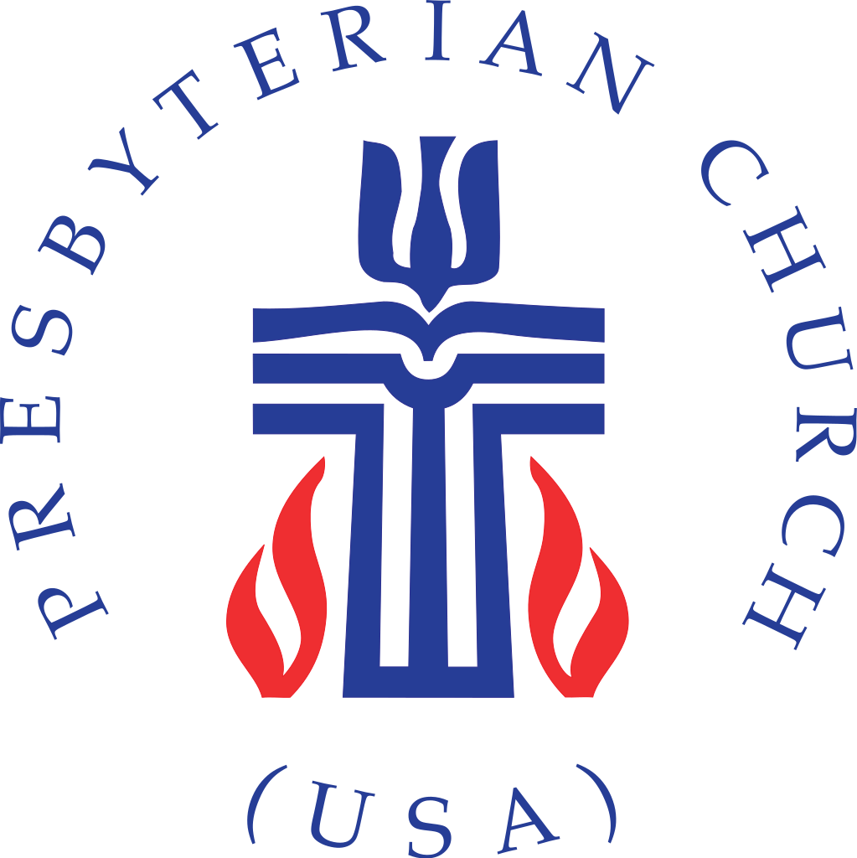

Highland Presbyterian Church​ seeks to be a diverse and inclusive Christian Community as we embody the love and forgiveness of Jesus by serving the Community and the World, drawing people to Christ.
Prelude
Gathering

Welcome & Announcements Rev. Matthew Benz-Whittington

Call to Worship (Responsive) Dawn Briere

One: In the beginning, at creation, the Spirit hovered over the waters of the deep.
All: In the waters of the flood, God cleansed the earth and humankind.
One: God caused the waters to part so that Israel could cross from slavery to liberation.
All: God formed Jesus in the waters of Mary’s womb.
One: Jesus taught us how to live by washing his disciples’ feet in water.
All: Drinking water from a well, Jesus met a Samaritan woman, the first to recognize him as Christ.
One: Today we celebrate the baptism of Jesus, the Christ.
All: Thanks be to God!

*Opening Hymn Today We All Are Called to be Disciples Hymn 757

Time for the Children Revs. Matthew and Bethany Benz-Whittington

The Word

Prayer for Illumination Dawn Briere

Still-speaking God, as these words from Scripture are read, may it be to us as if the heavens are opening, and we see your Spirit descending on us like a dove, revealing your love for us as your children. Amen.
Holy Scripture Genesis 1:1-5

When God began to create the heavens and the earth, the earth was complete chaos, and darkness covered the face of the deep, while a wind from God swept over the face of the waters. Then God said, “Let there be light,” and there was light. And God saw that the light was good, and God separated the light from the darkness. God called the light Day, and the darkness he called Night. And there was evening and there was morning, the first day.
Mark 1:4-11

So John the baptizer appeared in the wilderness, proclaiming a baptism of repentance for the forgiveness of sins. And the whole Judean region and all the people of Jerusalem were going out to him and were baptized by him in the River Jordan, confessing their sins. Now John was clothed with camel’s hair, with a leather belt around his waist, and he ate locusts and wild honey. He proclaimed, “The one who is more powerful than I is coming after me; I am not worthy to stoop down and untie the strap of his sandals. I have baptized you with water, but he will baptize you with the Holy Spirit.”

In those days Jesus came from Nazareth of Galilee and was baptized by John in the Jordan. And just as he was coming up out of the water, he saw the heavens torn apart and the Spirit descending like a dove upon him. And a voice came from the heavens, “You are my Son, the Beloved; with you I am well pleased.”

Sermon “In the Beginning” Rev. Dr. Cynthia M. Benz

Anthem As I Went Down to the River to Pray Highland Choir

Baptism of Georgia Ruth Benz-Whittington

Promises of the Gathered Community Elder Diane Brown

Statement of Faith Inclusive Apostle’s Creed

I believe in God, eternal, almighty, Creator of heaven and earth, and in Jesus Christ, the Redeemer of all, the Only Begotten One; who was conceived by the Holy Spirit, born of the Virgin Mary, lived and loved among us, suffered under Pontius Pilate, was crucified, died and was buried; who descended into hell, and on the third day rose from the dead;
Jesus, Our Savior, ascended into heaven, sits at the right hand of the loving God, and will come again to judge the living and the dead.
I believe in the Holy Spirit, the holy catholic Church, the communion of saints, the forgiveness of sins, the resurrection of the body, and life everlasting. Amen.

Baptism Music Take Me to the Water Hymn 480

Offertory

*Doxology Praise God, from Whom All Blessings Flow Hymn 609

*Prayer of Thanksgiving (Communal) Rev. Bethany Benz-Whittington

Saving God, you have gathered us into one baptism, regardless of our backgrounds and status. Therefore, we praise you with our tithes and offerings. May they join with others to become a mighty river, bringing your peace and healing to the world. Amen.

Eucharist

Communion, Prayers of the People, and the Lord’s Prayer

Invitation

Lord’s Prayer

Our Father who art in heaven, hallowed be thy name. Thy kingdom come, thy will be done, on earth as it is in heaven. Give us this day our daily bread; and forgive us our debts, as we forgive our debtors; and lead us not into temptation, but deliver us from evil. For thine is the kingdom and the power and the glory, forever. Amen.

Communion Music For Everyone Born Hymn 769

Sending

*Closing Hymn In Christ There is No East or West Hymn 317

*Charge and Benediction

Postlude

Upcoming Events
MLK Day Weekend Events
January 13-16
Blount County residents are invited to celebrate and remember the life and legacy of Dr. Martin Luther King Jr. the weekend of January 13-16. A MLK Day Business Luncheon, scheduled for noon, Jan. 13, will be at the Airport Hilton. The Rev. Vivian Hill, associate minister at Rest Haven Baptist Church, will lead the community worship service at St. John Missionary Baptist Church in Alcoa at 4 p.m., Jan. 15. The MLK Day March assembles at 12:30 p.m., Jan. 16, at the Martin Luther King Community Center in Alcoa to walk to the Maryville College campus for the MLK Day Celebration, scheduled at 2 p.m.

Annual Meeting
January 22nd
Highland will hold its Annual Meeting on Sunday, January 22nd with a Potluck Lunch to follow. The 2023 budget will be presented and the congregation will vote on the next class of elders. Let the Hospitality Committee know if you would like to bring an item to the Potluck.

Weekly Schedule for January 8th – January 15th

Sunday, January 8 – Sunday Worship (Baptism Sunday) 10:30 a.m. Potluck Lunch 11:30 a.m.

Monday –

Tuesday –Highland Quilters- 9 a.m.

Wednesday – Book Study 10:00 a.m. OA – 1 p.m.

Thursday – 7:00 p.m. in the Fellowship Hall.

Friday –

Saturday –

Sunday, January 15 – Sunday Worship 10:30 a.m. MLK Day Worship 4 p.m. (see Upcoming Events)

Special Thanks to Rev. Dr. Cynthia M. Benz, Rev. Bethany Benz-Whittington, Diane Brown, Dawn Briere for leading worship, the saints of Eusebia Presbyterian Church, all who traveled for this special service, and the hospitality committee for organizing today’s lunch.

