Highland Presbyterian Church

April 13th, 2025
Palm Sunday
10:30 a.m.

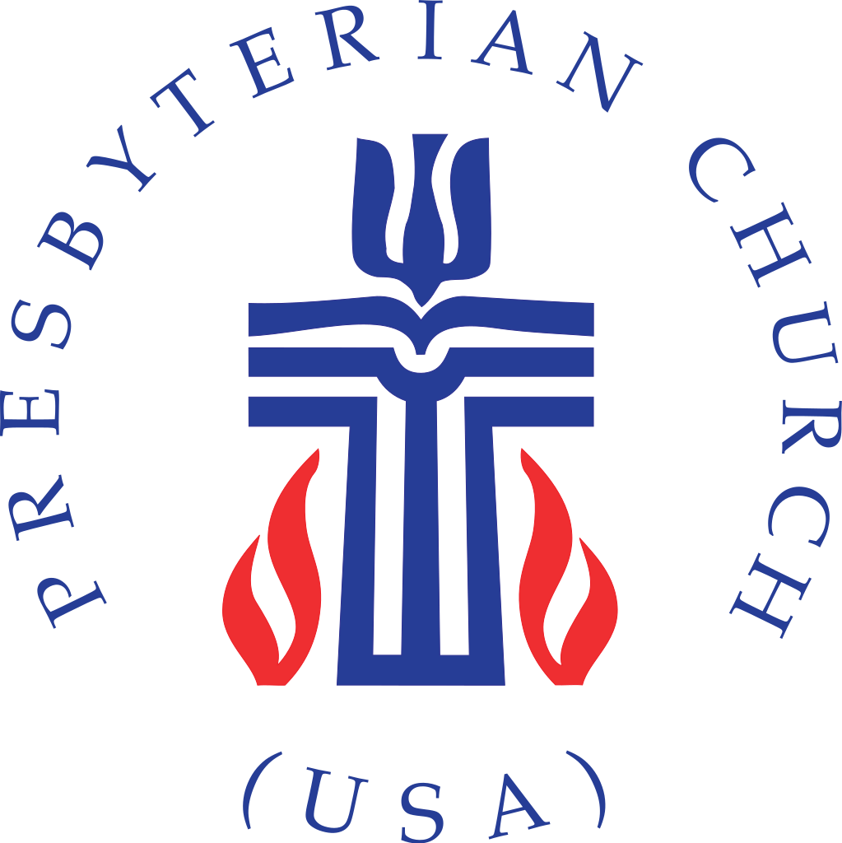

Highland Presbyterian Church​ seeks to be a diverse and inclusive Christian Community as we embody the love and forgiveness of Jesus by serving the Community and the World, drawing people to Christ.





Gathering

Call to Worship (Responsive) Rev. Matthew Benz-Whittington

One: Blessed is the one who comes in the name of the Lord.
All: Hosanna! Hosanna in the highest!
One: This is the day the Lord has made.
All: Hosanna! Hosanna in the highest!
One: Let us rejoice and be glad.
All: Hosanna! Hosanna in the highest!

Llama Procession We Are Marching In the Light of God Hymn 853

We are marching in the light of God;
we are marching in the light of God. (x2)

We are marching, we are marching, we are marching in the light of God

We are dancing . . .
We are praying . . .
We are singing . .

Prelude Prepare Ye the Way of the Lord Anderson

Lenten Refrain Come to Me, O Weary Traveler Highland Choir

Welcome & Announcements Rev. Matthew Benz-Whittington

*Opening Hymn All Glory, Laud, and Honor Hymn 196

Call to Compassion Susan Ambler

Prayer of Compassion (Communal)

God of heaven and earth, we give you thanks for sending us Jesus Christ in your name. Even though we profess to follow him, we confess that in times of trial we too often deny him. We shout ‘Hosanna’ and then run and hide. Forgive us and heal us, we pray. Help us to put our faith not in the princes of this world, but only in the Prince of Peace. In Jesus’ name we pray. Amen.

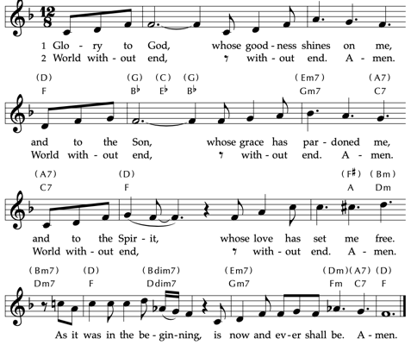
Assurance of Pardon
Time for the Children Rev. Matthew Benz-Whittington
The Word
Prayer for Illumination Susan Ambler

Loving God, your Word has the power to restore our lives. Open our hearts to the presence of your Spirit, for your love and compassion echoes from these words. Amen.

Holy Scripture Luke 19:28 – 40

After Jesus had said this, he went on ahead, going up to Jerusalem.

When he had come near Bethphage and Bethany, at the place called the Mount of Olives, he sent two of the disciples, saying, “Go into the village ahead of you, and as you enter it you will find tied there a colt that has never been ridden. Untie it and bring it here. If anyone asks you, ‘Why are you untying it?’ just say this, ‘The Lord needs it.’” So those who were sent departed and found it as he had told them. As they were untying the colt, its owners asked them, “Why are you untying the colt?” They said, “The Lord needs it.” Then they brought it to Jesus, and after throwing their cloaks on the colt, they set Jesus on it. As he rode along, people kept spreading their cloaks on the road. Now as he was approaching the path down from the Mount of Olives, the whole multitude of the disciples began to praise God joyfully with a loud voice for all the deeds of power that they had seen, saying,

“Blessed is the king
who comes in the name of the Lord!
Peace in heaven,
and glory in the highest heaven!”

Some of the Pharisees in the crowd said to him, “Teacher, order your disciples to stop.” He answered, “I tell you, if these were silent, the stones would shout out.”

Anthem Hosanna, Loud Hosanna Highland Choir

(Refrain for Congregation to Sing)

Hosanna, loud hosanna the little children sang!
Through pillared court and temple the lovely anthem rang;
To Jesus, who had blessed them, close folded to His breast;
The children sang their praises, the simplest and the best.

Sermon “Shouting Stones” Rev. Matthew Benz-Whittington

Moment for Mission One Great Hour of Sharing David Kemp

Offertory Crown Him with Many Crowns Elvey / Keveren

*Doxology Praise God, from Whom All Blessings Flow Hymn 609

Praise God, from whom all blessings flow.
Praise God, all creatures high and low.
Alleluia, alleluia!
Praise God, in Jesus fully known:
Creator, Word, and Spirit one.
Alleluia, alleluia!
Alleluia, alleluia, alleluia!

*Prayer of Thanksgiving (Communal)

Holy One, we give you thanks for the great deeds of salvation that you have done and continue to do. Bless these offerings of thanksgiving that they may further your kingdom in this world; through Jesus Christ we pray. Amen.

Prayers of the People and the Lord’s Prayer

Lord’s Prayer

Our Father, who art in heaven, hallowed be thy name, thy kingdom come, thy will be done, on earth as it is in heaven. Give us this day our daily bread. And forgive us our debts, as we forgive our debtors. And lead us not into temptation, but deliver us from evil. For thine is the kingdom, and the power, and the glory, forever. Amen.

Sending

*Closing Hymn Filled with Excitement Hymn 199

*Charge and Benediction Rev. Matthew Benz-Whittington

Postlude Solemn March Widor/Blake

Free Little Neighborhood Item of the Week
Our Free Little Neighborhood Item of the week is boxed meals. Next time you’re at the grocery store, please pick up any boxed meals that would be easy for a person to cook at home.
Weekly Schedule for February 9th – February 16th

Sunday, April 13 – Sunday School 9:15 a.m.
Llamas Arrive Outside 10:00 a.m.
Sunday Worship (Palm Sunday) 10:30 a.m.
Session 11:30 a.m.

Tuesday – Quilters 9:00 a.m. in the Fellowship Hall
Happy Highlanders Leave from Highland at 10:45 a.m. Beck Cultural Exchange Center in Knoxville.

Wednesday – OA- 1 p.m.
Lent Book Study 5:30 p.m. – 7 p.m. in the Fellowship Hall

Thursday – Piano Lessons 3:00 – 5:00 p.m. Sanctuary
Maundy Thursday/Good Friday Service 6:00 p.m.

Sunday, April 20 – Maryville College Sunrise Service 7:00 a.m.
Men’s Easter Breakfast 9:00 a.m.
Easter Sunday Worship 10:30 a.m.
Easter Egg Hunt 11:30 a.m.

Holy Week at Highland

Palm Sunday, April 13th -We will walk our property with Palms and shouts of ‘Hosanna’ for Palm Sunday on April 13th

Maundy Thursday, April 17th -We will have a combined Maundy Thursday/Good Friday service in the sanctuary at 6:00 p.m. with communion and reflection on the passion story.

Easter Sunday, April 20th

Maryville College Easter Sunday Sunrise service, 7:00 a.m. Lloyd Beach on the Maryville College campus. Rain location: Center for Campus Ministry.

Men’s Breakfast at 9:00 a.m. in the Fellowship Hall with wonderful food prepared by the men of the church and great time for fellowship.

Easter Worship 10:30 a.m. in the Sanctuary

Egg Hunt 11:30 a.m. on the church property.

Donations of eggs, candy, and/or money for the Easter Egg Hunt would be greatly appreciated. If you would like to make a donation, please see Stacey Davis, Kathy White, or Carole Schenk. Thank you!

Happy Highlanders
Tuesday, April 15th

We hope you can join us Tuesday, April 15th for a trip to Beck Cultural Exchange Center in Knoxville. The Beck Cultural Exchange Center's mission is to be the place where Black history and culture are preserved, nurtured, taught, and continued. We are excited to tour this facility and learn, discover and experience the rich legacy of African Americans inside a vibrant Cultural Corridor, the Beck Cultural Corridor.

WHEN: Tues., April 15, 10:45 a.m. at Highland, where we will carpool to Beck and enjoy lunch after at 71South, a nearby restaurant located in the heart of the Urban Wilderness in Knoxville. Their building is one of the oldest churches in Knoxville, dating back to the 1930s.

PLEASE NOTE THE TIME WILL BE 10:45 a.m. and we likely won't be back before 3 p.m. We have a lunch reservation at 1:15 p.m.

