Highland Presbyterian Church
November 19th, 2023
10:30 a.m.

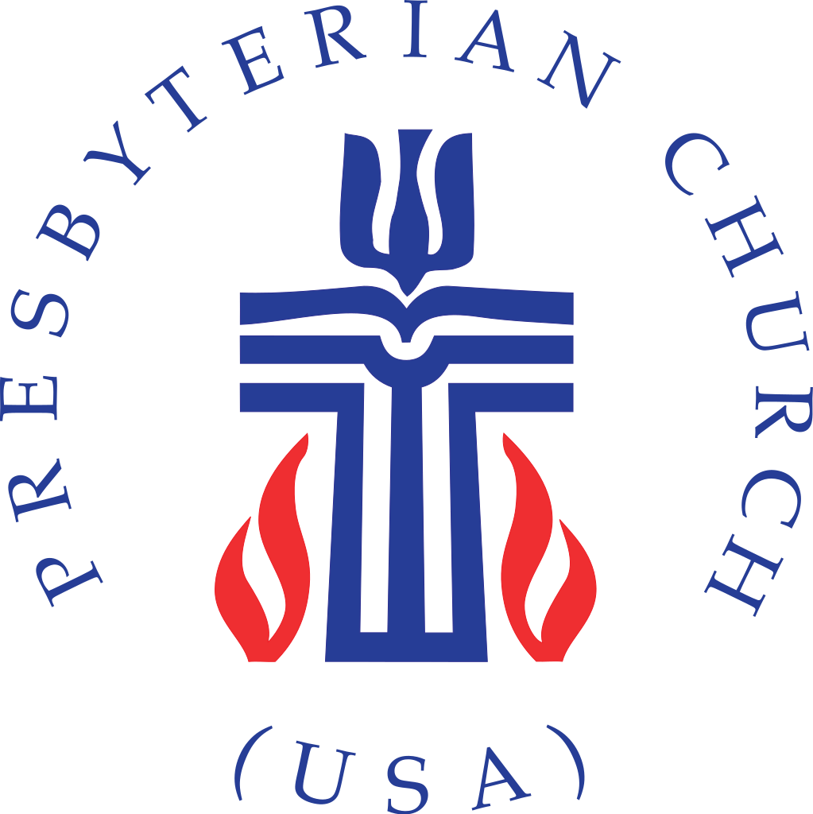

Highland Presbyterian Church​ seeks to be a diverse and inclusive Christian Community as we embody the love and forgiveness of Jesus by serving the Community and the World, drawing people to Christ.





Prelude City Called Heaven spiritual / Taylor
Gathering
Welcome & Announcements Rev. Matthew Benz-Whittington

Call to Worship (Responsive) Jeremy Lloyd

One: Clothe yourselves with faith and love;

All: We are confident in our salvation in Christ Jesus.

One: The Lord is with us!

All: Let us encourage one another in our faith. Let us worship God!

*Opening Hymn When Morning Gilds the Skies Hymn 667

Call to Confession Jeremy Lloyd

Prayer of Confession (Communal)

Loving God, we confess that we have sinned against you by not honoring our siblings in faith. When we place our shortcomings before you, it is your love that guides us back towards love. As we stand in awe of your grace for us, we ask your forgiveness through the mercy of Christ, in whose name we pray. Amen.

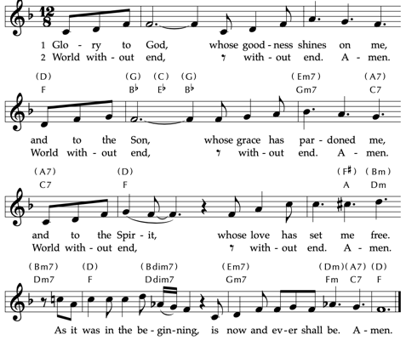
Assurance of Pardon
Time for the Children Rev. Matthew Benz-Whittington
The Word

Prayer for Illumination Jeremy Llyod

Come, Holy Spirit, open our minds and hearts this day, that we may be illumined by your living Word and walk together as children of light. Amen.

Holy Scripture 1st Thessalonians 5:1—28

Now concerning the times and the seasons, brothers and sisters, you do not need to have anything written to you. For you yourselves know very well that the day of the Lord will come like a thief in the night. When they say, “There is peace and security,” then sudden destruction will come upon them, as labor pains come upon a pregnant woman, and there will be no escape! But you, brothers and sisters, are not in darkness, for that day to surprise you like a thief; for you are all children of light and children of the day; we are not of the night or of darkness. So, then, let us not fall asleep as others do, but let us keep awake and be sober, for those who sleep, sleep at night, and those who are drunk get drunk at night. But since we belong to the day, let us be sober and put on the breastplate of faith and love and for a helmet the hope of salvation. For God has destined us not for wrath but for obtaining salvation through our Lord Jesus Christ, who died for us, so that whether we are awake or asleep we may live with him. Therefore encourage one another and build up each other, as indeed you are doing.

But we appeal to you, brothers and sisters, to respect those who labor among you and have charge of you in the Lord and admonish you; esteem them very highly in love because of their work. Be at peace among yourselves. And we urge you, brothers and sisters, to admonish the idlers, encourage the fainthearted, help the weak, be patient with all of them. See that none of you repays evil for evil, but always seek to do good to one another and to all. Rejoice always, pray without ceasing, give thanks in all circumstances, for this is the will of God in Christ Jesus for you. Do not quench the Spirit. Do not despise prophecies, but test everything; hold fast to what is good; abstain from every form of evil.

May the God of peace sanctify you entirely, and may your spirit and soul and body be kept sound and blameless at the coming of our Lord Jesus Christ. The one who calls you is faithful, and he will do this.
Brothers and sisters, pray for us.

Anthem Keep Your Lamps Trimmed and Burning Highland Choir

Sermon “Encourage One Another” Rev. Matthew Benz-Whittington

Offertory Shall We Gather at the River arr. Colburn

*Doxology Praise God, from Whom All Blessings Flow Hymn 609

Praise God, from whom all blessings flow.
Praise God, all creatures high and low.
Alleluia, alleluia!
Praise God, in Jesus fully known:
Creator, Word, and Spirit one.
Alleluia, alleluia!
Alleluia, alleluia, alleluia!

*Prayer of Thanksgiving (Communal)

For all that you are and all that you do, we give you thanks, our Creator, Redeemer, and Sustainer. We wait in hope for the coming of your realm and offer these gifts to further your kingdom on earth; in Jesus’ name. Amen.

Prayers of the People and Lord’s Prayer

Lord’s Prayer

Our Father who art in heaven, hallowed be thy name. Thy kingdom come, thy will be done, on earth as it is in heaven. Give us this day our daily bread; and forgive us our debts, as we forgive our debtors; and lead us not into temptation, but deliver us from evil. For thine is the kingdom and the power and the glory, forever. Amen.

Sending

*Closing Hymn All Who Love and Serve Your City Hymn 351

*Charge and Benediction Rev. Matthew Benz-Whittington

Postlude Prayer for Peace Schroeder
Free Little Neighborhood Item of the Week
Our Free Little Neighborhood Item of the week is clothing for cold weather. As the temperatures begin to drop, people will need to start bringing out their cold weather clothing and you may find items you do not need anymore. We will keep this as our item for a few weeks so please bring in socks, gloves, scarfs, jackets and more if you are able to.

Upcoming Events

Advent Book Study
Christmas In The Four Gospel Homes
November 28th – December 20th

Join us for the four weeks of Advent as we read through Christmas In The Four Gospel Homes. This is a weekly devotional for the season of Advent with each chapter focusing on the four Gospels and comparing each to a house, describing the unique characteristics of each house, and how it would be decorated for the Christmas season.

Books can be purchased for $20. The study will be offered Tuesday nights on Zoom at 7:00 p.m. starting November 28th and on Wednesdays at 10:00 a.m. in the church parlor starting November 29th.

Weekly Schedule for November 19th – November 26th

Sunday, November 19 – Sunday Worship 10:30 a.m.
BCEAC Thanksgiving Service 2:00 p.m. at Blount County Library

Monday –

Tuesday – Quilters 9:00 a.m. in the Fellowship Hall

Wednesday – OA- 1 p.m.
Choir Practice 7:00 p.m. Sanctuary

Thursday – Office Closed for Thanksgiving

Friday –

Saturday –

Sunday, November 26 – Sunday Worship 10:30 a.m.

