Highland Presbyterian Church

March 16th, 2025
10:30 a.m.

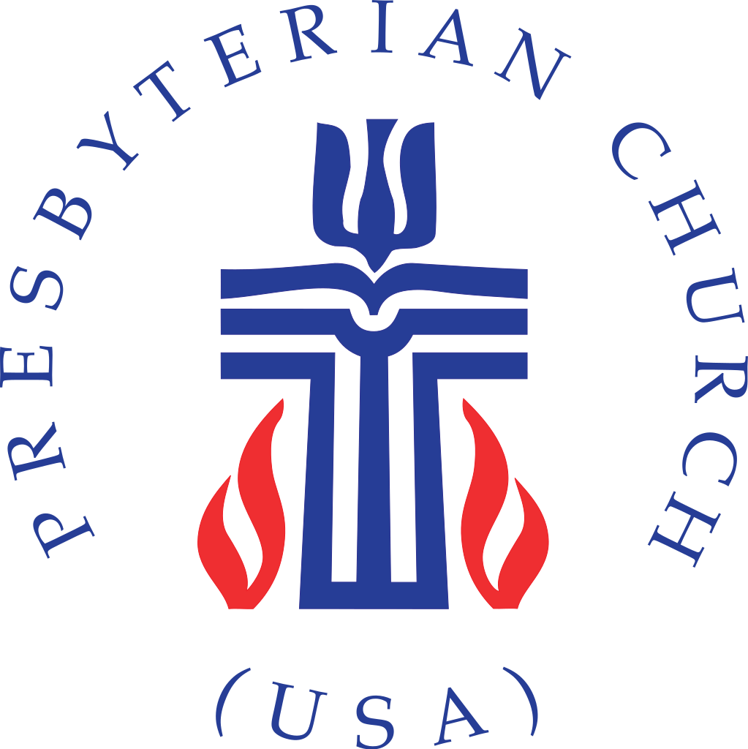

Highland Presbyterian Church​ seeks to be a diverse and inclusive Christian Community as we embody the love and forgiveness of Jesus by serving the Community and the World, drawing people to Christ.





Prelude Melodia Sacra Saxton

Gathering

Welcome & Announcements Rev. Matthew Benz-Whittington

Call to Worship (Responsive) Eleanor Wills

One: As a hen gathers her brood under her wings,

All: God gathers us as children.

One: We follow Jesus on this journey to Jerusalem.
One: We follow saying, “Blessed is the one who comes in the name of the Lord.”

One: Jesus Christ is our salvation.
All: Jesus is the way, the truth, and the life.

*Opening Hymn The God of Abraham Praise Hymn 49

Call to Confession Eleanor Wills

Prayer of Confession (Communal)

Merciful God, you have made us citizens of heaven, but we confess that we have set our minds on earthly things. We have let our desire for security restrain our commitment to serve the poor.
We have let our love of things dull our generosity to the needy. We have let our craving for public status prevent our honesty about hidden sins.
Yet, you know the desires of our heart and nothing is hidden from you. By the power of the Holy Spirit, conform our sin-weakened bodies to the glory of Christ, that we may be the body of Christ for the world.
Amen.

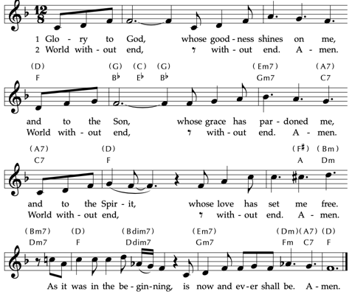
Assurance of Pardon

Time for the Children Rev. Matthew Benz-Whittington
The Word

Prayer for Illumination

Living God, through the reading of the Scriptures and by the power of your Spirit, may we hear for ourselves the good news, and believe, because of your Word, that Jesus Christ is the Savior of the world. Amen.

Holy Scripture Luke 13:31—35

At that very hour some Pharisees came and said to him, “Get away from here, for Herod wants to kill you.”

He said to them, “Go and tell that fox for me, ‘Listen, I am casting out demons and performing cures today and tomorrow, and on the third day I finish my work.

Yet today, tomorrow, and the next day I must be on my way, because it is impossible for a prophet to be killed outside of Jerusalem.’

Jerusalem, Jerusalem, the city that kills the prophets and stones those who are sent to it!

How often have I desired to gather your children together as a hen gathers her brood under her wings, and you were not willing!

See, your house is left to you. And I tell you, you will not see me until the time comes when you say, ‘Blessed is the one who comes in the name of the Lord.’ ”

Anthem Blest Are They Highland Choir

Sermon “What Wondrous Love is This” Rev. Matthew Benz-Whittington

Offertory Jesus Is all the World to Me Thompson/Keveren

*Doxology Praise God, from Whom All Blessings Flow Hymn 609

Praise God, from whom all blessings flow.
Praise God, all creatures high and low.
Alleluia, alleluia!
Praise God, in Jesus fully known:
Creator, Word, and Spirit one.
Alleluia, alleluia!
Alleluia, alleluia, alleluia!
*Prayer of Thanksgiving (Communal)

O God, we have beheld your goodness to us. Accept the offering of the work of our hands, and use us for the sake of Christ, in whose name we pray. Amen.

Prayers of the People & The Lord’s Prayer

Our Father who art in heaven, hallowed be thy name. Thy kingdom come, thy will be done, on earth as it is in heaven. Give us this day our daily bread; and forgive us our debts, as we forgive our debtors; and lead us not into temptation, but deliver us from evil. For thine is the kingdom and the power and the glory, forever. Amen.

Sending

*Closing Hymn Immortal, Invisible, God Only Wise Hymn 12

*Charge and Benediction Rev. Matthew Benz-Whittington

Postlude Beautiful Savior Silesian melody / Wood

Free Little Neighborhood Item of the Week

Our Free Little Neighborhood Item of the week is breakfast items. Next time you’re at the grocery store, please pick up cereal, granola bars, oatmeal as we continue to help our neighbors.
Upcoming Events

Lent Study
Wednesday night and Sunday morning

Join us for the season of Lent as we will gather on either Wednesday nights from 5:30 – 7:00 p.m. for food, fellowship and book discussion or Sunday mornings for the Adult Sunday school class from 9:15-10:00 a.m.

We will use Kathy Escobar’s book Pause as our guide and books can be purchased for $10. Let Pastor Matthew know if you would like to join.

Small and Mighty Youth
Sunday, March 23rd

Join our fellow Presbyterian Churches for our next Small and Mighty Youth Event on Sunday, March 23rd from 5:30 – 7:30 p.m. We will gather at Farragut Presbyterian Church and put together care baskets that will go to those who were impacted by Hurricane Helene last year. RSVP to Pastor Matthew.

Happy Highlanders March Event
Sunday, March 30th, New Providence Pres.

Please note this event is on a Sunday. We hope you can join us Sunday, March 30, 4 p.m. for the Maryville College Spring Concert at New Providence Presbyterian Church. Bruce and Pam will plan to arrive at New Providence early in order to save space for us to sit together. If you have questions, please call Pam at 970-290-4683.

Weekly Schedule for March 16th – March 23rd

Sunday, March 16 – Sunday Worship (2nd Sunday of Lent) 10:30 a.m.
Worship Committee 11:30 a.m.

Monday –

Tuesday – Quilters 9:00 a.m. in the Fellowship Hall
Luke Bible Study 6:00 p.m. (on Zoom)

Wednesday – OA- 1 p.m.
Luke Bible Study 5:30 – 7:00 p.m. in the Fellowship Hall

Thursday – Piano Lessons 3:00 – 5:00 p.m. Sanctuary

Friday –

Saturday – Basket Group All Day Fellowship Hall

Sunday, March 23 – Sunday School 9:15 a.m.
Sunday Worship (3rd Sunday of Lent) 10:30 a.m.
Mission and Faith Formation Committee 11:30 a.m. Fellowship Hall
Small and Mighty Youth 5:30 – 7:30 p.m. Farragut Presbyterian Church

