Highland Presbyterian Church

May 11th, 2025
10:30 a.m.

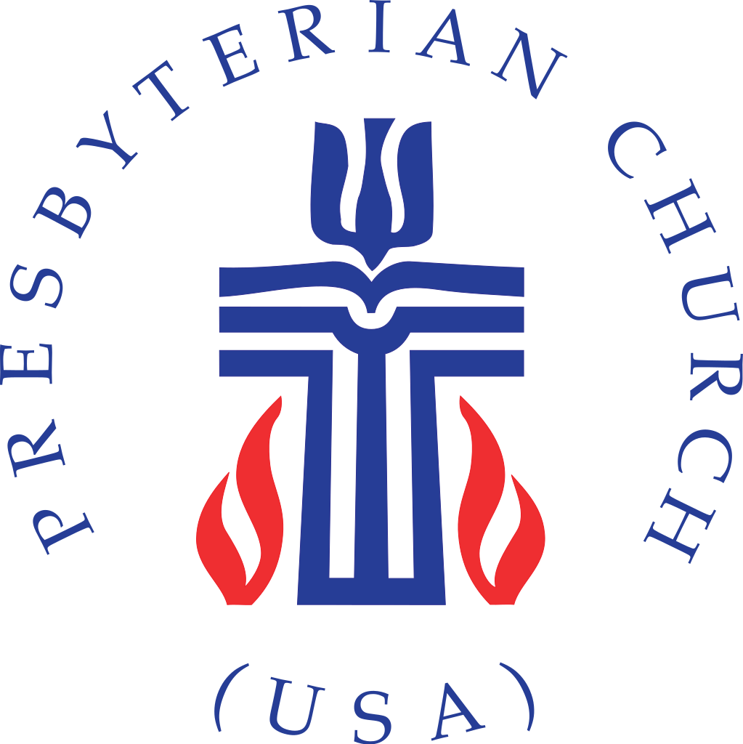

Highland Presbyterian Church​ seeks to be a diverse and inclusive Christian Community as we embody the love and forgiveness of Jesus by serving the Community and the World, drawing people to Christ.





Prelude

Gathering

Welcome & Announcements Rev. Dr. Wendy Neff

Call to Worship (Responsive) Jeremy Lloyd

One: Alleluia, Christ is risen!

All: The Lord is risen indeed, Alleluia!

One: Blessing and honor is yours, O God.

All: Glory to God forever. Alleluia!

*Opening Hymn Christ is Alive! Hymn 246

Call to Confession Jeremy Lloyd

God is present to guide our journey and eager to forgive us when we go astray; therefore, in humility and faith, let us confess our sins against God and neighbor.

Prayer of Confession (Communal)

Holy God, we confess that we have strayed from your paths of right relationship and peace, and we have dishonored you, ourselves, and your creation; we repent of these hurtful ways.

Forgive us, we pray, as we learn to forgive others, and guide our feet into the way of peace. Amen.

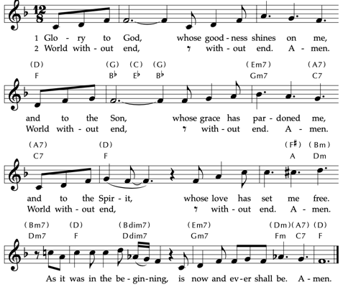
Assurance of God’s Love

Time for the Children
The Word

Prayer for Illumination Jeremy Lloyd

Shepherd of Souls, you call us to an abundant feast at the table of your word; open our hearts to feed on your goodness, that by the power of the Holy Spirit we might dwell evermore deeply in you. Amen.

Holy Scripture Acts 9:36-43

Now in Joppa there was a disciple whose name was Tabitha, which in Greek is Dorcas. She was devoted to good works and acts of charity. At that time she became ill and died. When they had washed her, they laid her in a room upstairs.

Since Lydda was near Joppa, the disciples, who heard that Peter was there, sent two men to him with the request, “Please come to us without delay.” So Peter got up and went with them, and when he arrived, they took him to the room upstairs. All the widows stood beside him, weeping and showing tunics and other clothing that Dorcas had made while she was with them.

Peter put all of them outside, and then he knelt down and prayed. He turned to the body and said, “Tabitha, get up.” Then she opened her eyes, and seeing Peter, she sat up. He gave her his hand and helped her up. Then calling the saints and widows, he showed her to be alive.

This became known throughout Joppa, and many believed in the Lord. Meanwhile, he stayed in Joppa for some time with a certain Simon, a tanner.

Psalm 23
The Lord is my shepherd; I shall not want.

He makes me lie down in green pastures;
he leads me beside still waters;
he restores my soul.

He leads me in right paths for his name’s sake.

Even though I walk through the darkest valley,
I fear no evil,for you are with me;
your rod and your staff, they comfort me.

You prepare a table before me
in the presence of my enemies; you anoint my head with oil;
my cup overflows.

Surely goodness and mercy shall follow me
all the days of my life, and I shall dwell in the house of the Lord
my whole life long.

Anthem Great Is Thy Faithfulness Hymn 39

Sermon “Resurrection and New Life” Rev. Dr. Wendy Neff

Statement of Faith (Communal) from the Iona Community Worship Book

We Believe in God
whose love is the source of all life
and the desire of our lives,
whose love was given a human face in Jesus of Nazareth,
whole love was crucified by the evil that waits to enslave us all
and whose love, defeating even death,
is our glorious promise of freedom.
Therefore, though we are sometimes fearful and full of doubt,
in God we trust;
and, in the name of Jesus Christ,
we commit ourselves, in the service of others,
to seek justice and to live in peace,
to care for the earth and to share the commonwealth of God’s goodness,
to live in the freedom of forgiveness and the power of the spirit of love,
and in the company of the faithful so to be the church,
for the glory of God. Amen.

Offertory Praise Him! Praise Him! Allen / Hayes

*Doxology Praise God, from Whom All Blessings Flow Hymn 609

Praise God, from whom all blessings flow.
Praise God, all creatures high and low.
Alleluia, alleluia!
Praise God, in Jesus fully known:
Creator, Word, and Spirit one.
Alleluia, alleluia!
Alleluia, alleluia, alleluia!

*Prayer of Thanksgiving (Communal)

Holy God, you are our hope and our strength, our light and our sovereign, our shepherd and our savior. With all the saints in heaven and on earth, we praise our holy name and entrust every care to you; through Jesus Christ we pray. Amen.

Prayers of the People & The Lord’s Prayer

Our Father who art in heaven, hallowed be thy name. Thy kingdom come, thy will be done, on earth as it is in heaven. Give us this day our daily bread; and forgive us our debts, as we forgive our debtors; and lead us not into temptation, but deliver us from evil. For thine is the kingdom and the power and the glory, forever. Amen.

Sending

*Closing Hymn Today We All Are Called to be Disciples Hymn 757

Benediction

Postlude

Liturgy taken from Feasting on the Word Worship Companion; Liturgies for Year C, Volume 1.

Free Little Neighborhood Item of the Week
Our Free Little Neighborhood Item of the week is canned food. Next time you’re at the grocery store, please pick up any canned that would be easy for a person to prepare at home.

Weekly Schedule for May 11th – May18th

Sunday, May 11 – Sunday School 9:15 a.m.
Sunday Worship (Rev. Dr. Wendy Neff, General Presbyter for the Presbytery of East Tennessee) 10:30 a.m.
Monday –

Tuesday – Quilters 9:00 a.m. in the Fellowship Hall

Wednesday – OA - 1 p.m.

Thursday – Piano Lessons 3:00 – 5:00 p.m. Sanctuary

Friday –

Saturday –

Sunday, May 18 – Sunday School 9:15 a.m.
Sunday Worship (CLP Mary Boyd) 10:30 a.m.
Upcoming Events

Adult Sunday School How We Learn to Be Brave

On Sunday, May 4 at 9:15 a.m. to 10 a.m., our Adult Sunday School Class will begin an eight-week book study of How We Learn to Be Brave: Decisive Moments in Life & Faith by Mariann Edgar Budde, Episcopal Bishop of Washington.

Books are $20 and will be ordered soon. Please contact Martha Vargas 865-599-4583 or sign up in the back of the sanctuary to request a book and join us!

Documentary Screening Sunday, May 4 at New Providence

The Sustainability Committee from Highland and The Green Team from New Providence invite you to screening of the environmental documentary Common Ground, an environmental documentary about regenerative agriculture and the positive power of soil as a solution for both climate and human health.

Screening will be at New Providence on Sunday, May 4 at 12:15 p.m. in the Westminster Hall.

A simple sandwich lunch will be provided for people to eat while watching. There will be an informal discussion to follow the screening. Reach out to Elan Lloyd for more questions.

Happy Highlanders’ May Outing Sunday, May 20, 11 a.m.

We have a change of plans and are looking forward to our May Happy Highlanders outing to the Sequoyah Birthplace Museum in Vonore, with lunch before at Countryside Restaurant.

We will plan to meet at Highland at 11am and carpool to Vonore together. PLEASE NOTE THE EARLIER TIME. If you have any questions, please contact Pam Clifford, 970-290-4683. We hope you can join us!

