Highland Presbyterian Church
May 28th, 2023
Pentecost Sunday
10:30 a.m.

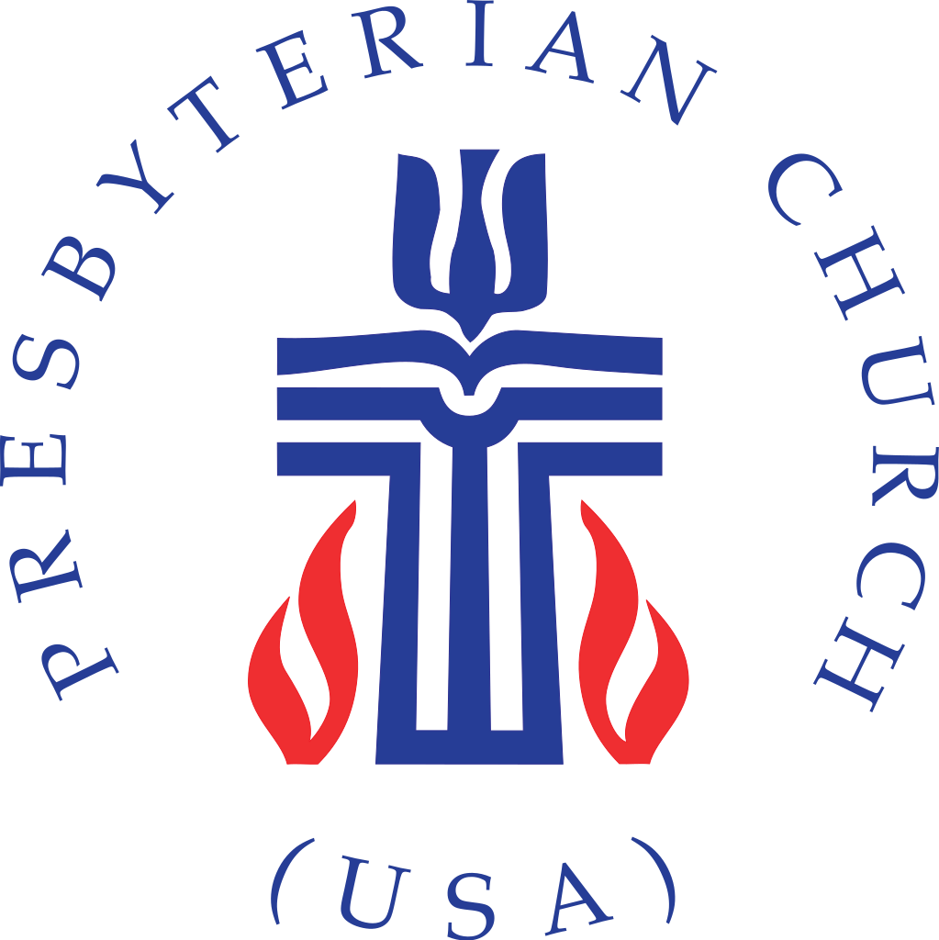

Highland Presbyterian Church​ seeks to be a diverse and inclusive Christian Community as we embody the love and forgiveness of Jesus by serving the Community and the World, drawing people to Christ.

Prelude Allemanda (from Concerto Grosso N.10) Corelli / Norris

Gathering

Welcome & Announcements Rev. Matthew Benz-Whittington

Call to Worship (Responsive) Leonard Blankner

One: Come, believers and faithful ones, sing your alleluias to God!
All: Praise God, who inspires us with the rush of a mighty wind and fills us with fire.
One: Praise God, who out of love for us sent Jesus Christ to live among us.
All: Praise God, whose Spirit is poured out upon all flesh so our sons and daughters might prophesy.
One: God reaches into our lives and claims us, calling us honored and loved.
All: We are God’s people; we are redeemed, for God has called us by name. Come, Holy Spirit, and lead us forth into the wonders of God’s love!

*Opening Hymn On Pentecost They Gathered Hymn 289

Call to Confession Leonard Blankner

Prayer of Confession (Communal)

God of new creation, we confess that we have failed to trust your bountiful goodness. By the power of the Holy Spirit, you brought forth the earth and its creatures in abundance. Yet, we hoard earth’s resources and refuse to share your gifts. We dishonor your generosity by withholding our charity to those in need.

Forgive us. By the power of your Spirit renew our hearts and free us from sins that we may enjoy the fullness of your blessing upon all creation. Amen.

Assurance of Pardon

Time for the Children Rev. Matthew Benz-Whittington

The Word
Prayer for Illumination Leonard Blankner

Almighty God, by the power of your Holy Spirit, speak to us in the language of our hearts, that we may hear your Word with understanding and answer your call with confidence. Amen.

Holy Scripture Acts 2:1—21

When the day of Pentecost had come, they were all together in one place. And suddenly from heaven there came a sound like the rush of a violent wind, and it filled the entire house where they were sitting. Divided tongues, as of fire, appeared among them, and a tongue rested on each of them. All of them were filled with the Holy Spirit and began to speak in other languages, as the Spirit gave them ability.
Now there were devout Jews from every people under heaven living in Jerusalem. And at this sound the crowd gathered and was bewildered, because each one heard them speaking in the native language of each. Amazed and astonished, they asked, “Are not all these who are speaking Galileans? And how is it that we hear, each of us, in our own native language? Parthians, Medes, Elamites, and residents of Mesopotamia, Judea and Cappadocia, Pontus and Asia, Phrygia and Pamphylia, Egypt and the parts of Libya belonging to Cyrene, and visitors from Rome, both Jews and proselytes, Cretans and Arabs—in our own languages we hear them speaking about God’s deeds of power.” All were amazed and perplexed, saying to one another, “What does this mean?” But others sneered and said, “They are filled with new wine.”
But Peter, standing with the eleven, raised his voice and addressed them, “Fellow Jews and all who live in Jerusalem, let this be known to you, and listen to what I say. Indeed, these are not drunk, as you suppose, for it is only nine o’clock in the morning. No, this is what was spoken through the prophet Joel:

‘In the last days it will be, God declares,
that I will pour out my Spirit upon all flesh,
and your sons and your daughters shall prophesy,
and your young men shall see visions,
and your old men shall dream dreams.
Even upon my slaves, both men and women,
in those days I will pour out my Spirit,
and they shall prophesy.
And I will show portents in the heaven above
and signs on the earth below,
blood, and fire, and smoky mist.
The sun shall be turned to darkness
and the moon to blood,
before the coming of the Lord’s great and glorious day.
Then everyone who calls on the name of the Lord shall be saved.’

Anthem Come Holy Spirit Highland Choir

Sermon “Exciting and Scary” Rev. Matthew Benz-Whittington

Statement of Faith (Communal) Excerpts from A Brief Statement of Faith PC(USA)

We trust in God the Holy Spirit, everywhere the giver and renewer of life.
The Spirit justifies us by grace through faith, sets us free to accept ourselves and to love God and neighbor, and binds us together with all believers in the one body of Christ, the Church. The same Spirit who inspired the prophets and apostles rules our faith and life in Christ through Scripture, engages us through the Word proclaimed,
claims us in the waters of baptism, feeds us with the bread of life and the cup of salvation, and calls women and men to all ministries of the church. In a broken and fearful world the Spirit gives us courage to pray without ceasing, to witness among all peoples to Christ as Lord and Savior, to unmask idolatries in Church and culture, to hear the voices of peoples long silenced, and to work with others for justice, freedom, and peace. With believers in every time and place, we rejoice that nothing in life or in death can separate us from the love of God in Christ Jesus our Lord

Offering of Our Gifts

Minute for Mission Pentecost Offering Jeremy Lloyd

Offertory Joy Song Hayes

*Doxology Hymn 609

*Prayer of Thanksgiving (Communal)

Good and gracious God, just as you poured out the power of your Spirit on the Day of Pentecost, pour out your power upon these gifts and the very lives that we offer to your purposes. Teach and inspire our young people to dream dreams and follow those dreams in serving you. May all that we offer in your name bring about a vision of your gracious and sovereign realm of love, in Jesus’ name. Amen.

Prayers of the People & Lord’s Prayer

Our Father who art in heaven, hallowed be thy name. Thy kingdom come, thy will be done, on earth as it is in heaven. Give us this day our daily bread; and forgive us our debts, as we forgive our debtors; and lead us not into temptation, but deliver us from evil. For thine is the kingdom and the power and the glory, forever. Amen.

Pentecost Prayer Refrain (sung when prompted) Hymn 288

Spirit of the Living God, fall a-fresh on me.
Spirit of the Living God, fall a-fresh on me.
Melt me; mold me; use me.
Spirit of the Living God, fall a-fresh on me.

Sending

*Closing Hymn We Will Go Out with Joy Hymn 539

*Charge and Benediction Rev. Matthew Benz-Whittington

Postlude March Wagner

Weekly Schedule for May 28th – June 4th

Sunday, May 28 – Sunday Worship 10:30 a.m. (Pentecost Sunday) Mission Committee 11:30 a.m.

Monday – Memorial Day. Church Office Closed. Beloved Community Memorial. Noon-1pm. Cedar Lawn Cemetery

Tuesday – Quilters at 9 a.m.

Wednesday – OA- 1 p.m.

Thursday – Presbyterian Women’s Circle- 1:30 pm Fellowship Hall. Girl Scouts at 7:00 p.m. in the Fellowship Hall

Friday –

Saturday –

Sunday, June 4 – Sunday Worship 10:30 a.m. (Communion Sunday)

Upcoming Events

The Beloved Community Outreach Foundation
Monday, May 29, noon-1:00 pm

Join the Beloved Community Outreach foundation for their 10th Annual Memorial/Decoration Day Celebration on Monday, May 29, 2023 noon-1:00 pm at Cedar Lawn Cemetery in Alcoa. This location is on Kings Court off N. Hall Road and a little past the Quality Inn Hotel. This will be a time of remembrance, celebration, and fellowship.

Presbyterian Women Bible Study
Thursday, June 1st, 1:30 pm

Join Highland’s PW for their last gathering of the year on Thursday, June 1st, and they will change location and meet in the fellowship hall that day. More details to follow.

