Highland Presbyterian Church

March 19th, 2023
4rd Sunday of Lent
10:30 a.m.

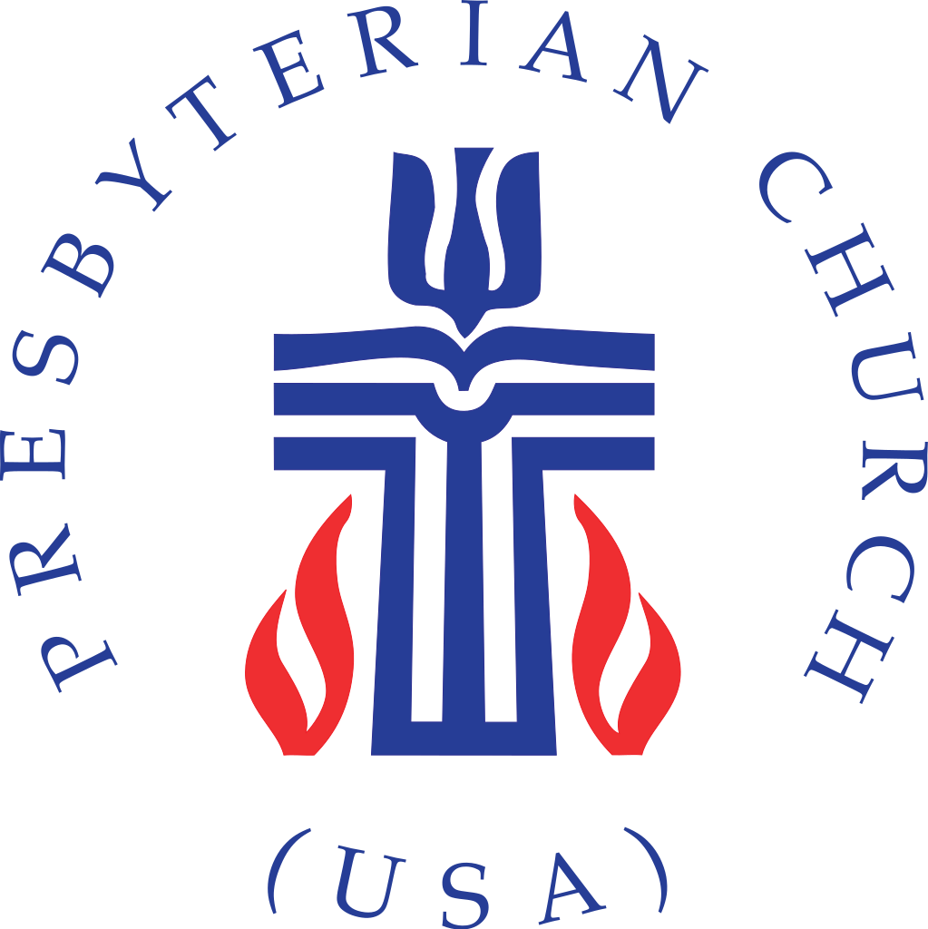

Highland Presbyterian Church​ seeks to be a diverse and inclusive Christian Community as we embody the love and forgiveness of Jesus by serving the Community and the World, drawing people to Christ.
Prelude. Jesus, Keep Me Near the Cross with In the Cross of Christ I Glory

Gathering
Lenten Refrain I Will Come to You Highland Choir

Welcome & Announcements Rev. Matthew Benz-Whittington

Call to Worship (Responsive) Sandy Miller

One: The Lord shepherds us.

All: God restores our souls.

One: We shall not fear evil.

All: For God is always with us.

One: God bathes our head in oil; our cup is so full it spills over!

All: Yes, God’s goodness and faithful love will pursue us all the days of our life. Let us worship God!

*Opening Hymn Great is Thy Faithfulness Hymn 39

Call to Confession Sandy Miller

Prayer of Confession (Communal)

Gracious God, we see ourselves as blameless, but pass judgment on others. We do not stand firmly enough with those who are vulnerable, but step back, protecting ourselves. Forgive us, we pray. Bring us into your light that we may see ourselves rightly. Bring us into your love that we may know ourselves loved. Bring us into your peace that we may live more fruitful lives. We pray in the name of Jesus Christ, the light of the world. Amen.

Assurance of Pardon Sandy Miller

Time for the Children Rev. Matthew Benz-Whittington

The Word
Prayer for Illumination Sandy Miller

Holy Scripture John 9:1—41 (selected verses)

As Jesus walked along, he saw a man blind from birth. His disciples asked him, “Rabbi, who sinned, this man or his parents, that he was born blind?” Jesus answered, “Neither this man nor his parents sinned; he was born blind so that God’s works might be revealed in him. We must work the works of him who sent me while it is day; night is coming, when no one can work. As long as I am in the world, I am the light of the world.” When he had said this, he spat on the ground and made mud with the saliva and spread the mud on the man’s eyes, saying to him, “Go, wash in the pool of Siloam” (which means Sent). Then he went and washed and came back able to see. The neighbors and those who had seen him before as a beggar began to ask, “Is this not the man who used to sit and beg?” Some were saying, “It is he.” Others were saying, “No, but it is someone like him.” He kept saying, “I am he.” But they kept asking him, “Then how were your eyes opened?” He answered, “The man called Jesus made mud, spread it on my eyes, and said to me, ‘Go to Siloam and wash.’ Then I went and washed and received my sight.” They said to him, “Where is he?” He said, “I do not know.”
They brought to the Pharisees the man who had formerly been blind. Now it was a Sabbath day when Jesus made the mud and opened his eyes. Then the Pharisees also began to ask him how he had received his sight. He said to them, “He put mud on my eyes. Then I washed, and now I see.” Some of the Pharisees said, “This man is not from God, for he does not observe the Sabbath.” Others said, “How can a man who is a sinner perform such signs?” And they were divided. So they said again to the blind man, “What do you say about him? It was your eyes he opened.” He said, “He is a prophet.”
The Jews did not believe that he had been blind and had received his sight until they called the parents of the man who had received his sight and asked them, “Is this your son, who you say was born blind? How then does he now see?” His parents answered, “We know that this is our son and that he was born blind, but we do not know how it is that now he sees, nor do we know who opened his eyes. Ask him; he is of age. He will speak for himself.”
So for the second time they called the man who had been blind, and they said to him, “Give glory to God! We know that this man is a sinner.” He answered, “I do not know whether he is a sinner. One thing I do know, that though I was blind, now I see.”

Anthem Be Thou My Vision Highland Choir

Sermon “Restore Me” Rev. Matthew Benz-Whittington

Statement of Faith (Communal) Excerpts from A Brief Statement of Faith PC(USA)

We trust in God the Holy Spirit, everywhere the giver and renewer of life. The Spirit justifies us by grace through faith, sets us free to accept ourselves and to love God and neighbor, and binds us together with all believers in the one body of Christ, the Church. The same Spirit who inspired the prophets and apostles rules our faith and life in Christ through Scripture, engages us through the Word proclaimed, claims us in the waters of baptism, feeds us with the bread of life and the cup of salvation, and calls women and men to all ministries of the church.
In gratitude to God, empowered by the Spirit, we strive to serve Christ in our daily tasks and to live holy and joyful lives, even as we watch for God’s new heaven and new earth, praying, “Come, Lord Jesus!”

Moment for Mission Building & Grounds Whitney Erickson

Moment for Mission One Great Hour of Sharing Sandy Miller

Offering of Our Gifts

Offertory Prelude No. 1 in C major Bach

*Doxology Hymn 609

*Prayer of Thanksgiving (Communal)

In gratitude, O God, we come to your table, into your presence, into your house. For all that you have done for us, most especially, for bringing us into the light of Jesus Christ, we offer our thanks and praise. Amen.

Prayers of the People & Lord’s Prayer

Our Father who art in heaven, hallowed be thy name. Thy kingdom come, thy will be done, on earth as it is in heaven. Give us this day our daily bread; and forgive us our debts, as we forgive our debtors; and lead us not into temptation, but deliver us from evil. For thine is the kingdom and the power and the glory, forever. Amen.

Sending

*Closing Hymn I Heard the Voice of Jesus Say Hymn 182

*Charge and Benediction

Postlude Holy God, We Praise Thy Name

