Chestnut Hill Business District
Taste of Summer: Dining in Chestnut Hill
Social Media Toolkit

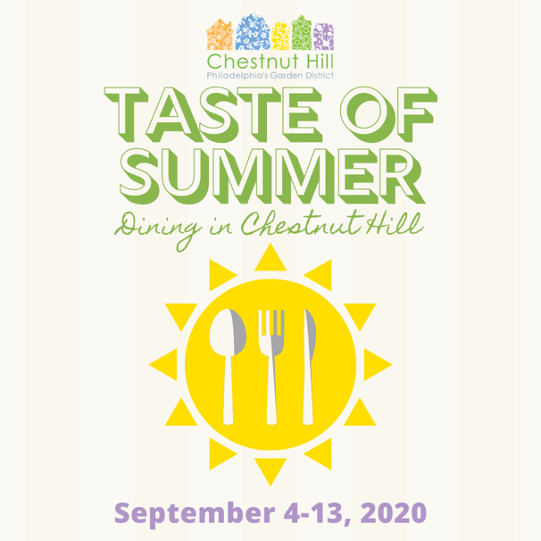
Description: A Taste of Summer: Dining in Chestnut Hill, from September 4-13, is a special, nine-day culinary experience featuring the best the Philadelphia neighborhood has to offer, from prix fix menus to à la carte options to take out.

A Taste of Summer highlights Chestnut Hill chefs’ new, innovative, and limited time summer menu items and specials.

As diners support local eateries, they also have a chance to win a $25 Chestnut Hill gift certificate by posting photos of their Taste of Chestnut Hill purchases and using the hashtag #PostYourPlateCH.

Website: http://bit.ly/TasteofSummerCH
Facebook: @ChestnutHill.Pa
Twitter: @ChestnutHillPA
Instagram: @chestnuthill_pa
Hashtags: #PostYourPlateCH #KeepItOnTheHill #ChestnutHillPA

To download the social media graphic and food images, click HERE.

To download the fact sheet, click HERE.

Sample Social Media Posts:

FACEBOOK/INSTAGRAM
Kick off your Labor Day Weekend by enjoying amazing culinary specials during A Taste of Summer: Dining in Chestnut Hill (@ChestnutHill.Pa / @chestnuthill_pa), September 4-13.

Support local restaurants during this dining experience that will show off chefs’ new and innovative — and limited-time only — menu items, from prix fixe menu items to a la carte options to take out.

We at [RESTAURANT NAME] will be offering [MENU ITEM AND PRICE]

Get a chance to win a $25 gift card! If you share your Taste of Summer meal photos on social media platforms and use the hashtag #PostYourPlateCH, you’ll be entered into the drawing!

Get more info here: https://chestnuthillpa.com/events/restaurant-week-a-taste-of-chestnut-hill-2020/

---

From September 4-13, visit the charming neighborhood of Chestnut Hill (@ChestnutHill.Pa / @chestnuthill_pa) for A Taste of Summer: Dining in Chestnut Hill, a culinary experiencing featuring prix fixe menus and a la carte options from local eateries that scream summertime!

Visit local eateries during Taste of Summer to fill your stomachs with limited time menu items you can only get in Chestnut Hill! https://chestnuthillpa.com/events/restaurant-week-a-taste-of-chestnut-hill-2020/

We will be offering [MENU ITEM AND PRICE]

Get a chance to win a $25 gift card! If you share your Taste of Summer meal photos on social media platforms and use the hashtag #PostYourPlateCH, you’ll be entered into the drawing!

---
Take a stroll through Chestnut Hill (@ChestnutHill.Pa / @chestnuthill_pa ) during A Taste of Summer: Dining in Chestnut Hill for limited-time summer special items showing off chefs’ new and innovative dishes! Before you know it, it will be fall and these dishes and cocktails will be gone! https://chestnuthillpa.com/events/restaurant-week-a-taste-of-chestnut-hill-2020/

We will be offering [MENU ITEM AND PRICE]

Get a chance to win a $25 gift card! If you share your Taste of Summer meal photos on social media platforms and use the hashtag #PostYourPlateCH, you’ll be entered into the drawing!

---

Bon appetit! Chestnut Hill (@ChestnutHill.Pa / @chestnuthill_pa ) restaurants will offer special summer menu items during A Taste of Summer: Dining in Chestnut Hill!

Enjoy prix fix menus and a la cart options AND find a new favorite eatery Special items may be part of breakfast, lunch, or dinner menus. Get them before fall comes around!
We will be offering [MENU ITEM AND PRICE]

https://chestnuthillpa.com/events/restaurant-week-a-taste-of-chestnut-hill-2020/ #KeepItOnTheHill

TWITTER
Kick off your Labor Day Weekend by enjoying amazing culinary specials during A Taste of Summer: Dining in @ChestnutHillPA, Sept. 4-13! We’ll offer [MENU ITEM AND PRICE]
https://chestnuthillpa.com/events/restaurant-week-a-taste-of-chestnut-hill-2020/

From Sept. 4-13, take part in A Taste of Summer: Dining in @ChestnutHillPA, a culinary experiencing featuring prix fixe menus and a la carte option! We will offer [MENU ITEM AND PRICE] https://chestnuthillpa.com/events/restaurant-week-a-taste-of-chestnut-hill-2020/

--

Take a stroll through Germantown Avenue during A Taste of Summer: Dining in @ChestnutHillPA for limited-time summer special items showing off chefs’ new and innovative dishes! https://chestnuthillpa.com/events/restaurant-week-a-taste-of-chestnut-hill-2020/ #KeepItOnTheHill

--

Bon appetit! We will offer [MENU ITEM AND PRICE] during A Taste of Summer: Dining in @ChestnutHillPA, September 4-13! https://chestnuthillpa.com/events/restaurant-week-a-taste-of-chestnut-hill-2020/

