EAST CENTRAL OEA RETIRED SEPTEMBER 2025 NEWSBRIEF by KATHLEEN PURDY

Welcome to the “Not Back to School” Edition
“I finally understand why I am called a grown up.
I groan every time I get up!”

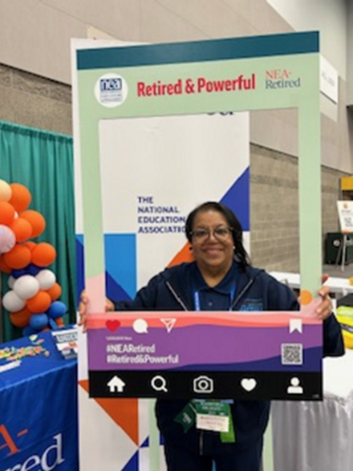On June 12, 2025, I presented the “Safe Zone School District Resolution” to my Marlington Local School Board members and attendees during their regular meeting. My presentation was prepared using the National Education Association’s toolkit and sample Model Policy because it is the “right of every child, regardless of immigration status, to access a free public k-12 education.”
The language of the resolution is closely tied to the Supreme Court Case Plyler v. Doe (1982, Teas) which is the foundational precedent showing that access to k-12 education is a Civil Right. If you would like more information to share with your local school district, feel free to contact me at Kathleen Purdy, ecoeavp@yahoo.com.
************************************************************************************
The Jack Kinnaman Memorial Scholarship Fund awards undergraduate students who are pursuing a degree in Education with financial assistance to achieve their educational goals.
If you wish to make a donation to the Kinnaman Scholarship electronically (the preferred donation method), please use this link: https://donatekinnaman.com/.
If you want to mail a check: Make your check payable to NEA Foundation. In the memo line: Jack Kinnaman Scholarship Fund and mail to National Education Association, Attn. Jack Kinnaman Scholarship Fund, 1201 16th St. NW., STE 414, Washington, DC 20036.
Below is a photo of the elected OEA/NEA Resolution Committee members with our Aspiring Educator who hails from Twinsburg, Alice Somers.

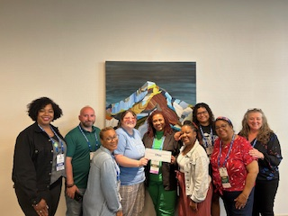
********************************************************************************

We are looking for two retired members interested in being representatives to the Ohio Alliance for Retired Members. Lunch and mileage are included. Please email Kathleen for more information. ecoeavp@yahoo.com or contact John Hoyes at jhoyes1942@gmail.com.
***********************************************************************************

The OEA-Retired Program and Services Committee have designed a virtual Fall Conference for strategic tips for staying calm and grounded. Be sure to register to attend. Our first speaker on Mindfulness is being presented by former Congressman Tim Ryan and others.
Mindfulness is about more than chanting mantras or meditating. Discover more practices for staying calm and centered.
OEA-Retired Conference will be held September 24, 2025, from 10:00 am – 12:00pm. You are invited to join “Living Well After the Bell: A Virtual Wellness Conference for Lifelong Educators.” After registering, you will receive a confirmation email about how to join the meeting. To register in advance use this link: https://ohea.zoom.us/meeting/register/1u0RhXtOSoqRxEnHha0YEw

**********************************************************************************
Our new OEA election year kicks off in September and below is information for another interest.
Getting involved is quite easy for building capacity.
- Being a Delegate is another opportunity to be involved. If you wish to be a candidate for OEA-Retired to the OEA Representative Assembly, you MUST file a form by September 10, 2025. Contact William Baird at OEA (800) 282-1500 or (614) 227-3169 for more information.
- Candidate declaration forms are now available on our OEA-Retired Website.
https://oea-r.ohea.us/page/election-information/
- OEA-Retired Advisory Council Positions up for election this spring are ESP-OEA-Retired Advisory Council Representative (Term ending July 1,2026) AND Higher Education -OEA-Retired Advisory Council Representative (Term ending July 14, 2028) If interested you must file a Declaration of candidacy form by February 10, 2026.
Click here for declaration of candidacy form for Advisory Council Positions
- If you wish to be a candidate for NEA-Retired Delegate to the NEA Representative Assembly, you must file a Declaration of Candidacy form by February10, 2026. Click here for declaration of candidacy form for NEA delegate

“Did you hear about the dog that had a difficult day at work? It was ruff. “

Thank you for your continued interest in the OEA-Retired mission, vision, and advocacy.
Don’t be left behind. Pencil the following important dates on your calendars:
- Advisory Council Retreat is Wednesday, September 3 and Thursday, September 4, 2025, in Columbus.
- September 9, 2025, will be the Ohio ARA Meeting in Columbus from 9:00 a.m. -3:00 p.m.
- September 10, 2025, is the Filing Deadline for OEA-Retired Candidates
- September 24, 2025, is the Fall Virtual Conference from 10:00a.m. – noon.
T=Together. E=Everyone. A=Achieves. M=More.
“Together Everyone Achieves More!”
Coming together is a beginning.
Keeping together is progress.Working together is success.
Teamwork makes the dream work!

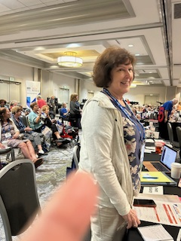
Kathleen Purdy, ECOEA-Retired District Representativeecoeavp@yahoo.com or (330) 257-9913.

To the right is OEA-Retired Mary Binegar at the NEA Retired Annual Meeting as our State Chair!

