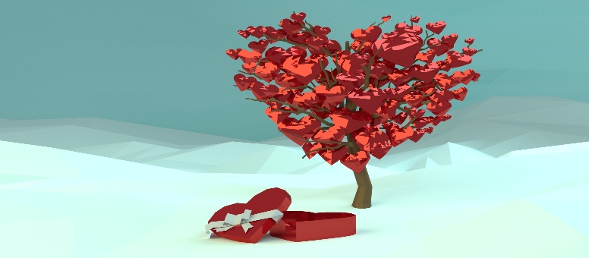

FEBRUARY 2026 EAST CENTRAL OEA RETIRED NEWS BRIEF
DISTRICT REPRESENTATIVE KATHLEEN PURDY, ecoeavp@yahoo.com
OHIO COLLEGE ASPIRING EDUCATORS
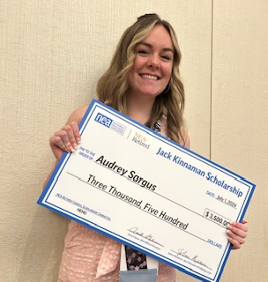

The NEA-Retired Jack Kinnaman Memorial Scholarship was created in memory of Jack Kinnaman, Vice President and former Advisory Council member of the NEA-Retired Board.
Jack cared about students, especially those who were financially affected and needed a helping hand. After his passing, his family set up scholarships, in his honor, to go to such students. Ohio has had Aspiring Educators chosen to receive $3,500 scholarships. Information about the NEA Student Program is available here: https://www.nea.org/about-nea/our-members/aspiring-educators.

How can you help? Please contact OEA-Retired Secretary Judy Buschle, at judybuschle@aol.com. During the Retired Annual Meeting (RAM), OEA Retired Delegates make their in-person contributions. We are expanding our amounts to process before our June 2026 Retired Meeting in Denver. Wish List: $250.

GET WELL SOON!

SsSOON!

Sending GET WELL WISHES to every retiree that is facing health challenges. I hope that you contact me so that your contact information may be shared with your colleagues! We care about each of you!
*************************************************************************************
Lock in OEA-R Lifetime membership at the lowest possible price and continue saving with NEA Member Benefits such as: NEA Travel where you can rent a car from as little as $25/day, MEGA special offers + Bonus to get ahead of the rush and book your spring and summer getaways before prices increase, OEA Unbeatable Hotel Rates, or member auto insurance discounts throughout your retirement. www.ohea.org/retired



*****************************************************************

Mid-Term Elections

Key Dates for the May 5 Primary: MARK YOUR CALENDARS
- April 6: Voter Registration Deadline
- April 7: Early Voting Begins
- April 28: Absentee Ballot Request Deadline
- May 5: Election Day
Elections always influence the legislative calendar. Ohio Equal Rights has started collecting signatures to put two proposed constitutional amendments before Ohio voters in November 2026. One amendment would remove the state’s constitutional ban on same-sex marriage, and the other would add stronger protections against discrimination by race, sex, religion, sexual orientation, gender identity, age, disability, and other traits. To qualify, Ohio Equal Rights must collect hundreds of thousand of signatures from registered voters in at least 44 of Ohio’s 88 counties by early summer. Staying informed and engaged remains as important as ever.

SAVE THE DATE!
Join your fellow retirees for the OEA-Retired Spring Conference on Tuesday, April 21, 2026!
We will gather at Stan Hywet (Summit County) for a guided tour of the estate’s beautiful home and gardens. This will be followed by a delicious lunch.
Stan Hywet Hall & Gardens is 70 acres and a historic house museum in Akron, Ohio. The estate includes gardens, a greenhouse, carriage house, and the main mansion, one of the largest houses in the U.S. This OEA-Retired Spring Conference is hosted by the NEOEA retirees.
Join Now! Pay OEA/NEA Retired Lifetime dues MONTHLY!
Belong for Life, only $450.00
No matter where you are in your career, your membership will be there when you retire.
Payment Options are now available to Make Lifetime Memberships easy and affordable.
2024-2026 OEA Retired Dues
Annual OEA-Retired - $25.00 Annual OEA Retired ESP - $12.50
OEA-Retired Life- $150.00/year OEA-Retired ESP Life- $75.00/year

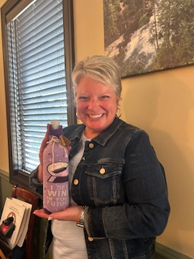
Pre-Retired Ramona Cochran President Juliann Doerschuk with Rep Kathleen
Lake Local, former Council Purdy holding the “Working for You!” card.
Chair, Hall of Fame LSC.

“Some people try to turn back their odometers.
Not me!
I want people to know WHY I look this way.
I’ve travelled a long way
And some of the roads weren’t paved.”

- Join us Wednesday, February 25th @ 5 pm for the Read Across America Kick-Off: “SAVE OUR EARTH—IT’S UP TO US! To register visit oea-r.ohea.us.
- OEA-R Spring Conference is April 21 in Akron.
- OEA-R 50th Anniversary is July 25^{th.}
- OEA Fund for Children and Public Education, OEA, 225 E. Broad Street, Box 2550, Columbus, OH 43215.
- OEA-R ARTeams need your input to continue to make our goals. We encourage ECOEA-R to get up and running to spread the work amongst each other.
- Continue to pay close attention to what is happening with STRS. You are invited to join other retirees in attending these meetings.
- OEA-RETIRED Advisory Council Elections are quickly approaching the filing deadline of February 15, 2026. Vacancies are Central, East Central, Higher Education, South East OEA, At-Large Rep., and ESP Rep. Contact OEA Secretary/Treasurer toll-free, 800.282.1500 for a form.
- NEA Retired Delegate to the Denver RA has the filing deadline of February 10^{th.}

In solidarity and unity,
Kathleen Purdy, District Retired Representative
ecoeavp@yahoo.com

