Ladder Safety: Portable Ladders – Types and Working Loads

Introduction
Ladders are one of the most commonly used tools on job sites, but also one of the most misused. Choosing the wrong ladder or using it improperly can lead to serious injuries. Today, we’ll review the different types of portable ladders, their working load limits, and how to choose the right one for the job.

Types of Portable Ladders & Their Safe Use
- Step Ladders
  - Use: Ideal for indoor or level-surface tasks where support is needed from both sides.
  - Safety Tips:
    - Fully open and lock the spreaders.
    - Never stand on the top cap or top step.
    - Use only on stable, level surfaces.
- Extension Ladders
  - Use: For reaching higher areas like rooftops or tall walls.
  - Safety Tips:
    - Maintain a 4:1 angle (1 foot out for every 4 feet up).
    - Extend at least 3 feet above the landing surface.
    - Secure the top and bottom to prevent movement.
- Platform Ladders
  - Use: Offers a larger standing area and more comfort for longer tasks.
  - Safety Tips:
    - Ensure the platform is locked before use.
    - Do not overreach—move the ladder instead.

- Multi-Position or Articulated Ladders
  - Use: Versatile for multiple configurations (step, extension, scaffold).
  - Safety Tips:
    - Lock all hinges and joints before climbing.
    - Follow manufacturer's instructions for each configuration

Working Load Limits
Ladders are rated by duty rating, which indicates the maximum safe load (user + tools + materials):Plan ahead:

Duty Rating | Type | Max Load
Type IAA | Special Duty | 375 lbs
Type IA | Extra Heavy Duty | 300 lbs
Type I | Heavy Duty | 250 lbs
Type II | Medium Duty | 225 lbs
Type III | Light Duty | 200 lbs

⚠️ Always check the label on the ladder for its duty rating before use.

Why Choosing the Right Ladder Matters

Using the wrong ladder can lead to:
- Falls from height due to instability or overreaching.
- Structural failure if the ladder is overloaded.
- Delays and inefficiency from using a ladder that doesn’t suit the task.

Choosing the correct ladder ensures:
- Proper reach without overextending.
- Stability and support for the task.
- Compliance with OSHA and site safety standards.

Discussion Point
What types of ladders do we use most often on this site and are they always the right ones for the job?
Let’s talk about any challenges or near-misses we’ve had and how we can improve ladder selection and use.

Non-Self-Supporting Portable Ladders
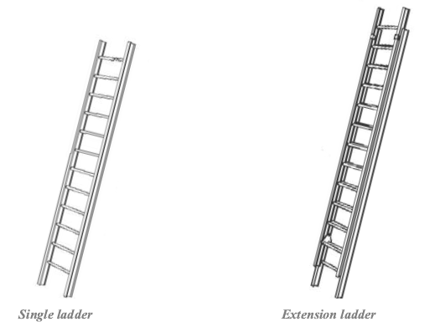

Self-Supporting Portable Ladders
