Great Things are Happening at Las Colinas Elementary School
Take Action and Join Las Colinas Elementary to Clean the Trinity River
The exhibition clean water group spoke with a representative from the City of Irving. After gathering more data about the sanitation of water in our area, they decided to do something to help keep water clean. This group scheduled to walk the Trinity River in Dallas on Saturday, May 18, to take Action! Anyone want to join us and help clean up the area around the Trinity River water supply? https://www.eventbrite.com/e/trinity-river-volunteer-day-may-cleanup-seedball-workshop-tickets-60273634062
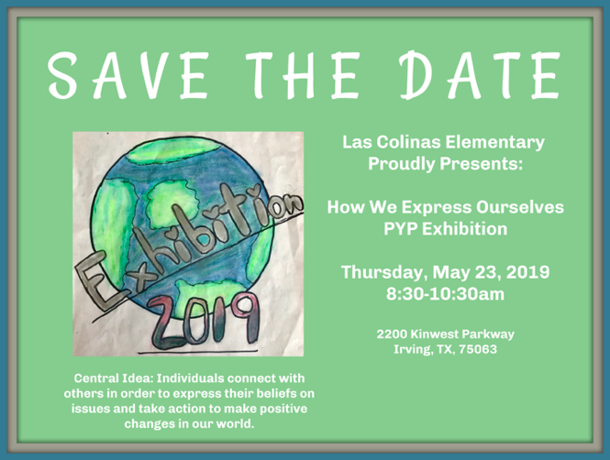
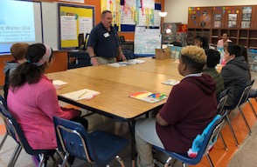

Exhibition Hunger and Poverty Groups Tour MetroCrest Social Services
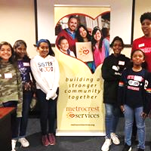
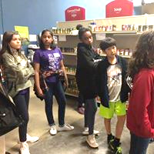
After interviewing Mr. Bodary to find out about the topics of poverty and hunger, students wanted to go further in their learning and see a local organization in action serving those in need our community. A field trip was arranged for students to attend MetroCrest Social Services after school. Many students from these groups, along with their parents, came to learn about the local food pantry and how they can donate and volunteer. After leaving MetroCrest Social Services, these exhibition students decided to take action. They are running a canned food drive, collecting food for the Sack Summer Hunger Program and creating birthday boxes.

Students at LCE Donate Items to Animals on the Move!
Mr. Eric Brittingham with Wildlife on the Move accepted the invitation to come and share with a small group of exhibition students who were researching endangered animals and their treatment. Students crafted deep questions to ask this expert. After the interview, students gave Mr. B items they had collected to donate for the cause to care for endangered animals.

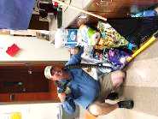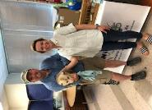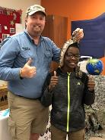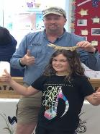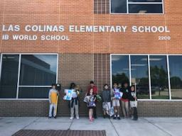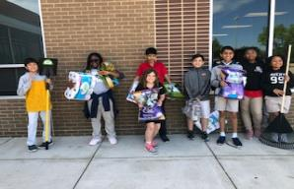

Students Take Action and Stand Up for No Smoking and No Vaping
Exhibition students are connected to current events in the community. They are taking a stand and wanting to raise the age to be able to smoke or vape to 22 years of age. During the research phase, these students found out many negative effects of smoking and vaping. They want to stop it all together, but maybe if the age gets raised in Texas, this could be a start to someday end smoking and vaping. These students took their petition to the IB Bash in CFB ISD where all the schools along the IB continuum were able to view and sign. After collecting signatures on this petition, these students plan to send this petition to their congressman in Texas.
