Great Things Happening at Good Elementary School

Third Grade Students Connect Leadership to Local Leaders and Take Action
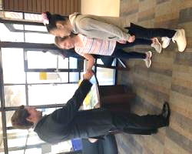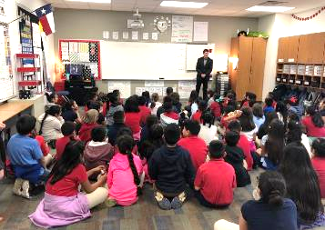
Leaders shape cultures and communities. The City of Carrollton Mayor, Kevin Falconer, accepted an invitation to come speak with third grade students at R.E. Good Elementary, IB World School. Students were researching about leadership and took action to invite Mayor Falconer to Good Elementary. Several students used their creativity and created a video invitation for Mayor Falconer. The video invite worked! Mayor Falconer came to Good Elementary and shared about leading the city of Carrollton. After listening about how he leads Carrollton, the students were able to make a real-life authentic connection to this unit of inquiry. Many thanks to Mayor Falconer for giving his time to share with our students at R.E. Good Elementary.

Exhibition Students Collaborate with Middle School Teacher to Take Action and Design a Product using a 3D Printer

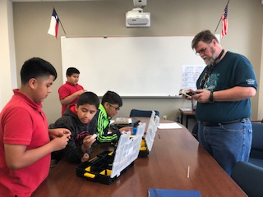
Exhibition this year at R.E. Good Elementary is centered around the theme, How the World Works. The product design group investigated and researched into product design today. They were fascinated about how 3 D printers are being used to create new products. They decided they wanted to contact a middle school in Carrollton-Farmers Branch ISD and find out if there was a way they could create a product. To their surprise they discovered Mr. K who loves engineering and was eager to help these elementary students. This Friday, May 3, these students will pick up their design. It is their hope that the piece, which is bring printed by the 3D printer, will serve a new purpose for all ages.

Exhibition Group Interviews Dr. Nisha Unni, UT Southwestern Hematologist/Oncologist
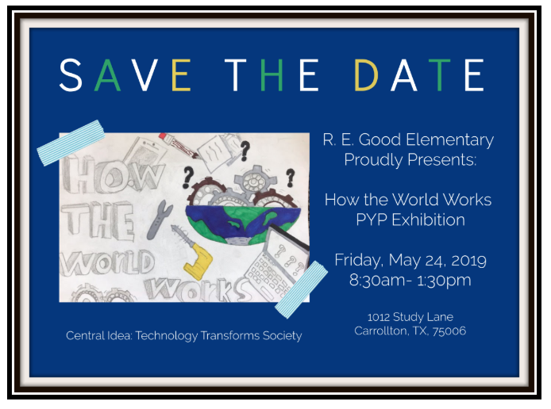
Students were able to participate in a mobile phone conference call interview with hematologist, Dr. Nisha Unni, who practices at the University of Texas Southwestern Medical Center in Dallas, Texas. Dr. Unni shared about her passion for medicine. She said, “Doctors must show empathy to their patients.” She loves teaching, being involved in research and on the cutting edge of new medical treatments and technologies. The inquisitive fifth graders are inquiring into how technology is being used today in this field of medicine. She mentioned that artificial intelligence may be used more in the changing field of medicine. The central idea of the Exhibition is technology transforms society. On May 6, students will meet Dr. Unni in person when they take a tour of the facility to learn more.
https://profiles.utsouthwestern.edu/profile/148963/nisha-unni.html

Service Learning to Help Those in Need – MetroCrest Canned Food Drive and Toys for Tots Organized and Facilitated by Students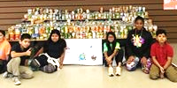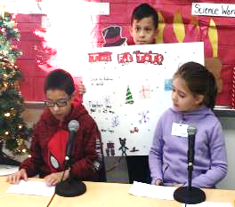
The MetroCrest Canned Food Drive and the Toys for Tots Toy Drive was led and facilitated by third and fifth grade students at R.E. Good Elementary in Carrollton Farmers Branch ISD. Students set goals, monitored daily progress, tracked the data and communicated the results on the school TV network. Service learning is deeply embedded into the climate of our IB World School.

Connecting One PYP Chinese Class to Another PYP Chinese Class in Texas through technology!
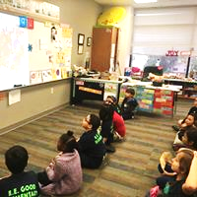
Chinese world language class at R.E. Good Elementary in CFB ISD connected to another Chinese class at Huffman Elementary in Plano ISD in Texas. Both schools are PYP schools. Using Skype, students were able to speak and listen to one another using the Chinese language they are learning. Fun was had by all and this real time communication and collaboration took learning Chinese to a new level. Our next step is to find a PYP school in China we can Skype with next school year.

Kindergarteners Spread Kindness Rocks Across the School
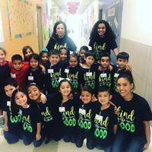
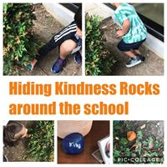

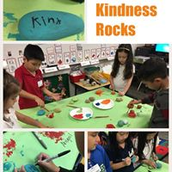
Kindergarten classes at R.E Good Elementary in Carrollton-Farmers Branch ISD took time to spread a little kindness around the school. “Kind is the new Good,” is the moto for this school year. These young students painted special caring messages on each rock and then hid those special rocks around the school for other students of all ages to find. These students also gave rocks to teachers. Overall, this caring action spread kindness around the campus and is still impacting students, teachers and parents alike today. “Kind is definitely the new Good! “

