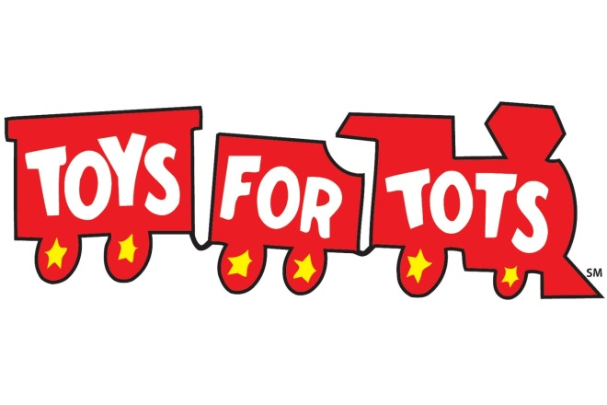

November 20, 2021
Bring a new unwrapped toy and receive $5 off your meal!

Meal will include
Spaghetti (Meat Sauce, Red Sauce or Chicken)
Green Beans or Corn
Garlic Bread
Cookie
Served from 5pm till 8pm (while supplies last)

