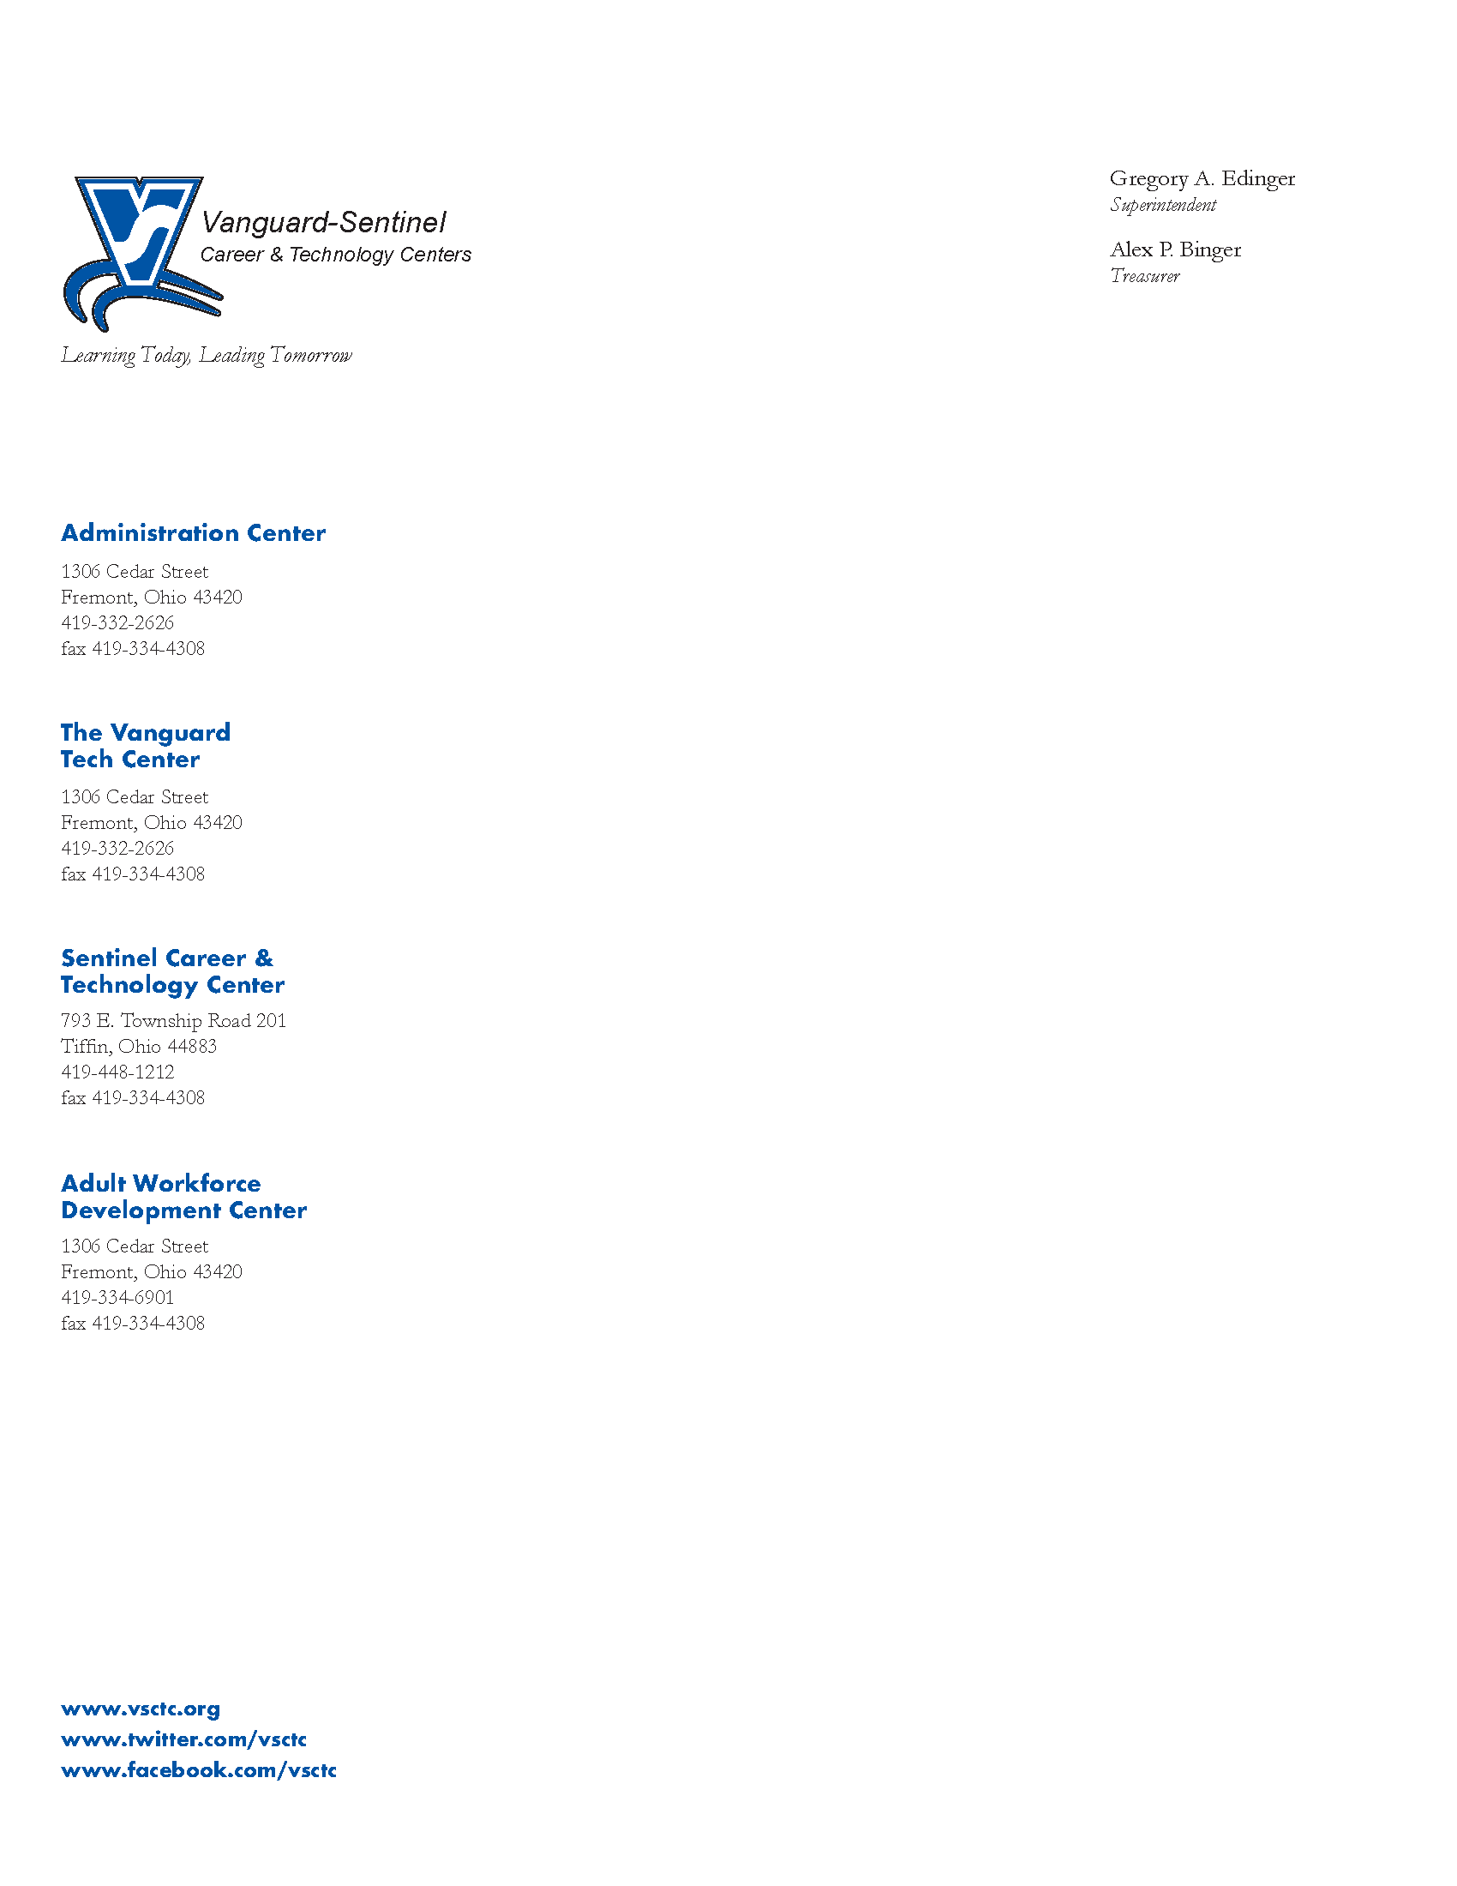
FOR IMMEDIATE RELEASE: January 26, 2021

Angie Morelock
Vanguard-Sentinel Career & Technology Centers
419-334-5694
amorelock@vsctc.org

AN E-EXPERIENCE PLANNED TO SHOWCASE CAREER TECH EDUCATION
Virtual event replaces annual open house to encourage students to consider Career Tech Education

Fremont, Ohio: Vanguard-Sentinel Career & Technology Centers (VSCTC) is excited to announce an e-Experience as an alternative to the annual public open house event. The e-EXPERIENCE will take place on February 2nd from 5:00 – 7:00 p.m. online on the district website at www.vsctc.org. This event will offer students and their families an opportunity to virtually explore the benefits of career-tech education like that offered at VSCTC.

“COVID-19 has truly impacted our recruitment efforts as we have not been able to host our popular campus visits for students at our partner schools” explains Superintendent Greg Edinger. “We are excited about this creative platform where people can still get an in-depth view of our programs and learn about the benefits of choosing Career Tech Education, while remaining safe and following safety guidelines.”

The e-EXPERIENCE is an interactive platform that uses many different tools where visitors can move at their own pace and explore programs that are of interest to them. Current students will walk you through different options that include:
- Question & Answer opportunities with instructors via Zoom calls.
- Exploring programs through short videos that feature students from that program.
- Taking a virtual tour of the lab and learning space for each program. Interactive buttons in the virtual tour feature more videos, photos, and information.
- Learning about course topics and available industry credentials.
- Applying for a program through the online application.
The above options can all be accessed beginning at 5:00 p.m. on Tuesday, February 2, 2021 on our website at www.vsctc.org. There will also be additional sessions to get your questions answered on February 3rd from 12:00 p.m. – 1:00 p.m., February 10th from 3:00 p.m. – 4:00 p.m., February 17th from 10:30 a.m. – 11:30 a.m., and February 24th from 8:30 a.m. – 9:30 a.m. Enrollment for the 2021-2022 school year is now open. Priority deadline is March 5, 2021 so apply today.
Vanguard-Sentinel Career & Technology Centers have been providing quality career technical education since 1968. We are a school of choice that provides students with specific, marketable skills to begin a career, pursue further training or attend college. For more information, visit www.vsctc.org.

# # #

