Fostoria City Schools November Highlights
November was a great month at FCS! Here are some highlights from our month.

Veterans Day Breakfast
Teachers at the Fostoria Elementary School, led by music teacher Mrs. Kris Stantos, organized an amazing Veterans Day Breakfast. Veterans were welcomed with coffee, juice, and doughnuts. Student artwork was on display. Our FES Pep Tribe Choir sang for the guests. The United Veterans of Fostoria Honor Guard was present, and the keynote speaker was Fostoria Mayor, Mr. Mennel.
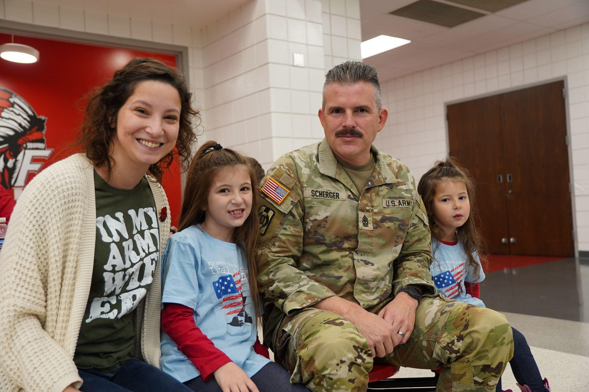
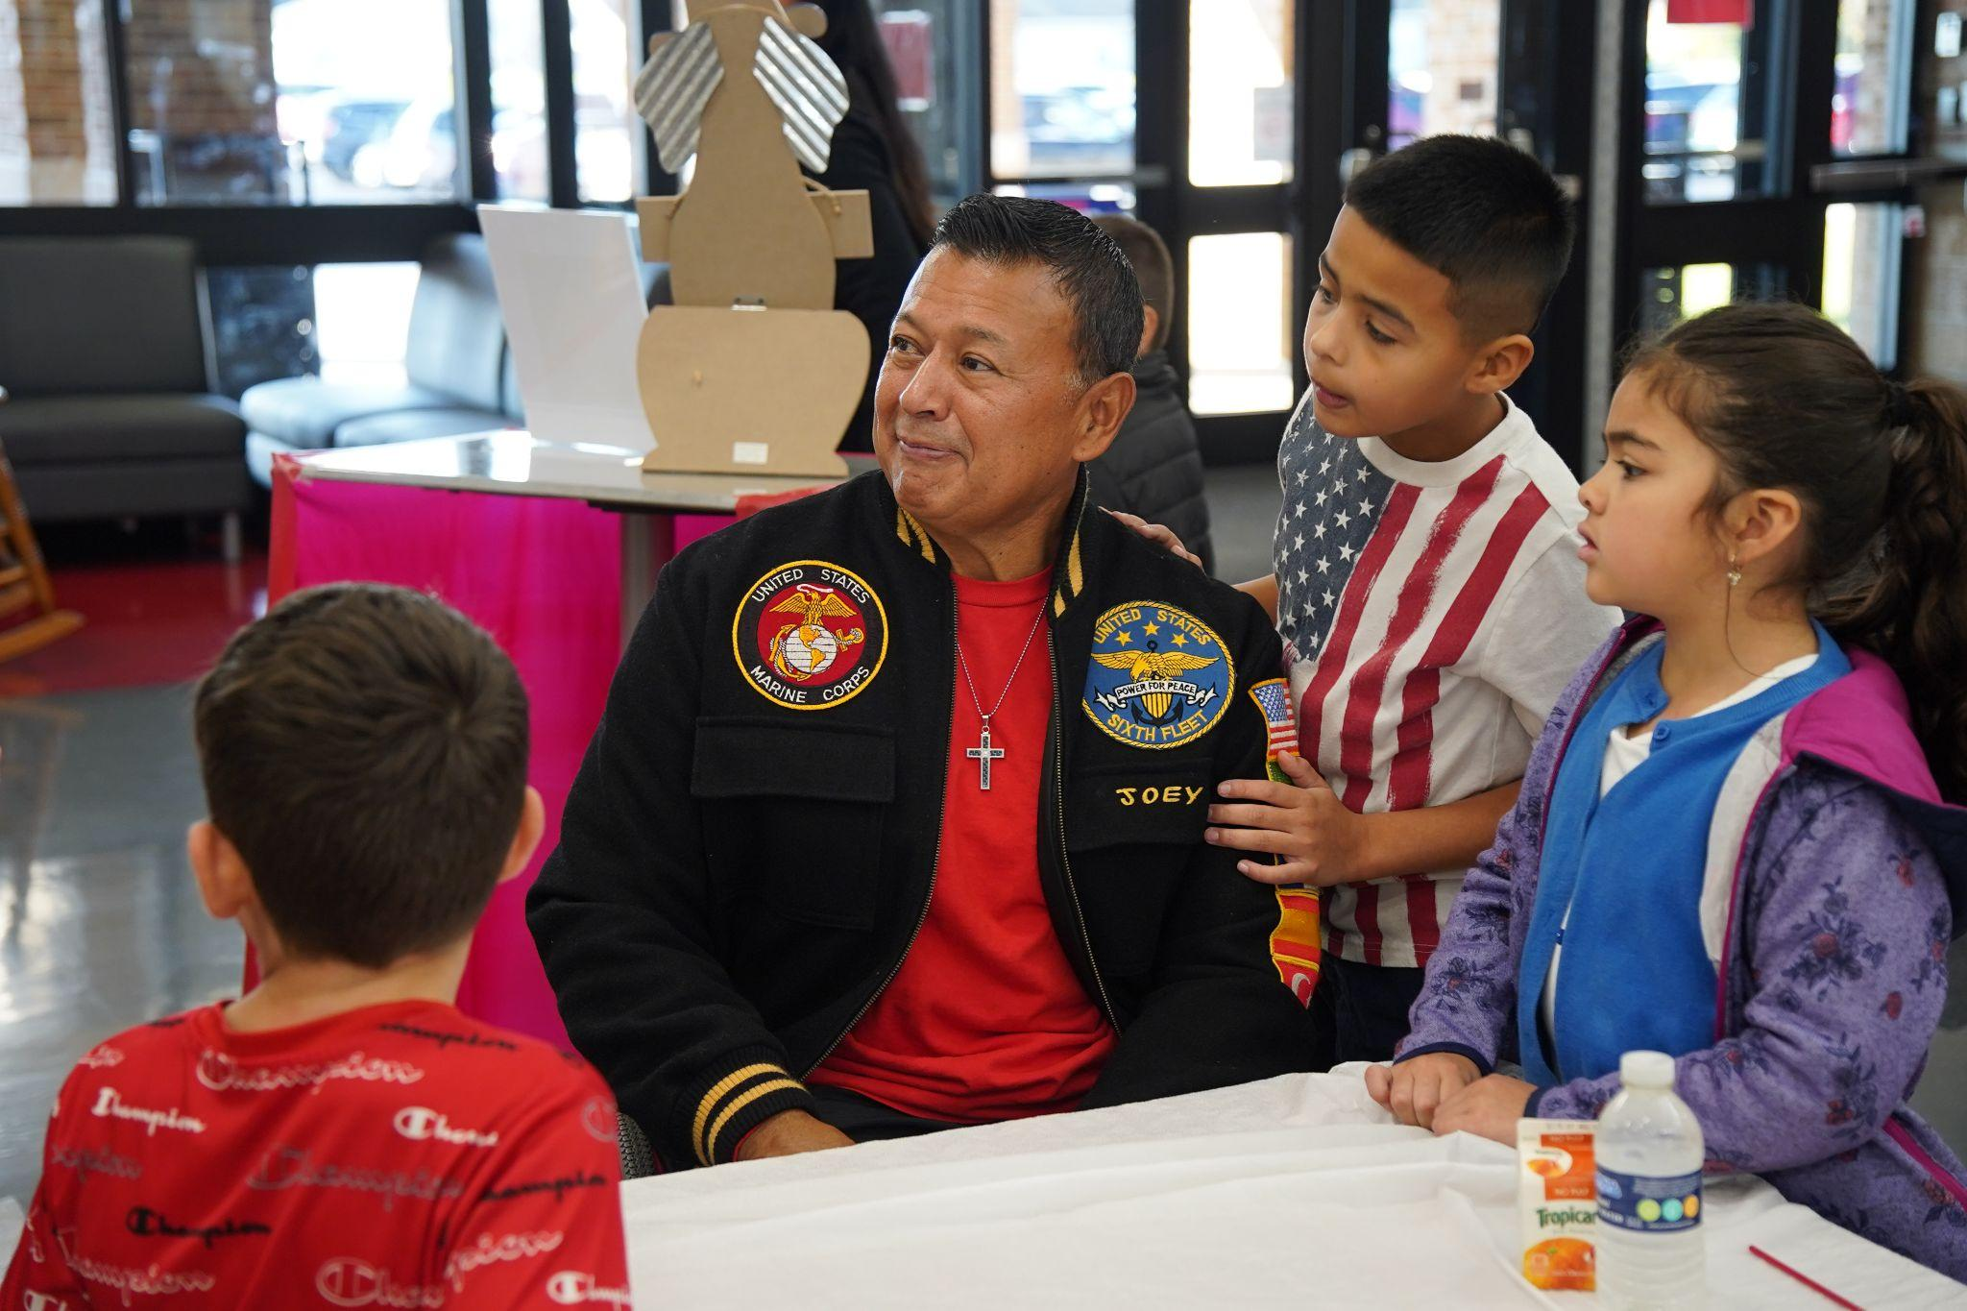
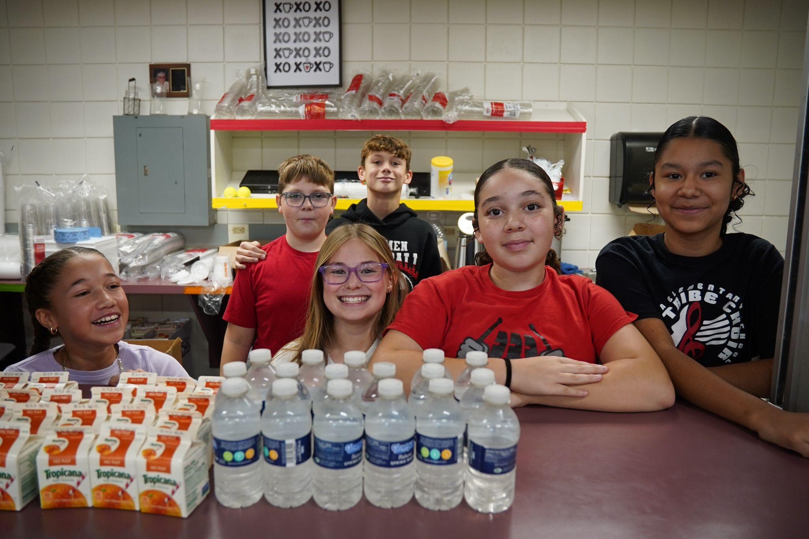
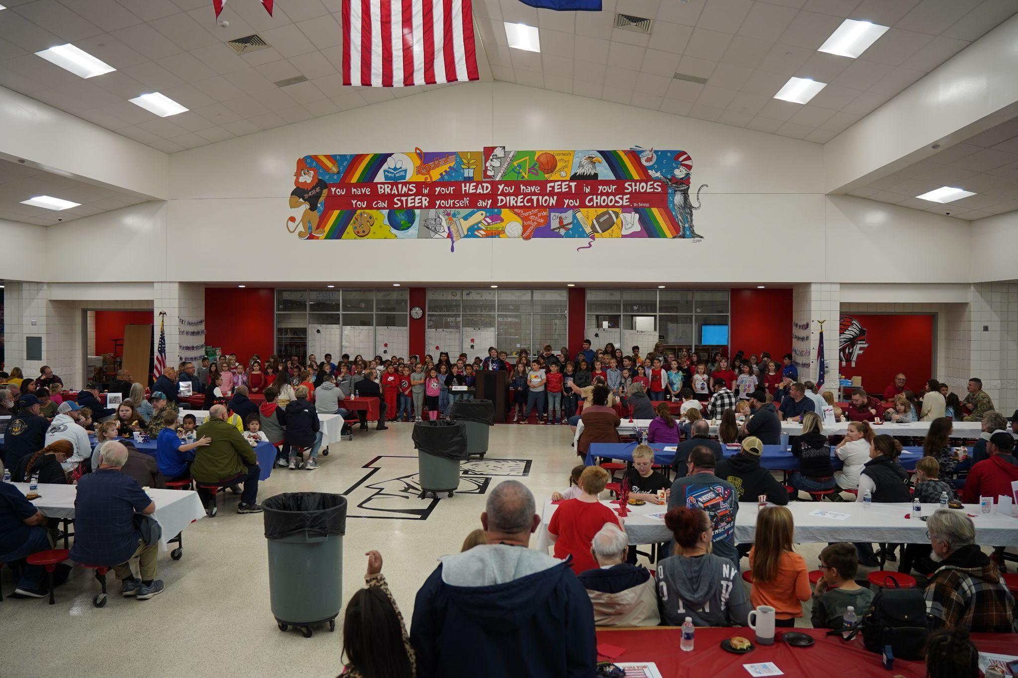
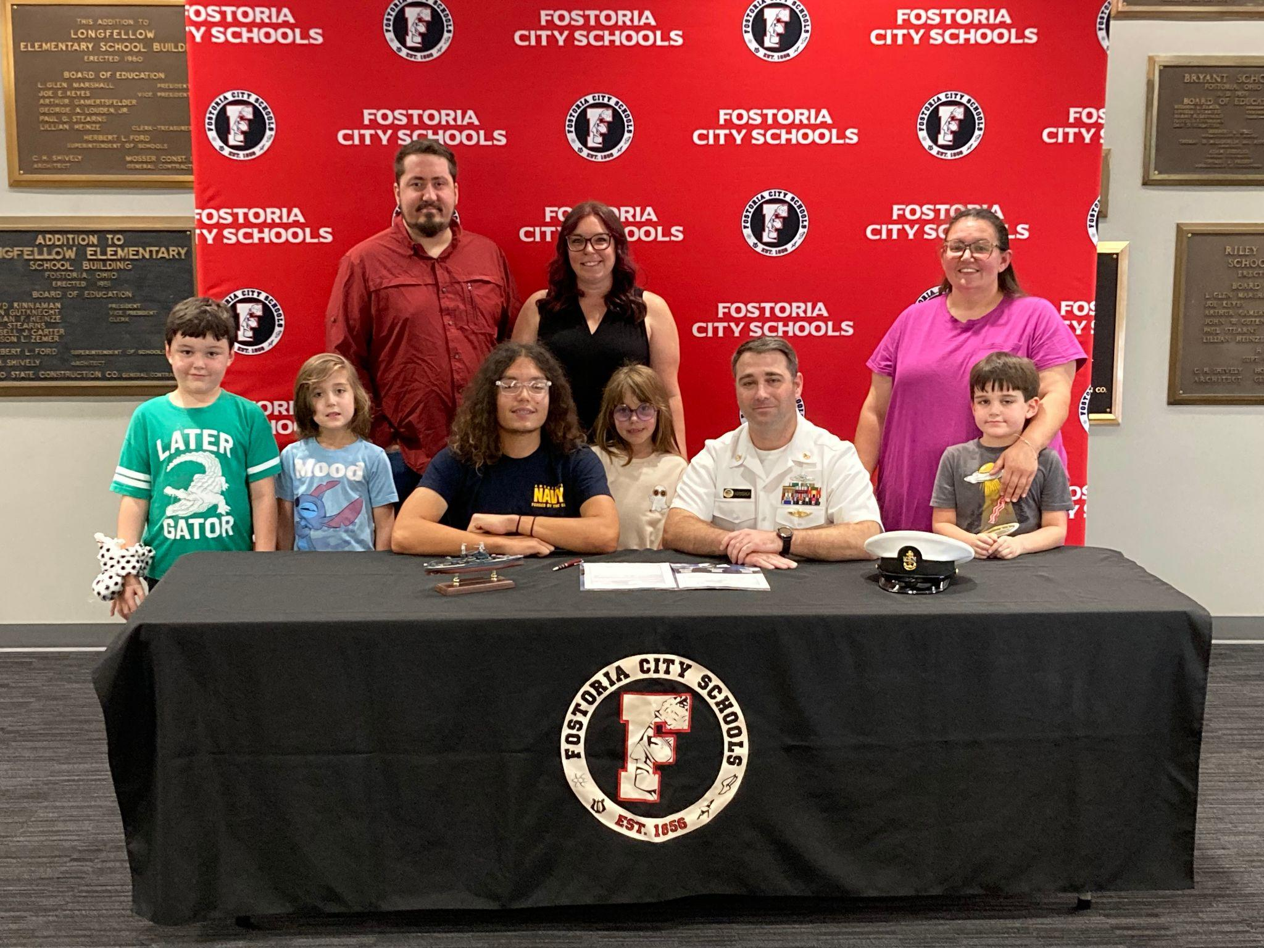
FJSHS Senior Recognized
FJSHS Senior Thaddieus Switzer-Vande Velde was recognized at our November BOE meeting. He was presented with a Certificate of Recognition as he signed his letter of intent to join the U.S. Navy.

Micah Hyde’s Champions Club
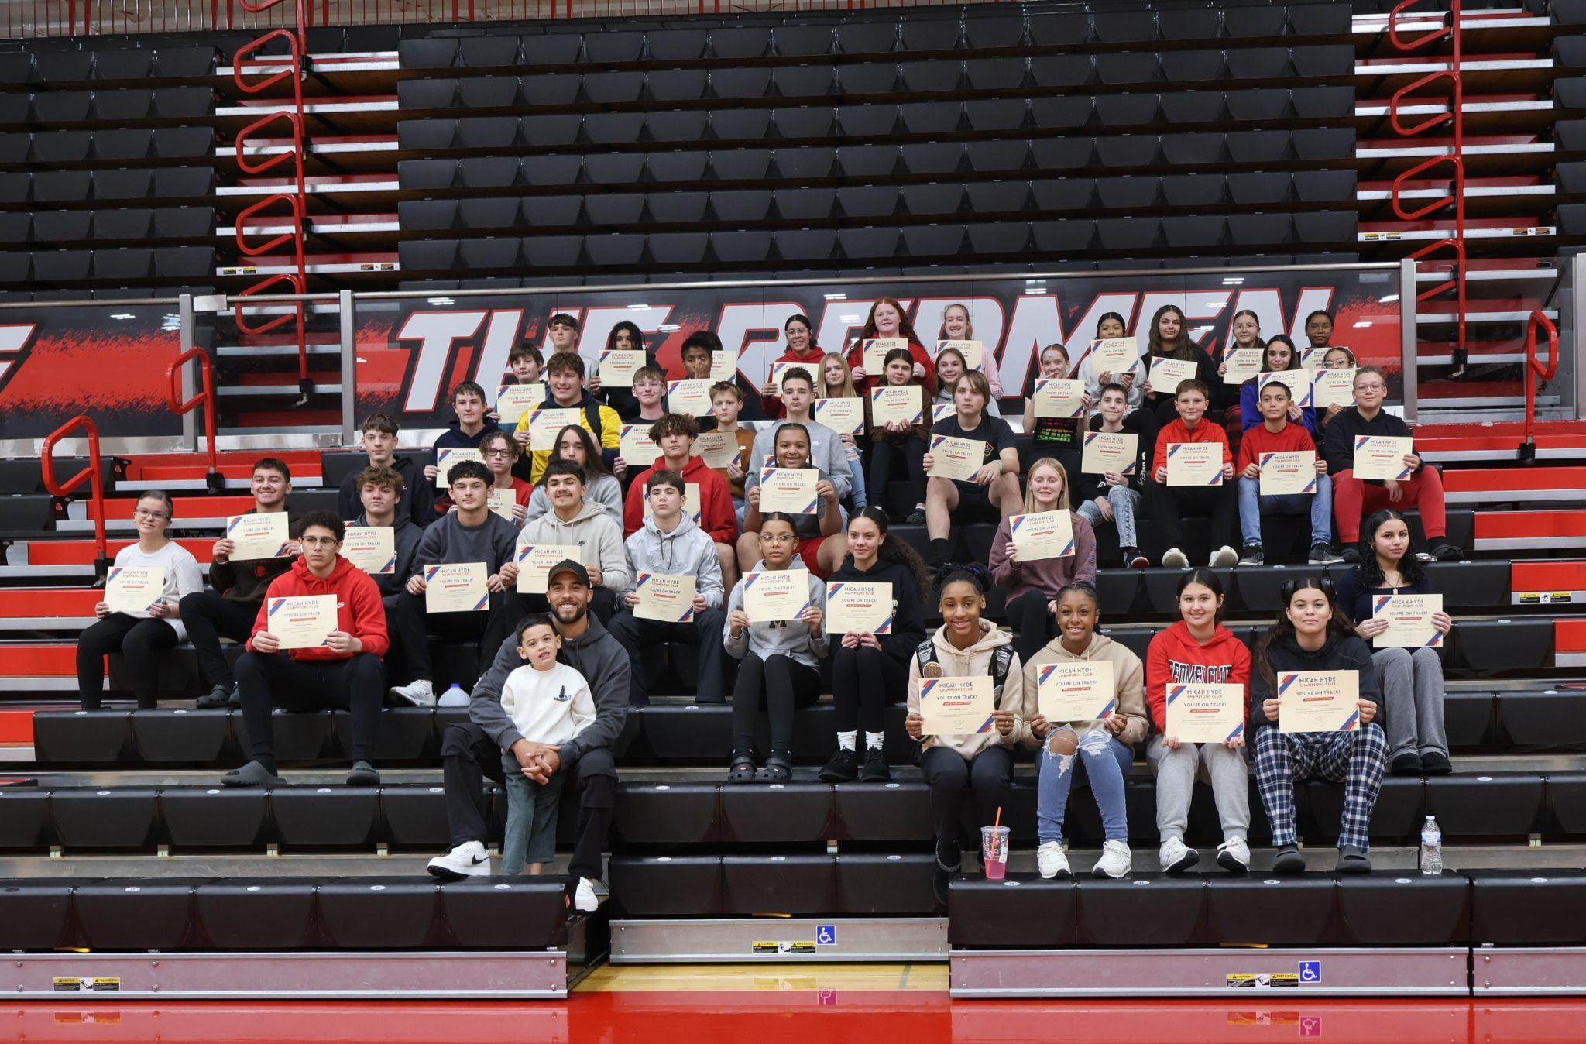
FHS alumn Micah Hyde came to the school to present certificates to the Micah Hyde Champions Club honorees for the first quarter of the 2024-2025 school year. These students, all multi-sport athletes on the honor roll, display the importance of academics and athletics. All students who enter FJSHS in seventh grade have the opportunity to participate in the MHCC scholarship program.

Fostoria City Schools December Highlights
December has been a month filled with great activities! Here are highlights of some of those activities.

Holiday Event
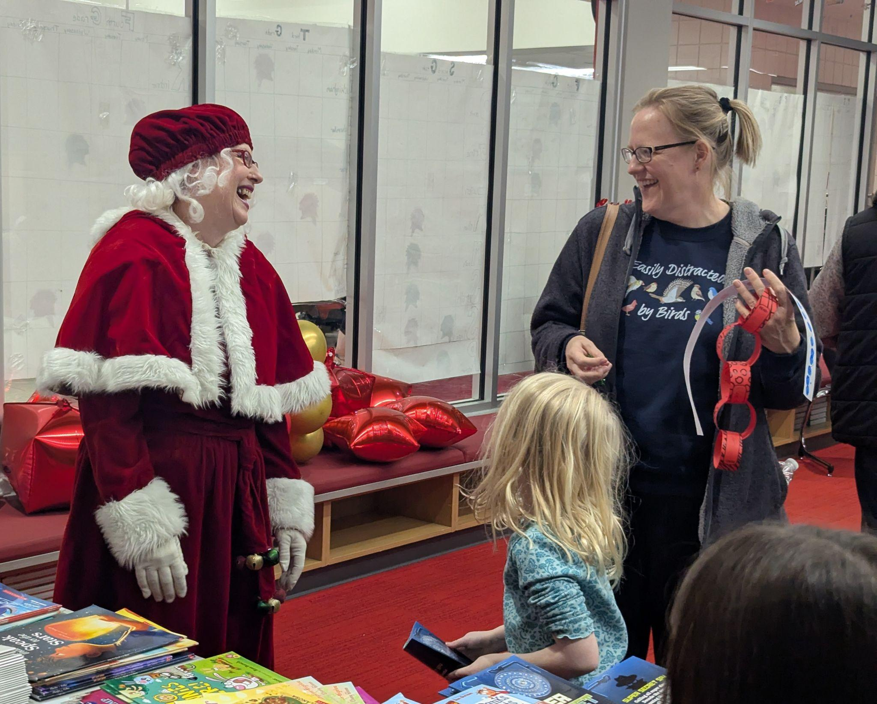
Our Parent Lighthouse and Title I teams organized a fun family holiday event. It began with a performance from our PepTribe Choir (elementary choir). After that, there were multiple activities for families to participate in, from cookie decorating to arts and crafts. Santa and Mrs. Clause even made appearances!
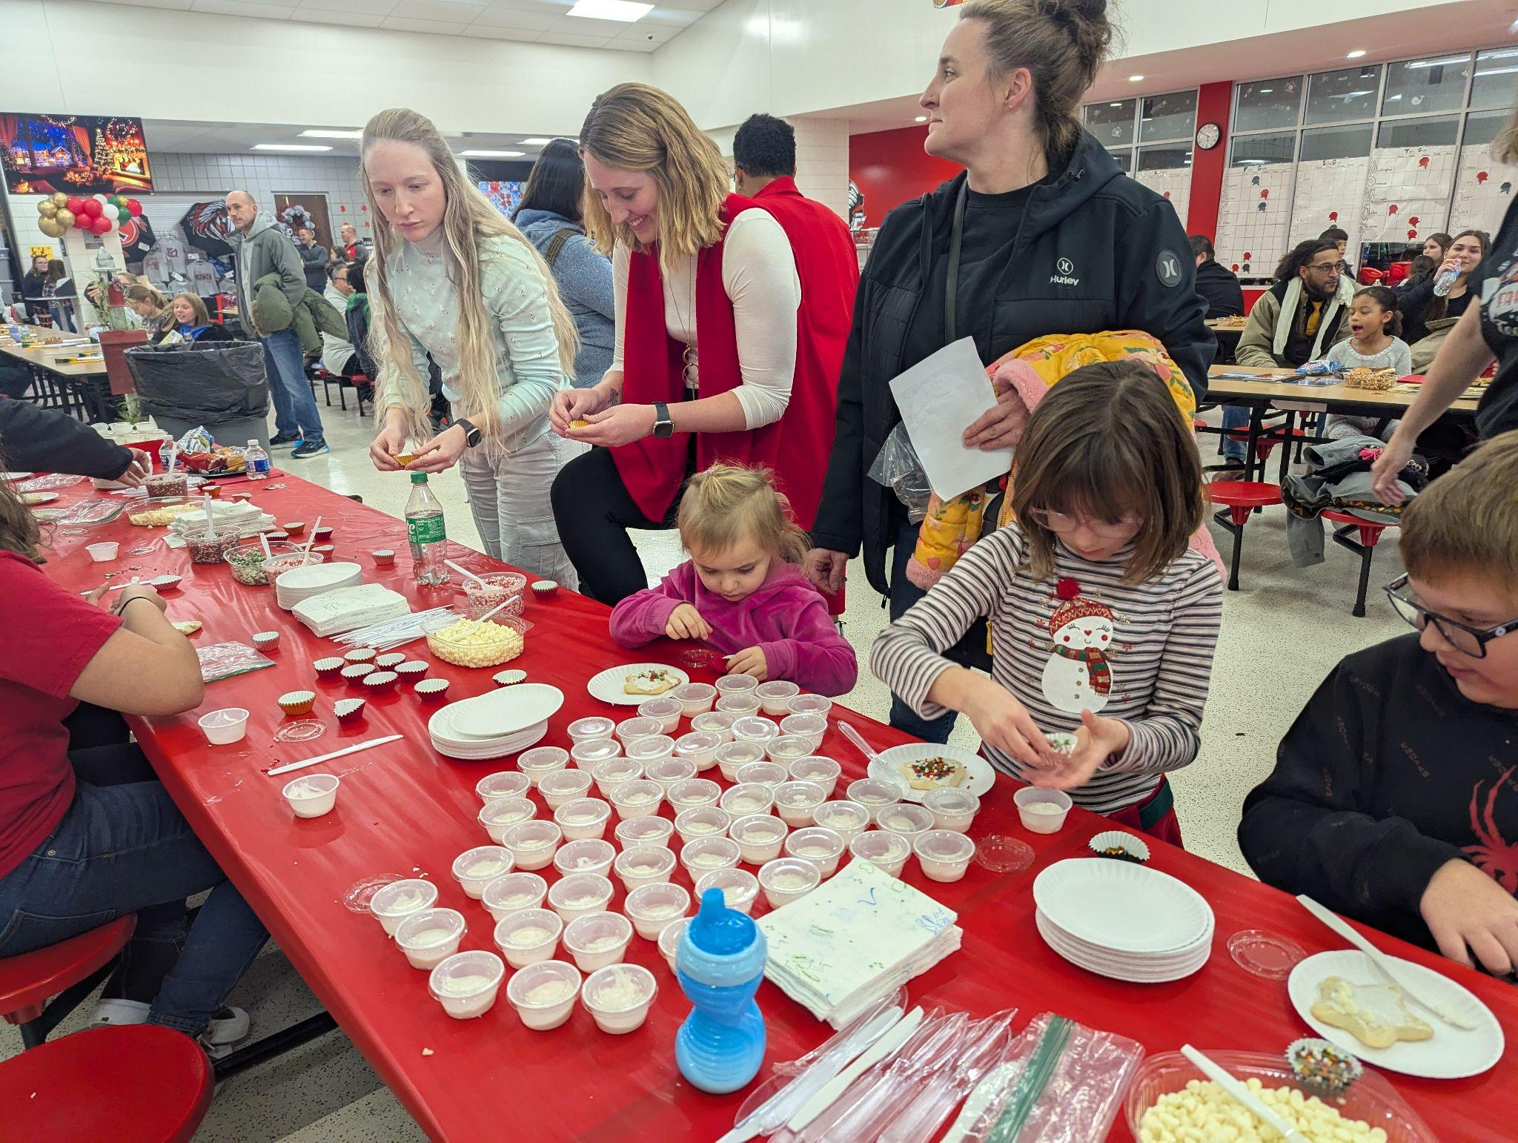
Winter Concerts
Tis the season for winter concerts! This month, we had several, ranging from band to choir. Our high school band winter concert was in conjunction with the Fostoria Community band.

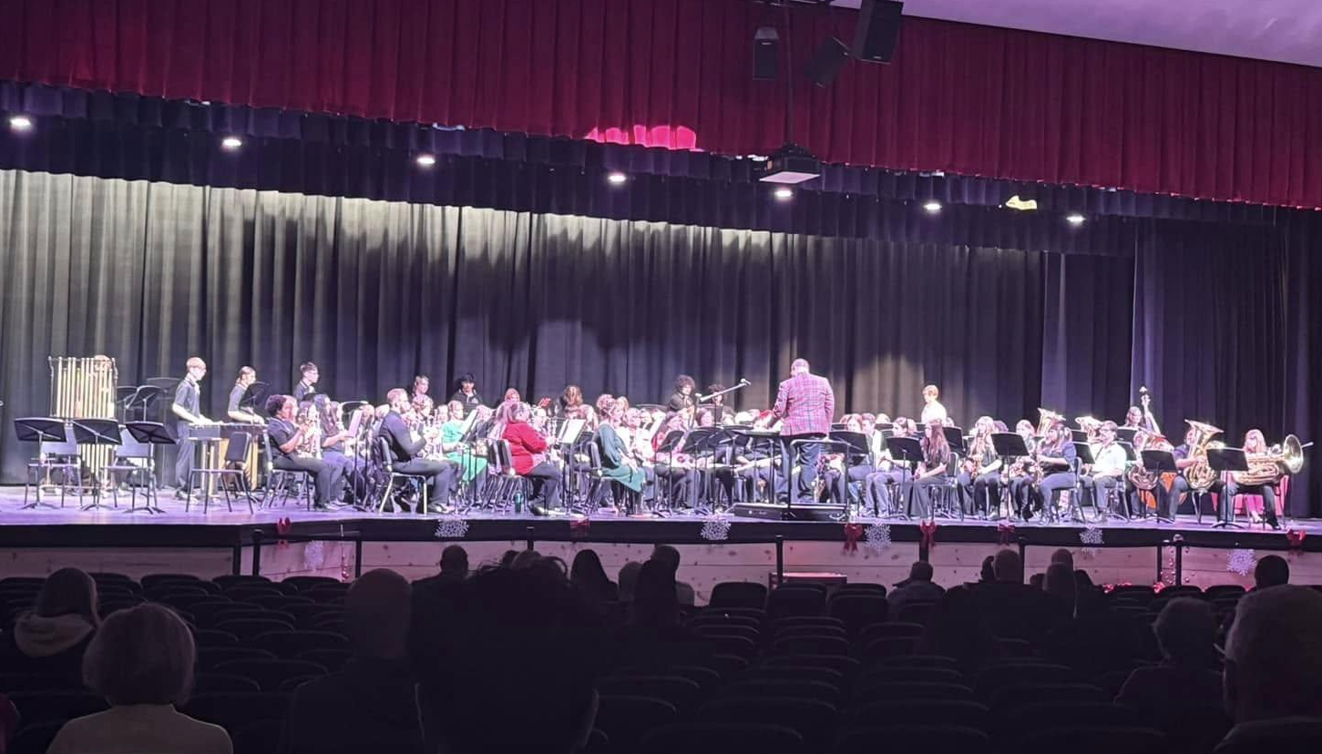

A Season of Giving
Mrs. Reed’s class at the Fostoria Academy did a fundraiser for the Seneca County Humaine Society. They delivered their gifts last week and spent time with some of the animals in the shelter.
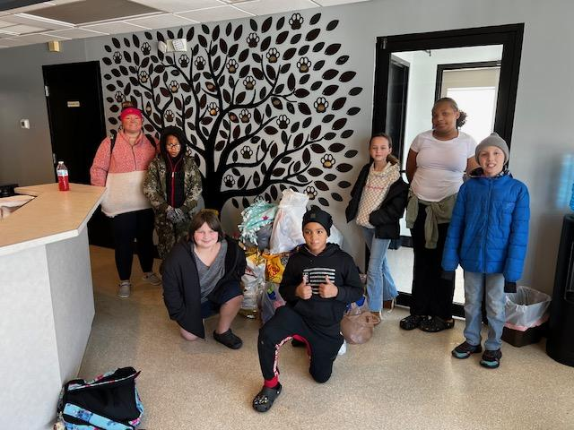

BOE Recognizes School Leaders
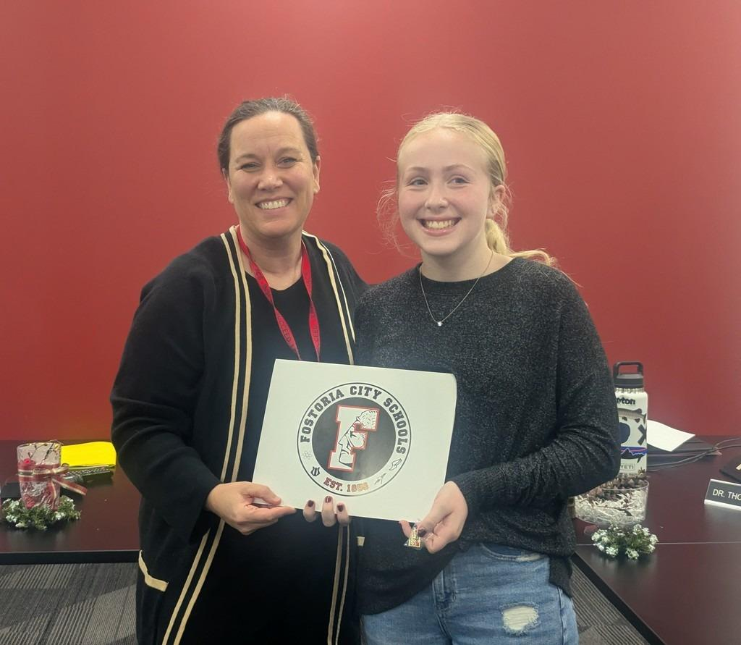
The Fostoria Board of Education recognized FES students Adele Lemley and Avery Settles at Monday night's BOE meeting. Adele and Avery were celebrated for receiving the Youth Asset Builder Award. Both students were nominated by their homeroom teachers for being positive role models and helping others.
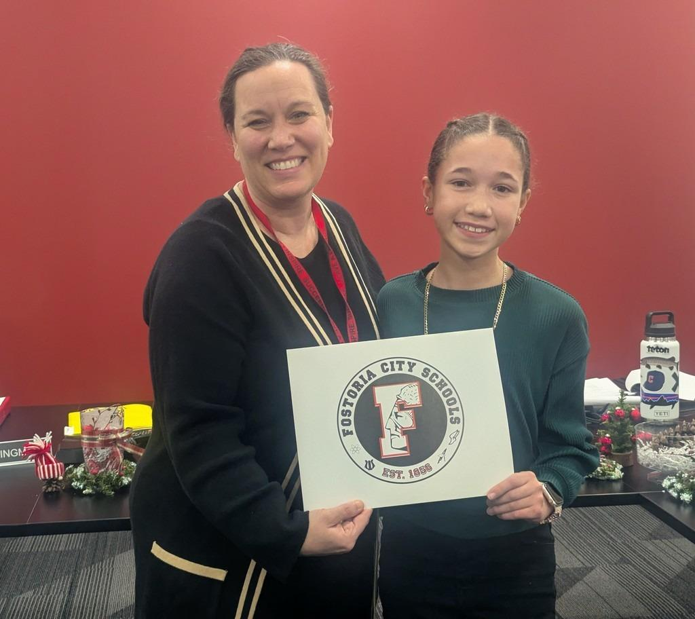

AIM Manufacturing Program
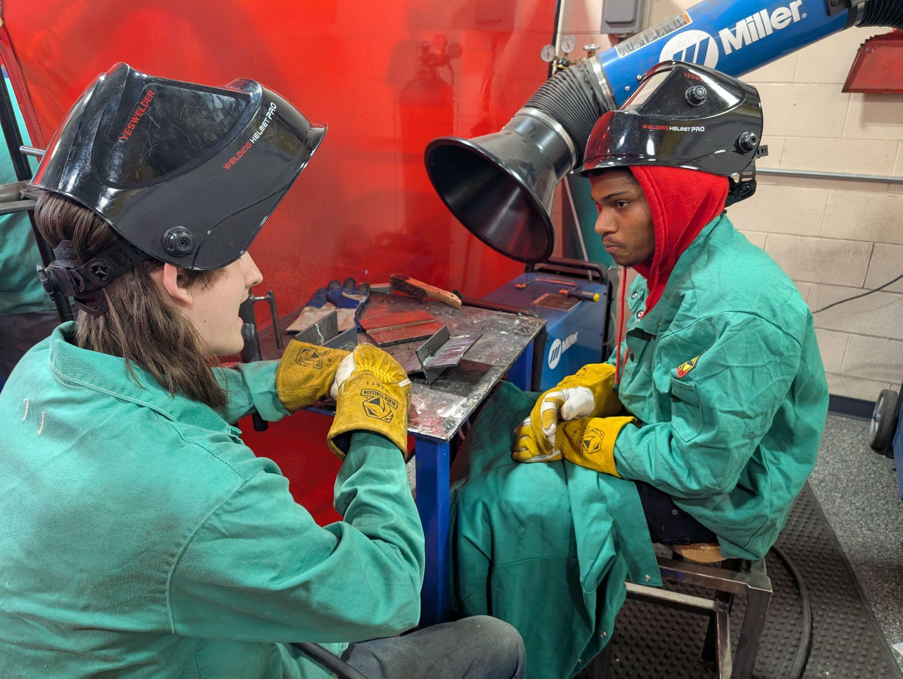
Mr. Weidner and Mr. Depinet traveled to Vanguard with students to check out their AIM Manufacturing program. This same program will be hosted at the Fostoria Learning Center starting in January.
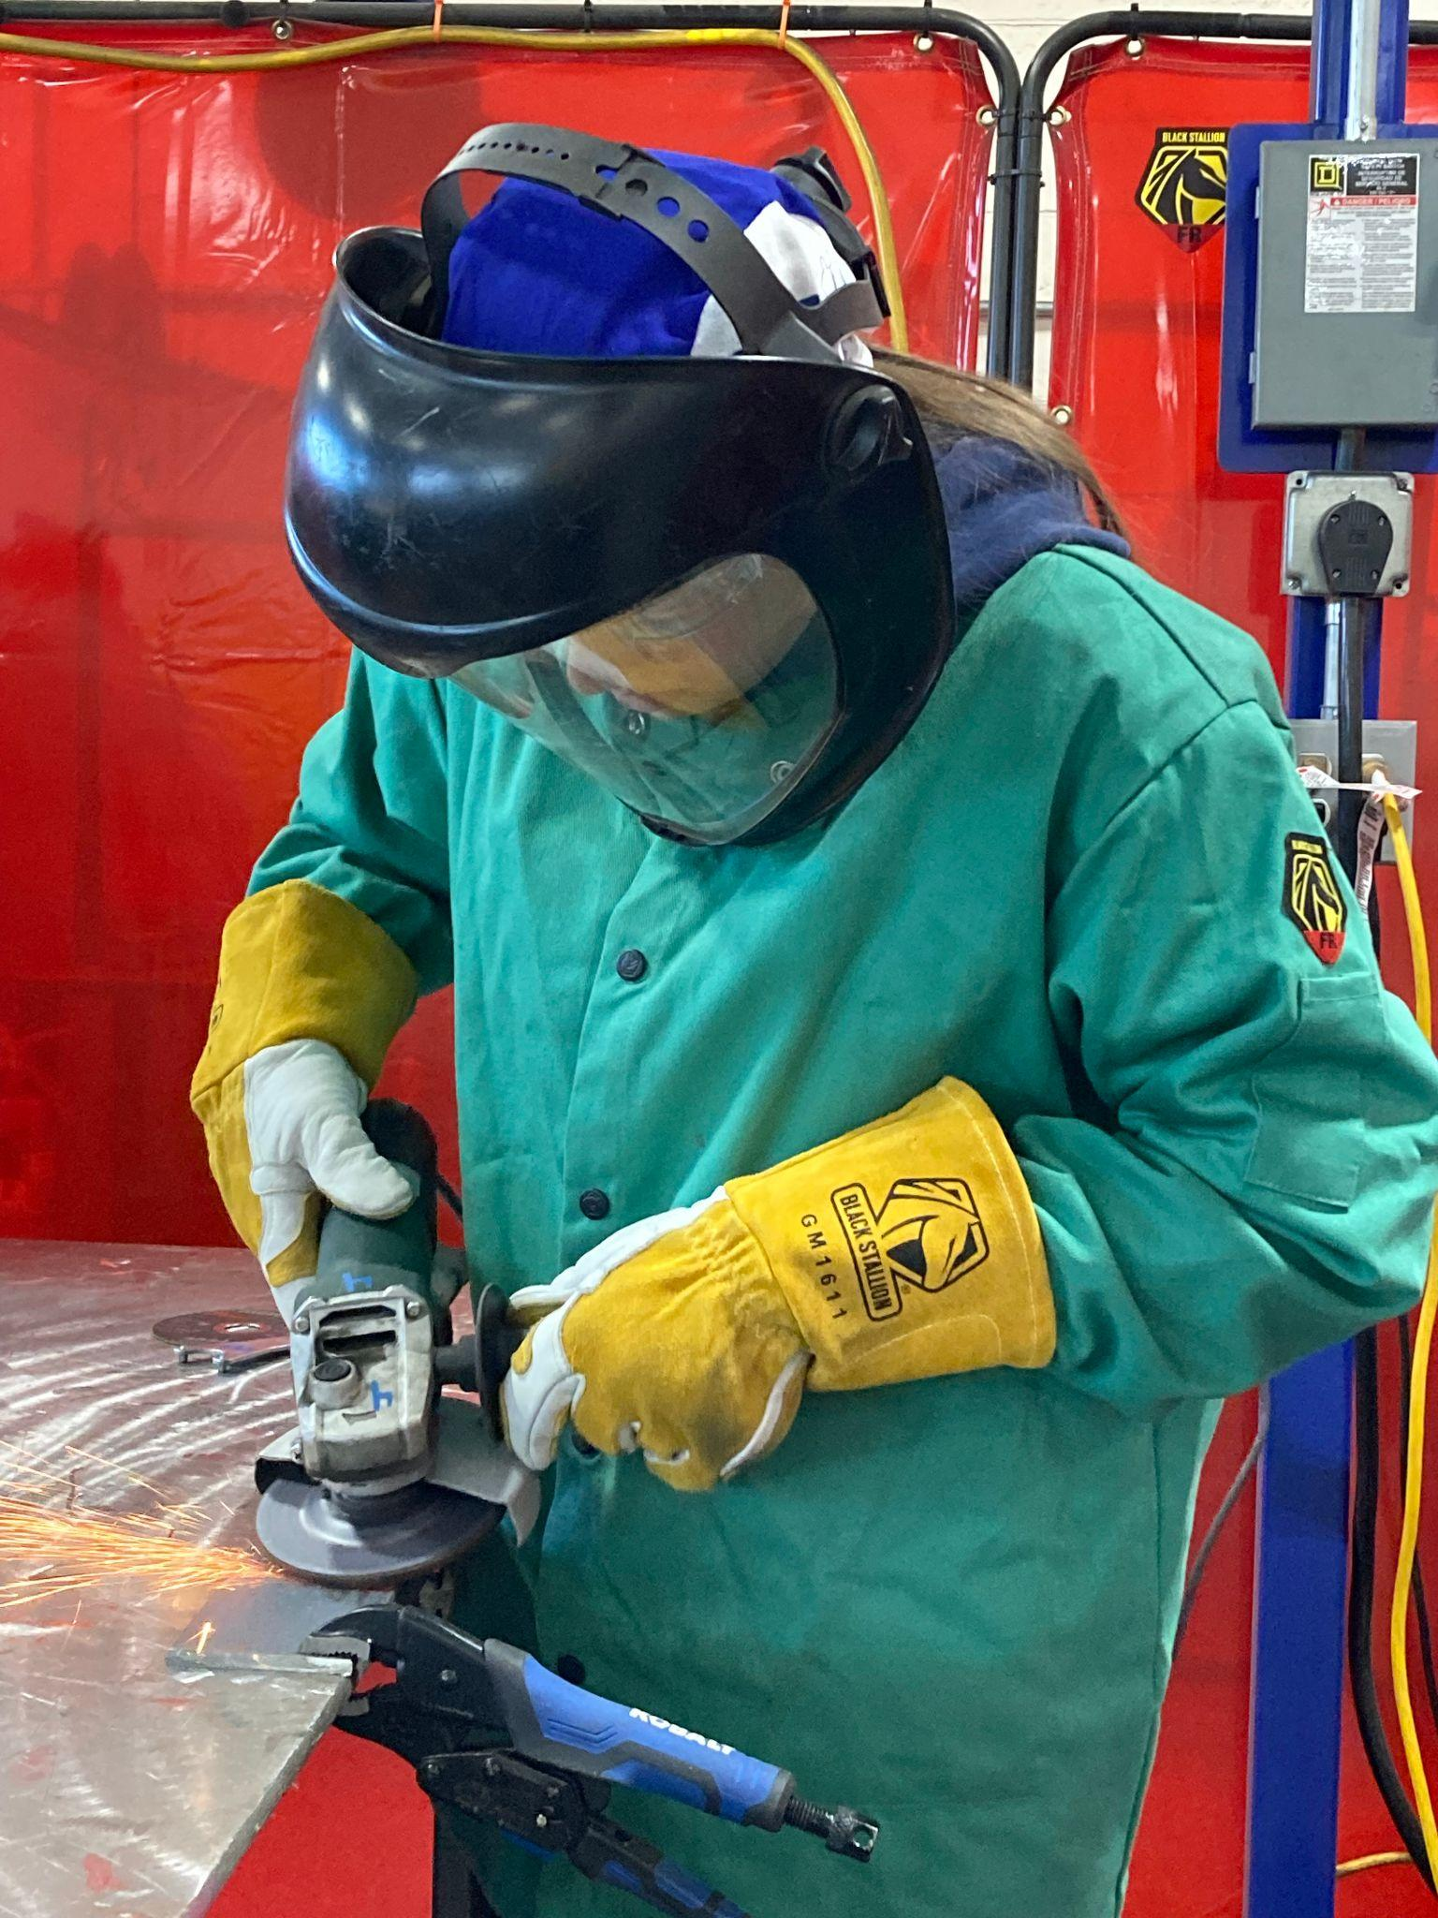

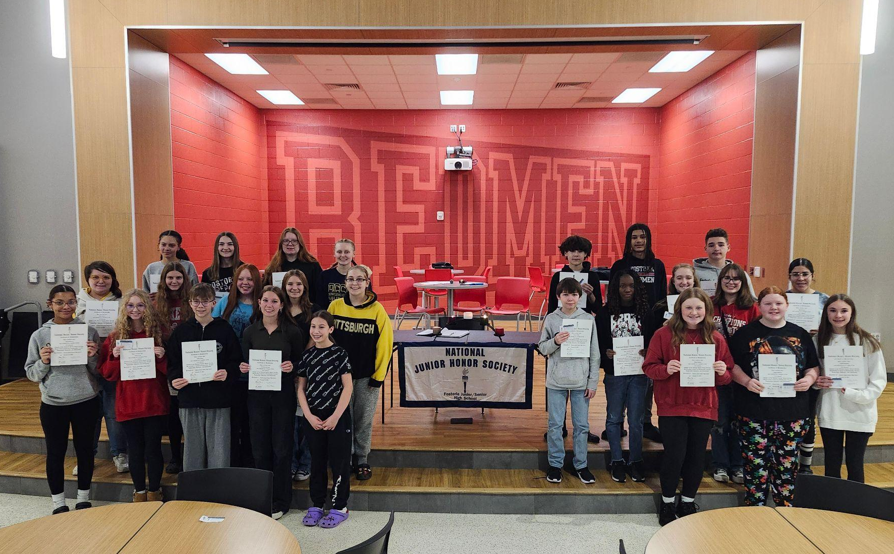

NJSHS Inductions
The National Junior Honors Society inducted 25 students on Monday, December 16th.

