
2019 NE Ohio Safety Expo

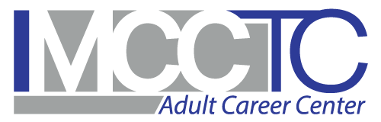
Ohio BWC/Division of Safety and Hygiene and the Mahoning County Career and Technical Center (MCCTC) have partnered to offer you a free health and wellness program while attending the NE Ohio Safety Expo on Friday October 11th at MCCTC. The Safety Expo will offer forty 60-minute training sessions and 50 exhibitors showing off their goods and services. Attendance fee is $30.00 and includes lunch.

Better You Better Ohio = A healthy you

Free opportunity to improve your health Better You, Better Ohio! is a free health and wellness program from Ohio BWC. Not a participant yet? It’s not too late. Register today, while attending the Safety Expo you can get a free biometric health screening from Quest Diagnostics and earn $75.00!
When
Friday October 11, 2019 Registration at 8:00 a.m.
Expo 9:00 a.m. to 4:00 p.m.

Where
MCCTC
7300 N Palmyra Rd,
Canfield, OH 44406

Have questions about the Expo or need additional information? Contact David Costantino at 330-301-5825 E-mail David.c.12@bwc.state.oh.us

Visit us at: go.activehealth.com/betteryoubetterohio

