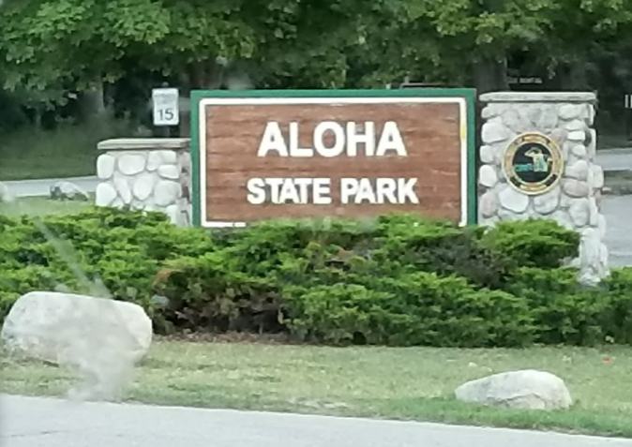 | Aloha State Park  Needs More Trees!  Help wanted  Monday, October 15  Aloha State Park  10:00 AM

A Shoreland Stewardship Event --Trees lost to the Emerald Ash Bore need to be replaced along the shoreline.

The Mullett Lake Area Preservation Society (MAPS) is partnering with the Aloha State Park to help restore the park shoreline buffer with added trees and no-mow greenbelts. The buffer will help protect the shoreline from erosion, and filter stormwater runoff from the park camping sites. | 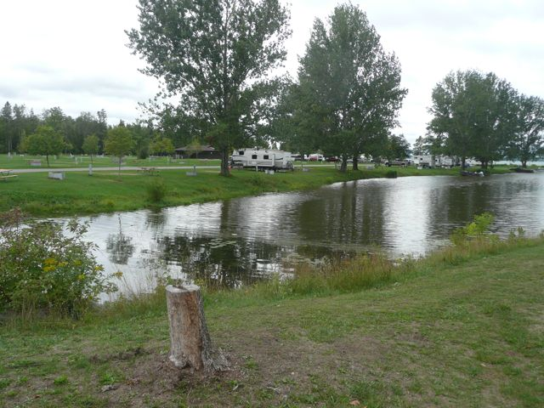
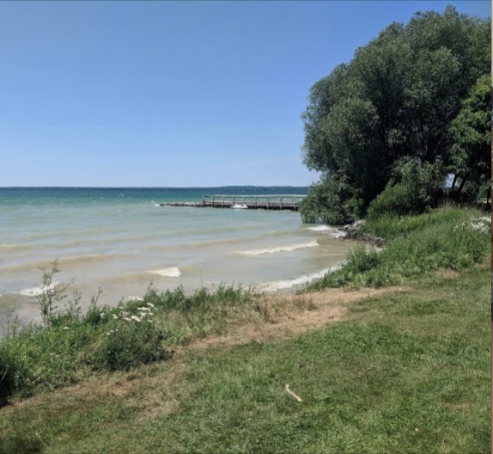 | 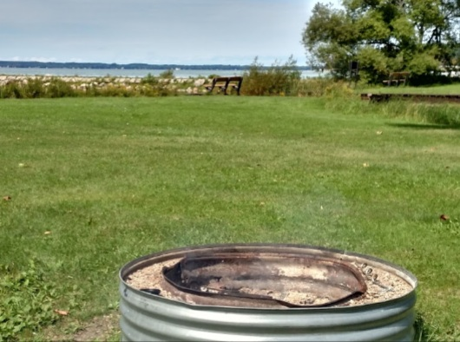

Park staff will dig the holes for planting 12’ trees. Adult volunteers are needed to help fill the holes and mulch the planted trees. Lunch will be provided. Bring work gloves, and a shovel and/or garden rake.

Please RSVP to be advised in case of weather or other changes:

Name:_________________________________ Email:_____________________________________

Phone:______________________________

Contact: Darrell Schwalm, schwalmie2@aol.com, 231-627-1120

