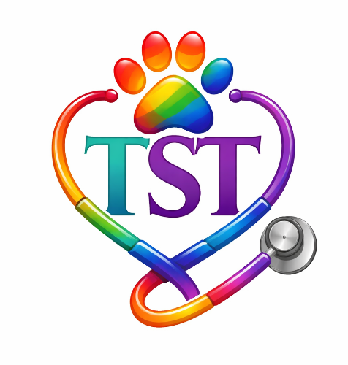

"Creating Safe Spaces in Veterinary Medicine"
Psychological safety, belonging, and inclusion contribute to healthier teams and improved wellbeing. During Pride Month, we recognize the importance of supporting LGBTQ+ colleagues and fostering workplaces where everyone feels respected and valued.
Every voice matters. Every identity belongs.
Happy Pride Month!

Veterinary medicine is strongest when every member of the team feels seen, supported, and valued.

Resources
Pridevmc.org
pflag.org
pawsibilitiesvetmed.com
aav.org/page/LGBTQIA

Ways to Be an Ally at Work
Respect names and pronouns
Use inclusive language with coworkers and clients
Challenge discrimination and bias when you see it
Listen with empathy and curiosity
Help create a workplace where everyone feels safe and welcome

VetCOT
Trauma Support Team Committee

