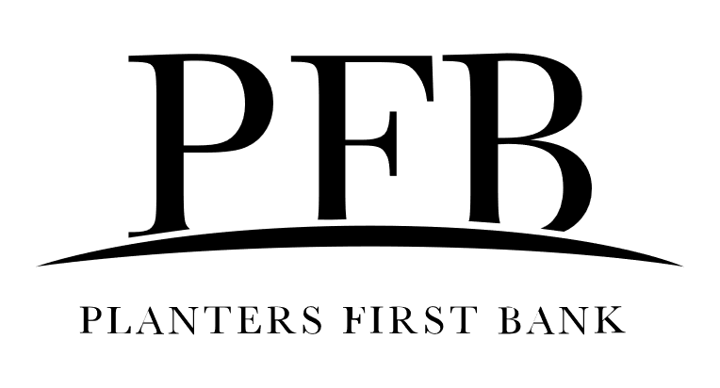 PPP Loan Forgiveness Q&A

Below you will find a compilation of information from Planters First Bank about the Paycheck Protection Program (PPP) loan forgiveness process. Although this information has been derived from several credible sources, it is ultimately the responsibility of each borrower(s) to know the rules of the PPP program and a borrower should not rely on this content as the primary source of information. Additionally, please note that Planters First Bank has funded the PPP loans in partnership with the SBA and because of this Planters First Bank is required to follow their rules and regulations. Information about the PPP loan forgiveness process is still being developed by the SBA and SBA expects to provide guidance soon. Please note that all information provided below could be modified further by SBA and Treasury. Accordingly, Borrowers should consult available resources provided by the U.S. Small Business Administration (“SBA”) and U.S. Department of the Treasury (“Treasury”), which can be found, among other places, at the following websites https://www.sba.gov/funding-programs/loans/coronavirus-relief-options/paycheck-protection-program and https://home.treasury.gov/policy-issues/cares/assistance-for-small-businesses for any updates to the PPP loan forgiveness.
When can my business apply for loan forgiveness?
Recipients of a Paycheck Protection Program (PPP) loan may apply for loan forgiveness from their bank after the eight-week period following disbursement of their loan. The amount of loan forgiveness, if any, a PPP loan recipient may receive will depend on a variety of factors discussed below but will not exceed the loan principal amount plus accrued interest.

What may be needed to request loan forgiveness?
In order to request forgiveness of all or part of the PPP loan: Borrower may be required to (a) supply Planters First Bank with all documents and records necessary to determine the requested forgiveness amount; (b) execute any and all documents reasonably requested by Planters First Bank in connection with processing the forgiveness amount; and (c) be responsible for determining the forgiveness amount.

What documentation may be needed to apply for loan forgiveness?
The borrower’s request for loan forgiveness will, at a minimum, require the following:
- Documentation verifying the number of full-time equivalent employees on payroll and pay rates for the required periods, including payroll tax filings reported to the IRS and state income, payroll and unemployment insurance filings;
- Documentation, including cancelled checks, payment receipts, transcripts of accounts, or other documents verifying payments on covered mortgage obligations, payments on covered lease obligations, and covered utility payments;
- A certification from an authorized representative of the borrower that the documentation presented is true and correct, and the amount for which forgiveness is requested was used to retain employees, make interest payments on a covered mortgage obligation, make payments on a covered rent obligation or make covered utility payments;
- Any other documentation that the SBA determines to be necessary.

Where do I submit my PPP loan forgiveness request?
The PPP loan forgiveness request should be submitted to Planters First Bank through sba@bankpfb.com. As SBA and Treasury release additional guidance on the PPP loan forgiveness process, Planters First Bank may provide borrowers with additional information regarding the PPP loan forgiveness application process.

What is the maximum amount that can be forgiven?
The amount of loan forgiveness can be up to the full principal amount of the PPP loan and any accrued interest. That is, if loan forgiveness is approved, the borrower will not be responsible for any loan payment assuming the borrower has used all of the PPP loan proceeds for forgivable purposes.

The actual amount of PPP loan forgiveness will depend, in part, on the total amount of payroll costs, payments of interest on mortgage obligations incurred before February 15, 2020, rent payments on leases dated before February 15, 2020, and utility payments under service agreements dated before February 15, 2020, over the eight-week period following the date of the loan

What percentage of loan forgiveness can include non-payroll costs?
Not more than 25 percent of the PPP loan forgiveness amount may be attributable for non-payroll costs. Proceeds from any advance up to $10,000 on the EIDL loan will be deducted from the available loan forgiveness amount of the PPP loan.

What percentage of the forgiveness amount must be payroll related?
The SBA has determined in consultation with the Treasury that 75 percent is an appropriate percentage in light of the CARES Act’s overarching focus on keeping workers paid and employed. Further, SBA and Treasury believe that applying this threshold to loan forgiveness is consistent with the structure of the Act, which provides a loan amount 75 percent of which is equivalent to eight weeks of payroll (8 weeks / 2.5 months = 56 days / 76 days = 74 percent rounded up to 75 percent). Limiting non-payroll costs to 25 percent of the forgiveness amount will align these elements of the program and will also help to ensure that the finite appropriations available for PPP loan forgiveness are directed toward payroll protection.

When does the eight-week period begin?
The eight-week period begins on the date of the first disbursement of the PPP loan to the borrower.

What will happen if I cannot provide the necessary documentation needed for loan forgiveness?
If borrower fails to provide the required documentation, the loan forgiveness will be denied.

Will reductions in staffing, employee salary, employee wages impact my forgivable amount?
Reductions in staffing, salary, and wages may impact the available forgiveness amount. As such borrowers should consult available SBA and Treasury guidance to determine the specific requirements for maintenance of staffing and employee salary wages.

Last Updated on May 7, 2020

