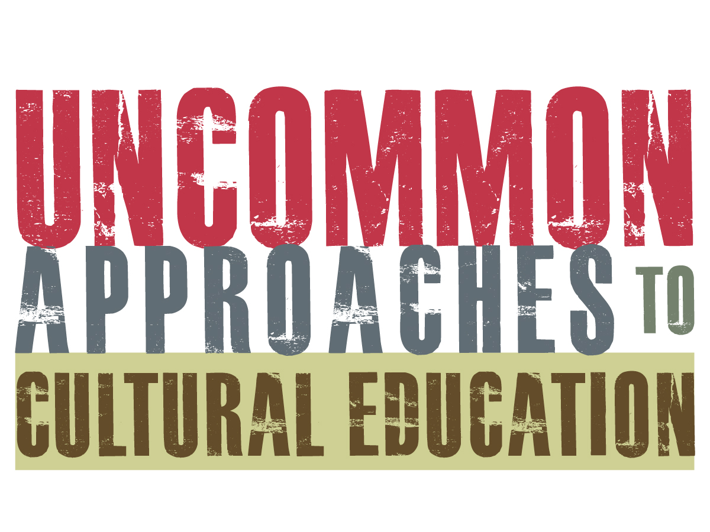

Please join us at these FREE workshops for classroom teachers; school, public and academic librarians; public historians; museum, archive and historic site staff; and representatives from public television, performing arts and other cultural organizations. The goal is to share our resources and effectively support learning in and out of the classroom.

Workshops will begin at 8:30 AM and end at 3:30 PM. Refreshments and lunch are included. For more information and to register: http://www.manyonline.org/uncommon-approaches or call 518-273-3400.

October 14, 2016 at the Everson Museum of Art, Syracuse
- Stephanie Hazzard, Baseball Hall of Fame
- Carol Yost, Memorial Art Gallery
- Andy Kitzmann, Erie Canalway National Heritage Corridor
- Rebecca Taylor, American Museum of Natural History
- Amy Hufnagel, The Olana Partnership

October 19, 2016 at the Corning Museum of Glass, Corning
- Kelli Huggins, Chemung County Historical Society
- Christine Ridarsky, Rochester Public Library
- Andrea Decker, Roberson Museum and Science Center
- Mary Mix, The Rockwell Museum

October 27, 2016 at the Hofstra University Museum, Hempstead
- Aimee Terzulli & Jeanmarie Walsh-Manfield, Long Island Children's Museum
- Mirium Bader, Lower East Side Tenement Museum
- Jonathan Boulware, South Street Seaport Museum
- Jenny Hutchinson, The Hyde Collection

November 3, 2016 at the Theodore Roosevelt Inaugural National Historic Site, Buffalo
- Mark Lozzo, Theodore Roosevelt Inaugural Site
- Karen Wallace, Buffalo Museum of Science
- Patrick Stenshorn, Albany Institute of History & Art
- Jennifer Haines, Genesee Country Village & Museum

November 15, 2016 at the New York State Museum, Albany
- Jonathan Boulware, South Street Seaport Museum
- Patrick Murphy, The Wild Center
- Andy Kitzmann, Erie Canalway National Heritage Corridor
- Samantha Saladino, Shaker Heritage Society, Cindy Dickinson, Hancock Shaker Village,
Dr. Jennifer Dorsey, Siena College
- Mia Nagawieki, New York Historical Society

