THANKSGIVING PROJECT
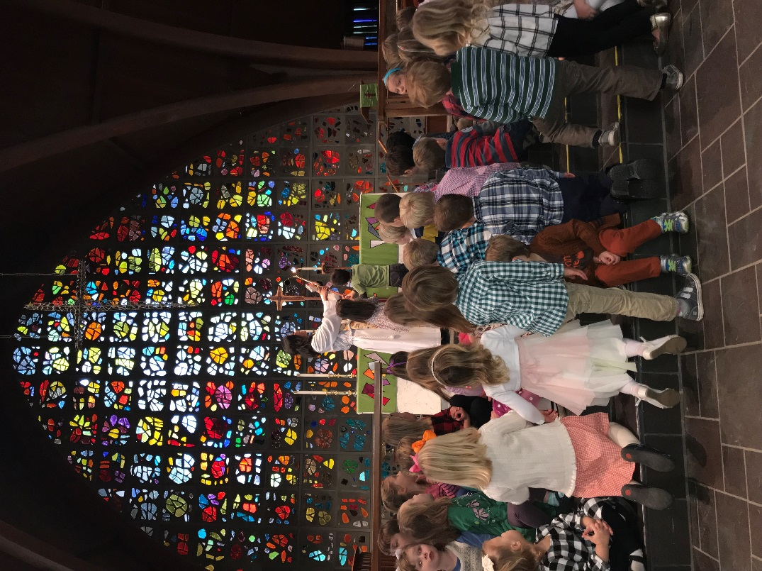
As part of our continued outreach, the Parish Day School children are asked to bring a special food item, as indicated below, to our Thanksgiving service on Tuesday, November 21 at 9:15 am. The food collected will be distributed to the Govans’ CARES Food Pantry. The meaning of the donation will be discussed in light of the Thanksgiving holiday. If you are unable to donate the assigned item, any non-perishable, canned or boxed food will be gratefully accepted.
2s | Boxed Biscuit/Muffin/Pie/Corn Bread Mix
Hooper 3 Day 3s | Canned/Boxed Gravy and/or Cream of Mushroom Soup
Libby 5 Day 3s | Canned Pumpkin
Loeb Pre-k | Instant Mashed Potato
Arrup Pre-k | Box/Bag Stuffing Mix
Kindergarten | Canned Vegetable- green beans, corn, sweet potato,
Pre-first | Canned Cranberry Sauce

