Farm to Table Expo Vendors March 7 – 16, 2025
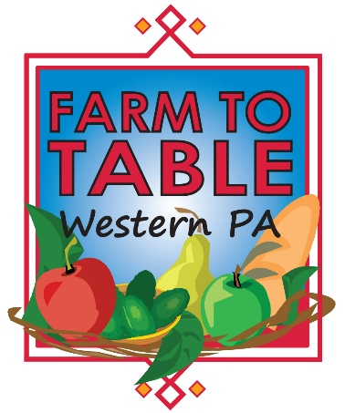
Pittsburgh Home & Garden Show

1:11 Juice Bar Variety of bottled 100% natural and raw cold-pressed juices.
5 Generation Bakers Jenny Lee breads & cake mixes
Anar Gourmet Foods Indian seasoning kits
BBQ Stus Barbecue sauces
Blackberry Meadows Farm Pork
Capricious Goats Baby goat snuggling. Goat milk products for sale.
Cherish Creamery Goat milk cheeses
Cherry Valley Organics USDA certified organic herbal teas, edible flowers, herb infused products
Coyne Family Farm Beef, pork, chicken, eggs
Farm Bureau Agricultural Trailer PA Farms to Families Immersion Lab

Footprints Farm Chicken, pork, beef
Forever Green Family Farm LLC Soup blends - gluten free
Goodnights Bison Bison meat
Hammajack Foods LLC Hot sauce
Highland Homestead Farm Beef, pork, poultry
Huckle Bee Farms Honey & teas
Inside Out Cookie Cookies
Keystone Cultures Co. Fermented Kombucha
Kizzle Foods Spices, Date Syrup, ZOBO Herbal Energy
Lancaster Trading House, Inc. Hempzel sourdough pretzels, mustard seed
Lemmon Bros Farms Maple syrup
Lettuce Ladies LLC Lettuce, microgreens, salad mix
Maestro Chef's Products Gourmet spices & seasoned flour
Olive Tap Olive oils & vinegars
Rent the Chicken Hatching chicks, Chicken Coop, Chicken Races
Searchlight Brand Strategies Locally made salsas & Locally roasted coffee & nuts
Setas Mushrooms Mushrooms - dried & growing kits
Sunny Slope Farms salsa, pickles, canned products, honey, jam, puffed grains
The Kefir Chicks Water Kefir, Beet Kvass, Kits
Uglie Acres Jams, jellies, fruit butters, BBQ sauce, toffee, fudge, peanut brittle
Uncle Jammys BBQ BBQ sauces & seasonings

