Where to Turn Resource Fair,
sponsored by Farm to Table Buy Local, 501c3
Duquesne Univ. Power Center Ballroom, Tues., June 17 & Tues., Sept 9, 2025, 9 am – 1 pm
Event Contact: Erin Hart, ehart@american-healthcare.net, 412-657-3028

Event brings together social service, education, healthcare, transportation and food resource & nutrition professionals to find Community Resources available in Southwestern PA. 40 vendors and 350 – 400 attendees will enjoy speakers, vendors & lunch.

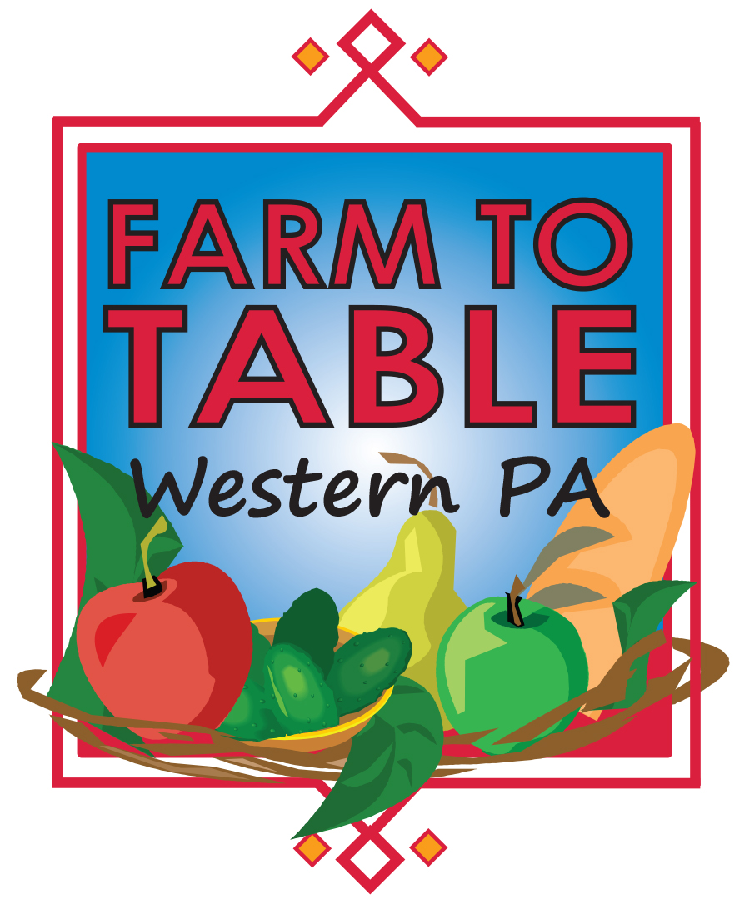

Pay by Check: Checks payable to: Farm to Table Buy Local, 305 Mt. Lebanon Blvd, Suite 215, Pittsburgh, PA 15234
Pay with Credit:  Credit will be processed under the name Farm to Table Buy Local. Your credit card bill will reflect this. | Credit Card Type: | Visa MasterCard American Express
 | Card Number: |  | Exp Date:
 | Name on card & Security Code:
SIGN HERE: ___________________________________________________________ DATE:______________________

Company: |  |  |  |  |  | Contact Name:
Address: |  |  |  |  |  | City/State/Zip:
Phone#: |  |  |  | Fax#: |  | Email:
# of tables |  | # of chairs: |  |  | Electricity? Yes No
Description of Table Presentation
Payment is due when you submit this contract.
Email to ehart@american-healthcare.net or Fax: 940-745-2723
Lunch & Hospitality Sponsor - $5,000
- Customized Exhibit space
- Inclusion in all on-site event announcements
- Full page ad in program
- Name and logo on event website
- Inclusion in event promotions

Exhibitor/Sponsor Fees ______

Ad Fee __________

Electricity ($175) __________

Extra Tables ($400 each) __________

Total __________

Program Advertising
Full page: $1,000
Half page: $500

Exhibit Table - $400 per event
Registration includes:
- 1 exhibit table
- Name in program

Event Sponsor - $1,500
- Customized Exhibit space
- Full page ad in program
- Name and logo on event website
- Inclusion in event promotions

Submit Logo with agreement!
SPONSORSHIP and EXHIBITOR LEVELS
BASIC INFORMATION – This will appear in the event program.
PAYMENT INFORMATION

