AAPD Suggested Comment Templates
In Response to the EPA’s Review of Science on Fluoride in Drinking Water: Preliminary Assessment Plan and Literature Survey (Assessment Plan)
Docket No. EPA-HQ-OW-2025-3823
These suggested templates were developed by the American Academy of Pediatric Dentistry (AAPD).
Choose one of the 4 messages below and personalize with your info.
All comments must be submitted to the Federal Register by 11:59pm EST on Friday, February 27, 2026. Please reach out to the AAPD Research & Policy Center (rpc@aapd.org) with any questions you have.
Once you submit comments using this as a guide, please share the Comment Tracking Number with AAPD after your submission (rpc@aapd.org).

Instructions for Submitting a Comment on Regulations.gov
Step |  | Action | Image Description Actions circled in red with star
1 |  | Open the docket here and click “Open for Comments” | 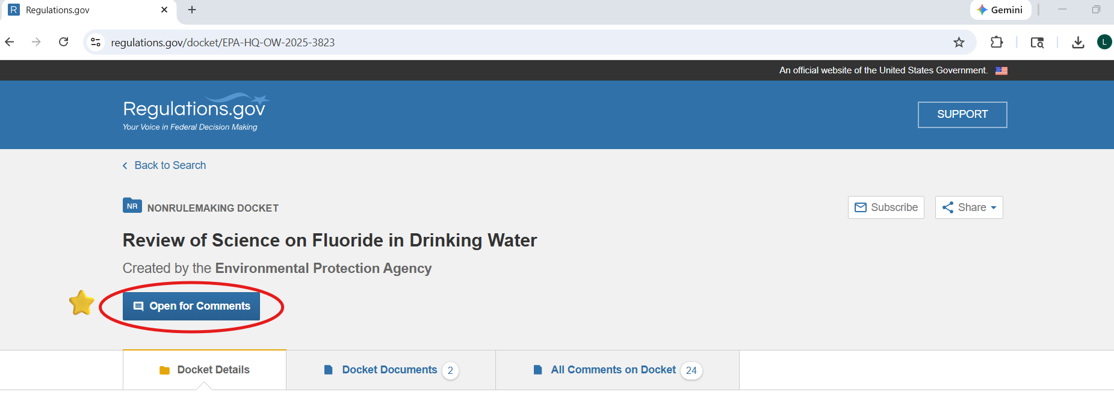
2 |  | On the second tab Docket Documents click on “Comment” | 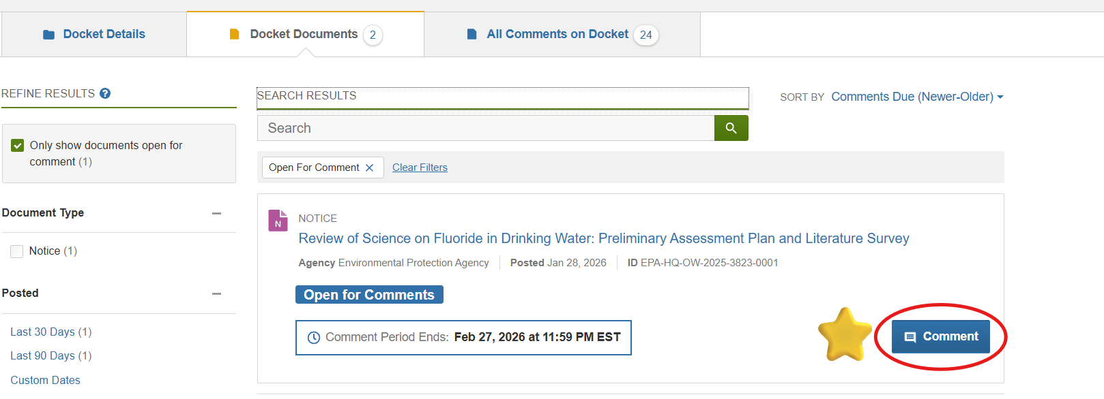
3 |  | Follow the instructions for uploading your comments and entering other required information.  Organizations: We recommend uploading a PDF on your organization’s letterhead. In the mandatory “Comment” textbox, simply state, “Please see attached from the [org].”  Individuals: Feel free to use comment box if easiest. | 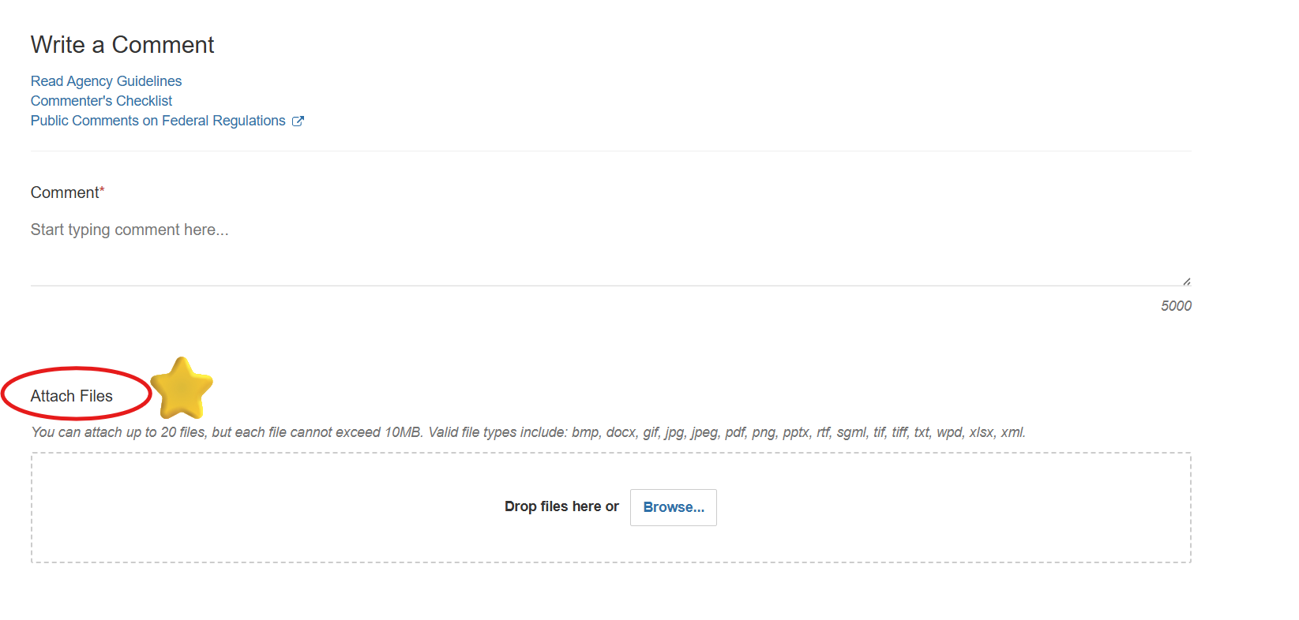
4 |  | Once you submit your comment, you will be provided with a Comment Tracking Number.  If you used any of the template material, we ask that you please provide your tracking number to RPC at rpc@aapd.org. | 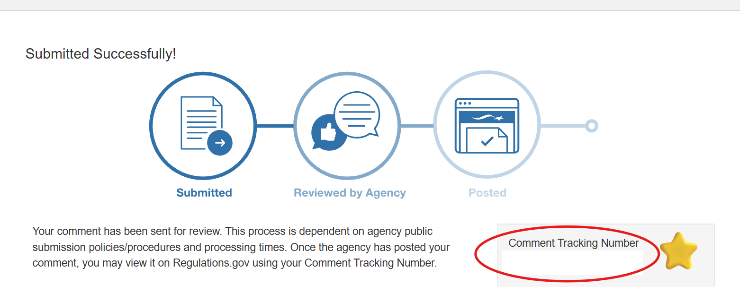

Message 1: Focus on State’s Economy
Core Message: Community water fluoridation is not just a health issue. It is a fiscal issue affecting Medicaid budgets, school performance, and workforce productivity.

I am a member of the California Society of Pediatric dentistry (CSPD) champions children’s health, and as pediatric dentists, we specifically advocate for children’s optimal oral health. I applaud steps the current administration has taken to reduce sugar intake and focus on reducing chronic disease – like dental caries (cavities) – for all children in America. However, I am highly concerned about the EPA’s Fluoride Preliminary Assessment Plan and Literature Survey (Assessment Plan) that will inform the Fluoride Human Health Toxicity Assessment (Toxicity Assessment) (Docket No. EPA-HQ-OW-2025-3823).

As pediatric dentists, we understand that too much fluoride – in amounts far above the US-recommended levels – can be toxic to children, which is exactly why we advocate for safe, effective usage of fluoride to prevent cavities and tooth decay in children. Current community water fluoridation levels in California is 0.7 to 1.2 mg/L (ppm). Fluoridated water at an appropriate level has the benefit of frequent, low-dose fluoride exposure that acts both systemically and topically to safely prevent tooth decay. In the US, we have been safely fluoridating water for this reason for 80 years. The safety profile of fluoridated water at the levels used in the United States (0.7ppm) is well established. The benefits of community water fluoridation include reductions in pain from tooth decay and the elimination of missed school days from dental pain. [Add any additional benefits comments.]

In addition to the well-established benefits of fluoride for children’s oral health, community water fluoridation also provides significant economic and social benefits to our communities and state. A recent study examining the impact of a potential water fluoridation ban in five states found that such a ban would result in more than 132,000 additional children needing cavities filled or teeth extracted, costing state Medicaid programs in these five states an estimated $40 million within just three years. California cannot afford increased Medicaid spending driven by preventable oral disease, particularly when community water fluoridation remains one of the most cost-effective public health interventions available. In fact, another recent analysis found that eliminating community water fluoridation would be associated with an increase in tooth decay among children and cost the overall U.S. healthcare system $9.8 billion over 5 years.

The impact of the EPA’s decision will extend beyond the dental chair: children experiencing tooth decay and dental pain are three times more likely to miss school and four times more likely to earn lower grades. These are outcomes that children in California cannot afford. Oral health directly affects academic performance, quality of life, and long-term workforce opportunities. Additionally, parents and caregivers of children with oral pain or unplanned dental visits reported missing 38.5 million work hours in 2023, underscoring how preventable dental cavities lead to lost wages, reduced productivity, and increased strain on families and the broader economy.

The EPA Assessment Plan currently points toward a de-fluoridation of water supplies that would undoubtedly lead to a surge in dental caries and healthcare costs. Therefore, I ask that the EPA clearly state that any derived reference dose for fluoride is simply a threshold to avoid adverse effects and does not negate the well-documented caries-prevention benefits and safety profile at recommended levels.

Thank you for the opportunity to provide comments.

Sincerely,

[your name]

Message 2: EPA Plan Relies on Flawed NTP Report
Core Message: The NTP report draws conclusions that are not applicable to safe water fluoridation practices in the US and gravely distorts the danger of fluoride. The EPA uses this report as “well-established” science for justifying its claims about the associations between fluoride and neurocognitive development.

I am a member of the California Society of Pediatric dentistry (CSPD) champions children’s health, and as pediatric dentists, we specifically advocate for children’s optimal oral health.

I am concerned over the heavy reliance of EPA’s Fluoride Toxicity Assessment Plan on the NTP Monograph on Fluoride and Neurocognition (NTP report). The EPA Assessment Plan states that neurodevelopmental effects are a “well-established” hazard. This wording is derived from the NTP report which examined fluoride levels higher than the typical US recommended levels of 0.7mg/L. It is both erroneous and misleading to state that there are “well-established” hazards of a chemical based on a report that examines levels of the chemical that exceed the national norm. In fact, the NTP report only found an association with fluoride levels greater than 1.5 mg/L as occurs naturally in countries like China and India. In its Assessment, I urge the EPA to stratify neurodevelopmental evidence by exposure level and prioritize US relevant exposures (≤1.5 mg/L, particularly ~0.7 mg/L).

The NTP report – upon which this EPA Assessment is relying heavily – failed peer review by the National Academies of Sciences, Engineering, and Medicine (NASEM) multiple times in 2020 and 2021. It was released without reflecting the necessary changes outlined by NASEM. The NTP authors explicitly acknowledge major limitations in their report, including that most underlying studies were low quality and carried a high risk of bias. They further caution that the findings should not be used to develop a dose-response analysis. Yet the EPA now suggests relying on these findings to inform its toxicity assessment – a move that contradicts the authors’ own recommendations and is inconsistent with principles of rigorous Gold Standard Science.

I strongly urge the EPA to allow NASEM to review and provide feedback on its Assessment Plan and Toxicity Assessment prior to release or use for any policy change.

Thank you for the opportunity to provide comments.

Sincerely,

[your name]

Message 3: Bias and lack of transparency
Core message: Major public health and policy decisions require transparency, interagency collaboration, and true subject matter expertise.

I am a member of the California Society of Pediatric dentistry (CSPD) champions children’s health, and as pediatric dentists, we specifically advocate for children’s optimal oral health.

I urge the EPA to engage its other relevant divisions and departments beyond the Office of Ground Water and Drinking Water in this process, as well as oral health officers at other agencies throughout the federal government. I understand that the EPA Office of Research and Development was responsible for conducting research, but the office was eliminated in 2025, and its experts are no longer engaged in this assessment effort. While I understand many employees were moved to other positions, including in the Office of Water, I remain concerned about the lack of infrastructure for conducting thorough and accurate scientific research on critical health initiatives. I ask that the EPA include its Office of Applied Science and Environmental Solutions (OASES) and their Children’s Health Protection Division in this Assessment Plan and Toxicity Assessment to ensure proper research protocol and ample expertise in children’s health.

Since there are significant health repercussions the Toxicity Assessment could impact, I am also concerned by the lack of consultation with other federal oral health and research professionals on this review. For example, the report states that the EPA will work with the CDC, but since the CDC Division of Oral Health was eliminated last spring, I do not foresee how that collaboration will be possible. The “Gold Science Standard” requires complete analysis and feedback from experts in dental health and otherwise and a transparent approach toward conducting the research. I ask that the EPA publish a complete, transparent systematic review protocol for public comment and engage health and research professionals in the review process.

Thank you for the opportunity to provide comments.

Sincerely,

[your name]

Message 4: Methodological flaws
Core message: Flaws in methodology, specifically the literature search, need to be reexamined to be in accordance with Gold Standard Science.

I am concerned with methodologic flaws of this EPA Assessment Plan that are not consistent with Executive Order 14303 on Gold Standard Science.

I am a member of the California Society of Pediatric dentistry (CSPD) champions children’s health, and as pediatric dentists, we specifically advocate for children’s optimal oral health.

The EPA Assessment Plan lacks clarity on its literature search parameters. The end date was noted as 2024, but the EPA goes go on to subjectively use and reference a limited number and sometimes controversial reports, while excluding other reports including thorough studies from 2025 (Warren et al 2025 and others). This is especially vexing when I consider the EPA’s use of sophisticated AI tools and software that would make it simple to update this timeframe. In accordance with Gold Standard Science and its principles on timeliness and comprehensiveness, the EPA’s search should be updated to include peer-reviewed publications from 2025 and early 2026 prior to moving forward with the Toxicity Assessment. I also request that the EPA provide rationale for inclusion of one paper from 2025 and the exclusion of other 2025 papers in the literature search.

Other methodology flaws in the Assessment Plan include the unclear definition and criteria consideration for exposure metrics, like measuring human fluoride levels via urine or blood, across all studies. This discrepancy could heavily influence the findings and conclusions due to the wide-ranging utility and reliability of fluoride exposure measurement.

Finally, the Assessment Plan suggests in some areas that the Toxicity Assessment has already been completed even though it is stated in other areas that the EPA will consider the public comments submitted by February 27 when developing the Systematic Review Protocol for the Toxicity Assessment. I am concerned about the lack of transparency which is needed for Gold Standard Science. The EPA must not complete the Toxicity Assessment without external review or comments. I urge the EPA to publish the complete Systematic Review Protocol for public comment to be in line with the Administration’s guidance on Gold Standard Science, which emphasizes transparency and peer review throughout the entire research process, not solely at the end.

I ask that the EPA address these concerns with the methodology by 1) updating the literature search through 2025 and early 2026, and 2) publishing a full systematic review protocol for public comment before reviewing and completing the Toxicity Assessment.

Thank you for the opportunity to provide comments.

Sincerely,

[name]

