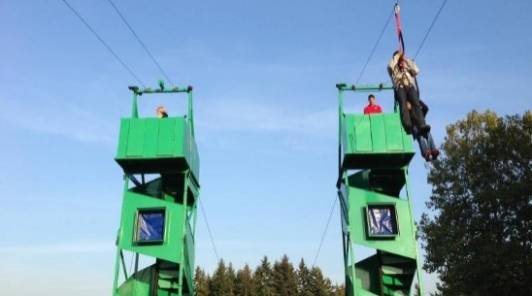
Spring Festival
Early bird pricing and details!

Date: March 30, 2019
Time: 4:00 p.m. – 8:00 p.m.
Where: 14100 North 32nd Street Phoenix, AZ 85032
What: Great Hearts North Phoenix -Archway and Prep Spring Festival
Who: Open to the Entire Great Hearts North Phoenix community, family and friends

Wristband Attractions/Pricing include:
Zipline, Laser Tag Maze, Defender Dome Dodge Ball, Human Foosball, 26' Climbing Mountain, Obstacle Courses, Human Demolition Zone, 24' Slide, Playlands and Bouncers, Face Painting, Carnival Games
PRESALE: $15 per student or $45 per family with 3 or more children
After March 24: $20 per student or $60 per family with 3 or more children
* Children 4 and under admitted free with paid sibling
Adult Zipline pass $5.00
Ticket Attractions/Pricing:
Dunk Tank, Raffle Baskets, Cake Walk, Teacher Battle Demolition Zone
PRESALE: 25 for $20.00
After March 24: $2.00 each
Additional Attractions: We will have 6-7 food trucks and our junior NPX class will be selling water, popcorn, ice cream, NPX Senate will be selling T-shirts and stickers
*You can pay online at Tinyurl.com/ghfestus or turn in this form with payment in sealed envelope to the front office in the designated North Phoenix Prep PSO Box
Include Cash/Check with this form to avoid online fees and increased pricing after March 24, 2019
*Make checks payable to NPX PSO
Name: ________________________________________________________________
Email address/Phone: ________________________________________________________________
Name of Student: ________________________________________________________________
#of Wristbands: ________________________________________________________________
# of Tickets (Groups of 25): ________________________________________________________________
# of Adult Zipline Bands: _____________________________________________________________
Prep students may pick-up the ticket order from the Office Manager, Ms. DeSilva beginning 3/26/2019

