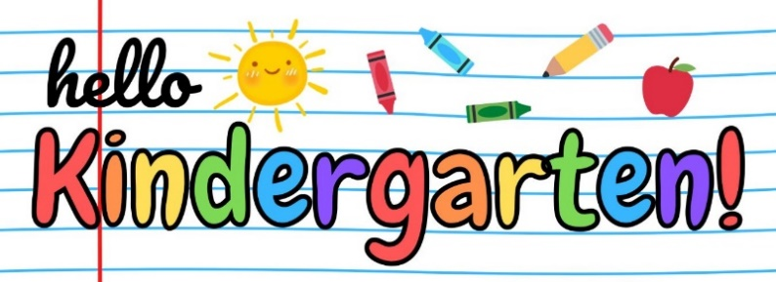

**2025-2026 Kindergarten Registration is now open for many School Districts in Montgomery County!**

**Please share this resource with your families.**

**Abington School District**

Registration: Now Open Online

Phone: 267-715-4233

Email: [k5registration@abington.k12.pa.us](mailto:k5registration@abington.k12.pa.us)

Website: [Abington School District](https://www.abingtonsd.org/o/abington/page/kindergarten-registration?fbclid=IwAR3iPiCNRqWpp_IGMGdW9KClMP2pVWkECesNW9RSKAAaYiBIQ3X2CU4pFJE)

**Boyertown School District**

Registration: Now Open In-Person

Phone: 610-367-6031 ext. 7

Email: [basdregistration@boyertownasd.org](mailto:basdregistration@boyertownasd.org)

Website: [Boyertown School District](https://www.boyertownasd.org/Page/6517)

**Cheltenham School District**

Registration: Online 3/3/2025 - 3/27/2025

Phone: 215-881-6322

Email: [tgray@cheltenham.org](mailto:tgray@cheltenham.org)

Website: [Cheltenham School District](https://www.cheltenham.org/departments/student-services/student-registration)

**Colonial School District**

Registration: Now Open Online

Phone: 610-834-1670 ext. 2150

Email: [lciccolone@colonialsd.org](mailto:lciccolone@colonialsd.org)

Website: [Colonial School District](https://www.colonialsd.org/departments/central-registration)

**Hatboro-Horsham School District**

Registration: Now Open Online

Phone: 215-420-5031

Email: [registration@hatboro-horsham.org](mailto:registration@hatboro-horsham.org)

Website: [Hatboro-Horsham School District](https://hatborohorshamsdpa.sites.thrillshare.com/page/enrollment-student-registration)

**Jenkintown School District**

Registration: Now Open Online

Phone: 215-885-3722 ext. 110

Email: [reedk@jtowndrakes.org](mailto:reedk@jtowndrakes.org)

Website: [Jenkintown School District](https://www.jenkintowndrakes.org/about-us/central-registration/)

**Lower Merion School District**

Registration: Now Open Online

Phone: 610-658-3996

Email: [registration@lmsd.org](mailto:registration@lmsd.org)

Website: [Lower Merion School District](https://www.lmsd.org/departments/student-services/registration)

**Lower Moreland School District**

Registration: Online appts. April 22-24

Phone: 215-938-0290 ext. 6201

Email: [carchutowski@lmtsd.org](mailto:carchutowski@lmtsd.org)

Website: [Lower Moreland School District](https://www.lmtsd.org/about-us/kindergarten-registration)

**Methacton School District**

Registration: Now Open Online

Phone: 610-489-5000 ext. 15034

Email: [information@methacton.org](mailto:information@methacton.org)

Website: [Methacton School District](https://www.methacton.org/kindergartenregistration)

**Norristown School District**

Registration: Now Open Online

Phone: 610-630-5001

Email: [registrar@nasd.k12.pa.us](mailto:registrar@nasd.k12.pa.us)

Website: [Norristown School District](https://www.nasd.k12.pa.us/page/student-registration)

**Springford School District**

Registration begins in March online

Phone: 610-705-6000

Email: [ncast@spring-ford.net](mailto:ncast@spring-ford.net)

Website: [Springford Area School District](https://www.spring-ford.net/parents/registration)

**Upper Dublin School District**

Registration: Now Open Online

Phone: 215-643-8971

Email: [registration@udsd.org](mailto:registration@udsd.org)

Website: [Upper Dublin School District](https://www.udsd.org/page/registration)

**Upper Merion School District**

Registration: Now Open Online

Phone: 610-205-8861

Email: [registration@umasd.org](mailto:registration@umasd.org)

Website: [Upper Merion School District](https://www.umasd.org/registration)

**Upper Moreland School District**

Registration: Now Open Online

Phone: 215-830-1514

Email: [ddaniels@umtsd.org](mailto:ddaniels@umtsd.org)

Website: [Upper Moreland School District](https://www.umtsd.org/page/registering-your-child-in-um)

**Upper Perkiomen School District**

Registration: Now Open Online

Phone: 215-541-2443

Email: [jmalone@upsd.org](mailto:jmalone@upsd.org)

Website: [Upper Perkiomen School District](https://www.upsd.org/departments/student-registration/kindergarten-welcome)

**Wissahickon School District**

Registration: Open Online 1/22 – 3/7/2025

Phone: 215-619-8000 ext. 1408

Email: [registrar@wsdweb.org](mailto:registrar@wsdweb.org)

Website: [Wissahickon School District](https://www.wsdweb.org/departments/registration/kindergarten-registration)

**North Penn School District**

Registration: Now Open Online

Phone: 215-853-1086

Email: [mckennmr@npenn.org](mailto:mckennmr@npenn.org)

Website: [North Penn School District](https://www.npenn.org/for_families/registration_information)

**Perkiomen Valley School District**

Registration: Now Open Online

Phone: 610-489-8506

Email: [registrar@pvsd.org](mailto:registrar@pvsd.org)

Website: [Perkiomen Valley School District](https://www.pvsd.org/families/new-student-registration/)

**Pottsgrove School District**

Registration: Now Open Online

Phone: 610-327-2277 ext 1045

Email: [studentregistration@pgsd.org](mailto:studentregistration@pgsd.org)

Website: [Pottsgrove School District](https://www.pgsd.org/resources/registration)

**Pottstown School District**

Registration begins in March online

Phone: 610-970-6621

Email: [ddurantehayward@pottstownk12.org](mailto:ddurantehayward@pottstownk12.org)

Website: [Pottstown School District](https://www.pottstownschools.org/StudentRegistration.aspx)

**Souderton School District**

Registration begins in March online

Phone: 215-723-6061 ext 10227

Email: [dderstine@soudertonsd.org](mailto:dderstine@soudertonsd.org)

Website: [Souderton School District](https://www.soudertonsd.org/students-families/enroll/kindergarten-registration)

**Springfield Township School District**

Registration: Now Open Online

Phone: 215-233-6000 ext 1015

Email: [patricia_carney@sdst.org](mailto:patricia_carney@sdst.org)

Website: [Springfield Township School District](https://www.sdst.org/about-us/kindergarten-registration)

Early Learning Resource Center (ELRC) Region 17 provides a single point-of-contact for Montgomery County families, early learning service providers, and community members looking to gain information and access services that support high-quality child care and early learning programs. Call our office or email [ELRCRegion17@pa.gov](mailto:ELRCRegion17@pa.gov) to learn more about before and after care programs, summer camps, subsidized child care, Keystone STARS, and more!