Support Our Annual Ethical Trade Sale

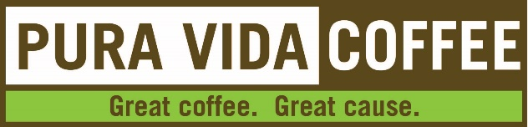
Coffee Order Form

Your Name:
Email Address:
Phone Number(s):
Coffee Choices | Whole Bean or Ground? | Quantity
French Roast | Choose an item. | Click here to enter text.
Sombra | Choose an item. | Click here to enter text.
Café Kilimanjaro | Choose an item. | Click here to enter text.
House Blend | Choose an item. | Click here to enter text.
Decaf House Blend | Choose an item. | Click here to enter text.
Ethiopian Sidamo | Choose an item. | Click here to enter text.
Coffee choices are listed from darker to lighter roast. For more information about the coffee, go to https://www.puravidacreategood.com/about-our-beans.

Each 12 oz bag of coffee is $10.
Note: $4 per bag will go directly to Our Lady of Guadalupe Parish.
Return this completed order form to Erin Pedras at erinpedras@centurylink.net. You can also print the order form and return to the parish office (mail slot next to door) with cash or check payable to OLG. Forms due by Monday, November 30th.

Pick up your coffee at the OLG north parking lot on Saturday, December 12, 11am – 3pm.

