1

How to Enroll in an
Open Learning Non-Credit Course

*Please use Google Chrome or Firefox (courses do not load properly in Internet Explorer or Safari).

- Go to mostcenter.umd.edu/courses, and select a course from the Course Catalog.
- OR -
Click on the following link to be directed to the Office of Extended Studies sub catalog within the Open Learning catalog, and select a course.

- Click the blue “Enroll” button and then follow the instructions below for Non-UMD Students. (Please note these instructions are for first-time users of Open Catalog without an existing UMD account. If you have a UMD e-mail address or an existing UMD Associates account, please sign into Open Learning using your credentials, select a course, and click the blue “Enroll in Course” button. The course should then appear in your Student Dashboard.)

For Non-UMD Students:

  - Click the “Create an Associate Account” link to create an Associate Account.
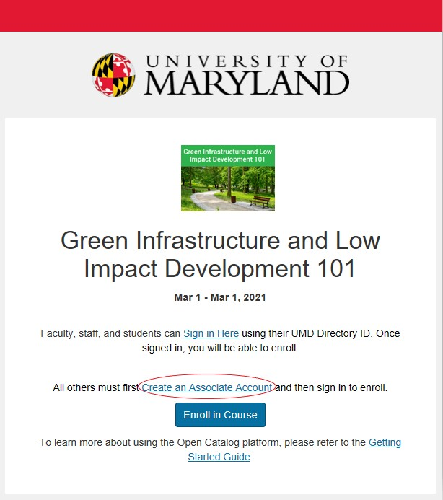

2

  - Once selected, you will be directed to the Associate Account Registration page. It will look like the image below:
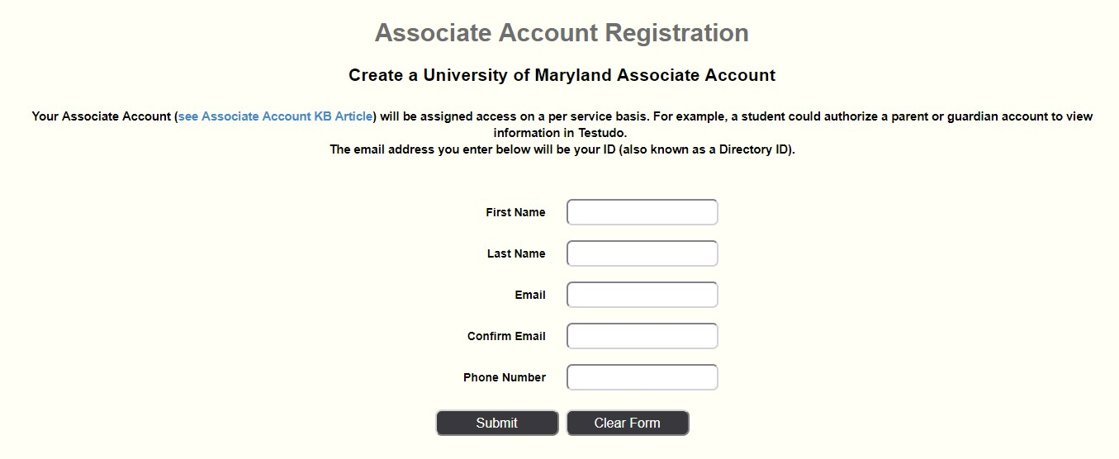
  - Complete the Associate Account Registration information then click the “Submit” button.

  - On the next page, will confirm your login ID. See the image below. Change the Drop-down to “Yes” and then click “Accept.”
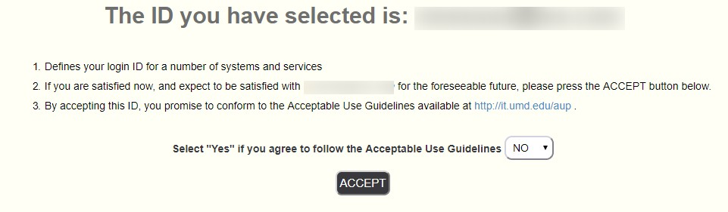

3

  - After you click “Accept,” you will receive an email stating that you have created an Associate Account. It will look like the image below. Click the link in the email.
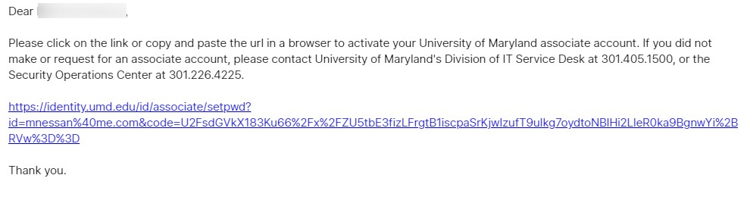
  - After you click the link in the email, you will be directed to a new screen where you will be able to create a password. It will look like the image below. Create a password according to the Password Requirements listed on the right side of the page, then click Update Password.
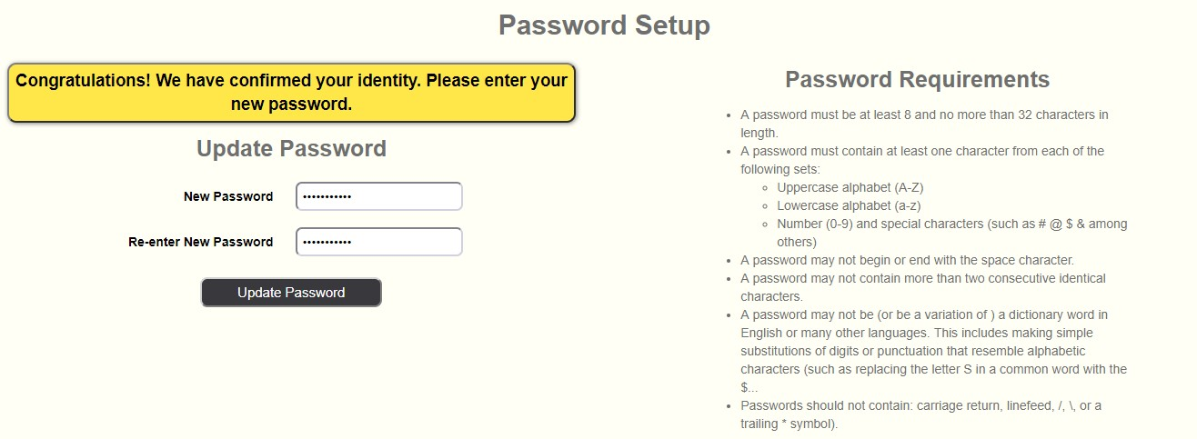
  - Return to the course listing and click the blue “Enroll” button.

4

  - On the following page, click “Sign in Here.” Login using your email and the password you created. If payment is required, you will then be directed to a screen that looks like the image below. If payment is not required, skip to step 12.
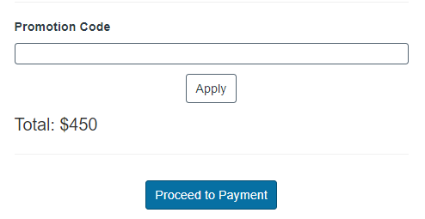
  - Enter the promotion code if one has been provided.

  - Click “Apply” to apply the promotion code. The total due should update. Now click “Proceed to Payment” to be directed to a secure payment page.

  - Enter your payment information and click “Pay Now.”

  - You are now enrolled in the course. You will receive an e-mail confirming
your enrollment. To access your course, click the link in the email you received. Be sure to save the link as a bookmark so you can access the course information as needed.

  - After you are enrolled in a course, if you want to access the course at a later time, log into your Open Learning account. Click your name in the top right corner of the screen, and select "Student Dashboard" from the dropdown menu to resume the course.

