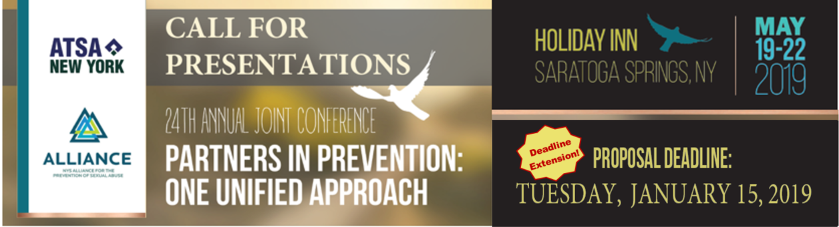
Dear Friends and Colleagues,

NYS ATSA and NYS Alliance are pleased to announce the annual call for papers for the 24th Annual Joint Conference, Partners in Prevention: One Unified Approach. Our 2019 conference will be held May 19-22 at the Holiday Inn Saratoga in Saratoga Springs, NY.

The NYS ATSA/NYS Alliance Conference provides an opportunity for participants to examine creative collaborations, services involving shared leadership and resources, as well as prevention, supervision, and treatment programs that reflect emerging best practices. The Conference provides attendees access to leaders in the field of sex offense specific treatment, supervision, assessment, management, prevention, and victim advocacy. We are certain that all will benefit from this opportunity to share, learn, and strategize with others dedicated to the shared mission to address and eliminate sexual abuse in New York State.

We are seeking presenters for the dates of May 21st & 22nd to reflect our conference theme and encourage submissions from victim advocates, medical professionals, researchers, lawyers (prosecutors and defense counsel), law enforcement (parole, probation, state police, federal and local police, etc.), CAC's, child protection agencies, and treatment providers. We encourage all individuals/groups working to reduce sexual violence to submit a presentation to ensure your important efforts and innovative approaches can be shared across the state.
Appropriate workshop topics include issues related to:
- Adult, Youth, and Family Specific Interventions
- Abuse Prevention Efforts and Projects
- Innovative Models of Community Collaboration
- Emerging Research
- Community Supervision and Management Practices
- Specialty Service Groups
- Practical Applications of Empirical Research
- Legal Issues and Court Practice
- Criminal Justice innovations to prevent sexual violence
- Legislation related to sex offense specific management

We welcome both poster and workshop proposals. Please review the following information and submit a complete proposal. Incomplete submissions may not be considered.

Proposals may be sent to: conference@nysalliance.com (one PDF with all information is preferred for digital submissions.) or NYSATSA/Alliance Conference, Attn: Ashley Fuller, P.O. Box 723, Sherburne, NY 13460. Submissions must be postmarked by January 15, 2019.

Anyone may submit a proposal to the NYS ATSA/ NYS Alliance Conference Committee. The information to follow will help you submit a complete and thorough proposal. Please take the time to read each item before completing the proposal form. Due to state CEU requirements, all submissions MUST include all requested information to be considered. You must submit one form per workshop submission.

- Types of Programs:
  - Workshops (90 minutes): Workshop/interactive format; didactic overview with experiential exercises, demonstration, group work, etc. expected; handouts strongly recommended.

  - Poster Sessions: Informal group discussions around a table exposing topics germane to participants. May be submitted individually or as a group of three related presentations. Posters offer the opportunity to present data and have substantive discussions with interested colleagues. The audience circulates among the posters, stopping to discuss papers of particular interest to them. Authors present their papers using a visual medium with key excerpts from the papers displayed on one side of a standard poster board. It’s a great opportunity for students!!!

- Submission Information: Please be clear and concise in all aspects of your proposal.
  - Complete each item on the proposal form, following the directions provided. The primary presenter is the contact person and responsible for notifying all co-presenters of acceptance, rejection, scheduling and any other info provided by NYS ATSA/ NY Alliance.

  - The Conference Committee will review all programs and decisions will be based on quality, clarity, and relationship to conference theme and content applicability. Deadline for proposal submissions is
January 15, 2019. Notifications of acceptance will be made by March 1, 2019.

  - The identified lead presenter will have their choice of complimentary registration for the day of their presentation or $150 discount off the full conference registration rate. This is not transferrable or applicable to fees for conference events other than registration.

  - Presenters are responsible for all travel, hotel, food and other expenses.

  - Speakers are required to bring their own laptop. LED projectors will be set up in each room. Other AV needs should be specifically outlined in the proposal. Presenters are responsible for all data connection cords used for connecting your personal electronic device/devices (such as MAC laptops) to any equipment we make available to you. Our projectors are all PC compatible. Internet access is available to all presenters free of charge! Please specify below if you will need internet access for your presentation.

  - Presenters are responsible for their own handouts and may request a number of registrants prior to the event.
NYS ATSA/NYS Alliance reserves the right to make available any PowerPoint or other material on our website during and after the event.

  - Workshops will be considered on the basis of their relevance to the conference theme and contribution to the profession. Workshops designed to market any specific vendor or item will not be considered. Vendors are encouraged to speak directly with our conference planners about available sponsorship or exhibition opportunities.

  - We suggest that you print and save a copy of your completed submission form for your records.

Paper/ Workshop Proposal Fact Sheet
Due to state CEU requirements, all submissions MUST include the following supporting information to be considered.

Title of Presentation: ____________________________________________________
Presentation Type (Select One): ( ) Poster ( ) 90 min workshop ( ) Other: __________
Presentation Focus (Check All That Apply): ( ) Adult ( ) Juvenile ( ) Prevention
( ) Treatment/ Management ( ) Research ( ) Other: ____________
Skill Level: ( ) Intro ( ) Intermediate ( ) Advanced
AV Needs: ( ) LCD ( ) Flip chart ( ) TV/ DVD ( ) Speakers ( ) Other: __________

PRIMARY PRESENTER
Name: ________________________________________________
Designations: ___________________________________
(Please include all appropriate degrees, including University, and certifications)
Title and License number: ______________________________________________
Agency: ______________________________________________________________
Address: _____________________________________________________________
City: __________________________ State: ____________ Zip: ____________
Phone: ________________________ Fax: _________________
E-Mail: ___________________________________________________

ADDITIONAL PRESENTERS

Name: ________________________________________________
Designations: ___________________________________
(Please include all appropriate degrees, including University, and certifications)
Title and License number: _______________________________________________
Agency: ______________________________________________________________
Address: _____________________________________________________________
City: __________________________ State: ____________ Zip: _____________
Phone: ________________________ Fax: _________________
E-Mail: ___________________________________________________

Please attach this face sheet to your summary material.

Summary of Presentation
Due to state CEU requirements, all submissions MUST include the following supporting information to be considered.

1. Abstract:
500-700 word abstract of your proposed presentation
2. Topic
a. Focus of presentation
b. How presentation relates to conference topic
c. Identify presentation as adult, juvenile, prevention, clinical, theoretical, researched based, etc.
d. Five (5) current/recent references of published work on the topic for a reading list
3. Bio and Resume or CV for all presenters
A short (4-6 line ONLY) biographical statement and current resume or CV (five pages max) must be included for all presenters.
4. Learning goals
a. THREE (3) measureable learning objectives
b. Two (2) true/false or multiple choice questions participants will be able to answer following your presentation

DEADLINE FOR SUBMISSION: Tuesday, January 15, 2019
Please attach the proposal fact sheet to your supporting information and summary.

Proposals may be submitted to:
conference@nysalliance.com
One PDF with all information is preferred for digital submissions.
or
NYS ATSA/The Alliance Conference
Attn: Ashley Fuller
P.O. Box 723
Sherburne, NY 13460
Submissions must be postmarked by January 15, 2019.

