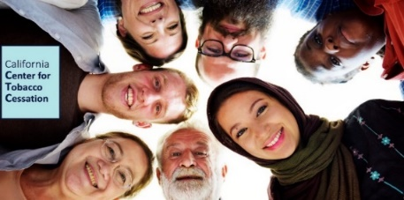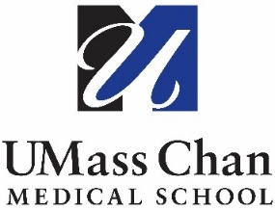

Tobacco Treatment Specialist (TTS) Training for California Providers
November 14-16, 2023
San Francisco, CA

Frequently Asked Questions (FAQ)
Q: Who should take our training?
A: Healthcare providers who have a strong interest in the field of tobacco or provide care to people who use tobacco. This may include physicians, nurse practitioners, physician assistants, nurses, pharmacists, pharmacy technicians, dentists, dental hygienists, dietitians, psychiatrists, psychologists, respiratory therapists, mental health professionals, addiction professionals, counselors, community health workers, doulas, peer specialists, and social workers, among others. The training will prepare providers to deliver effective evidence-based interventions for treating tobacco dependence.
Q: What topics are covered in the training?
A: Part 1:
1. Overview of the Tobacco Problem
2. Tobacco Use Disorder and Physical Health
3. Tobacco Use Disorder and Behavioral Health
4. Describing Tobacco Use Disorder
5. The Biology of Tobacco Use Disorder
6. Psychological Factors and Tobacco Use Disorder
7. Social, Cultural, and Environmental Influences on Tobacco Use Disorder
8. Guidelines for Systems
9. Role of the Tobacco Treatment Specialist and Additional Resources

Part 2:
1. Counseling Skills: Building Rapport with Motivational Interviewing
2. Pharmacotherapy for the Treatment of Tobacco Use Disorder
3. Cognitive and Behavioral Treatment Strategies
4. Intake, Assessment and Treatment Planning
5. TTS Exam and Certificates

Q: What is required to complete the TTS training?
A: TTS Part 1: is a 10-hour asynchronous training that must be completed on one’s own prior to Part 2
TTS Part 2: full attendance and participation in a 3-day training in San Francisco (November 14, 15 and 16, 8:30am - 4:30pm PST)
TTS Part 3: an exam, accessed online via Blackboard that must be completed within 6 weeks of completing Part 2

Participants who pass the final exam (by earning a score of 75% or above) will receive a document of completion that can be used when applying for the National Certificate in Tobacco Treatment Practice.

Q: When is the application period?
A: Applications are available starting Monday, August 28, 2023, and must be submitted by Tuesday, September 12, 2023. Final decisions will be communicated on Tuesday, September 26, 2023.

Q: What does the training cost?
A: The training is valued at $1,300; however, for accepted applicants, the California Center for Tobacco Cessation will provide scholarships to cover the entire fee. Three to five (3-5) travel stipends will be available to those demonstrating financial need.
Q: Does completing the TTS training mean I am certified?
A: No, completing the TTS training means you are a credentialed tobacco treatment specialist, but you are not certified.
Please note this training meets all required education hours and qualifies you to apply for the National Certificate (NCTTP), which is offered and managed by the National Association for Addiction Professionals (NAADAC). Please see ‘Eligibility & Application Requirements’ on this webpage: https://www.naadac.org/NCTTP.
Q: Can I treat tobacco dependence without being certified?
A: Yes.
Q: How do I become a CTTS?
The National Certificate is available through NAADAC. You can apply for your NCTTP after you become a TTS and complete a certain number of hours of clinical experience after training. The number of hours you will need to complete is based on your education level. You will also need to pass a certificate exam. Both an application fee and a testing fee are required.
For more information on earning your NCTTP, visit https://www.naadac.org/NCTTP
For training questions, contact Jessica Safier, at Jessica.Safier@ucsf.edu or call toll-free (877) 509-3786.

CaCTC is funded by the California Tobacco Prevention Program

