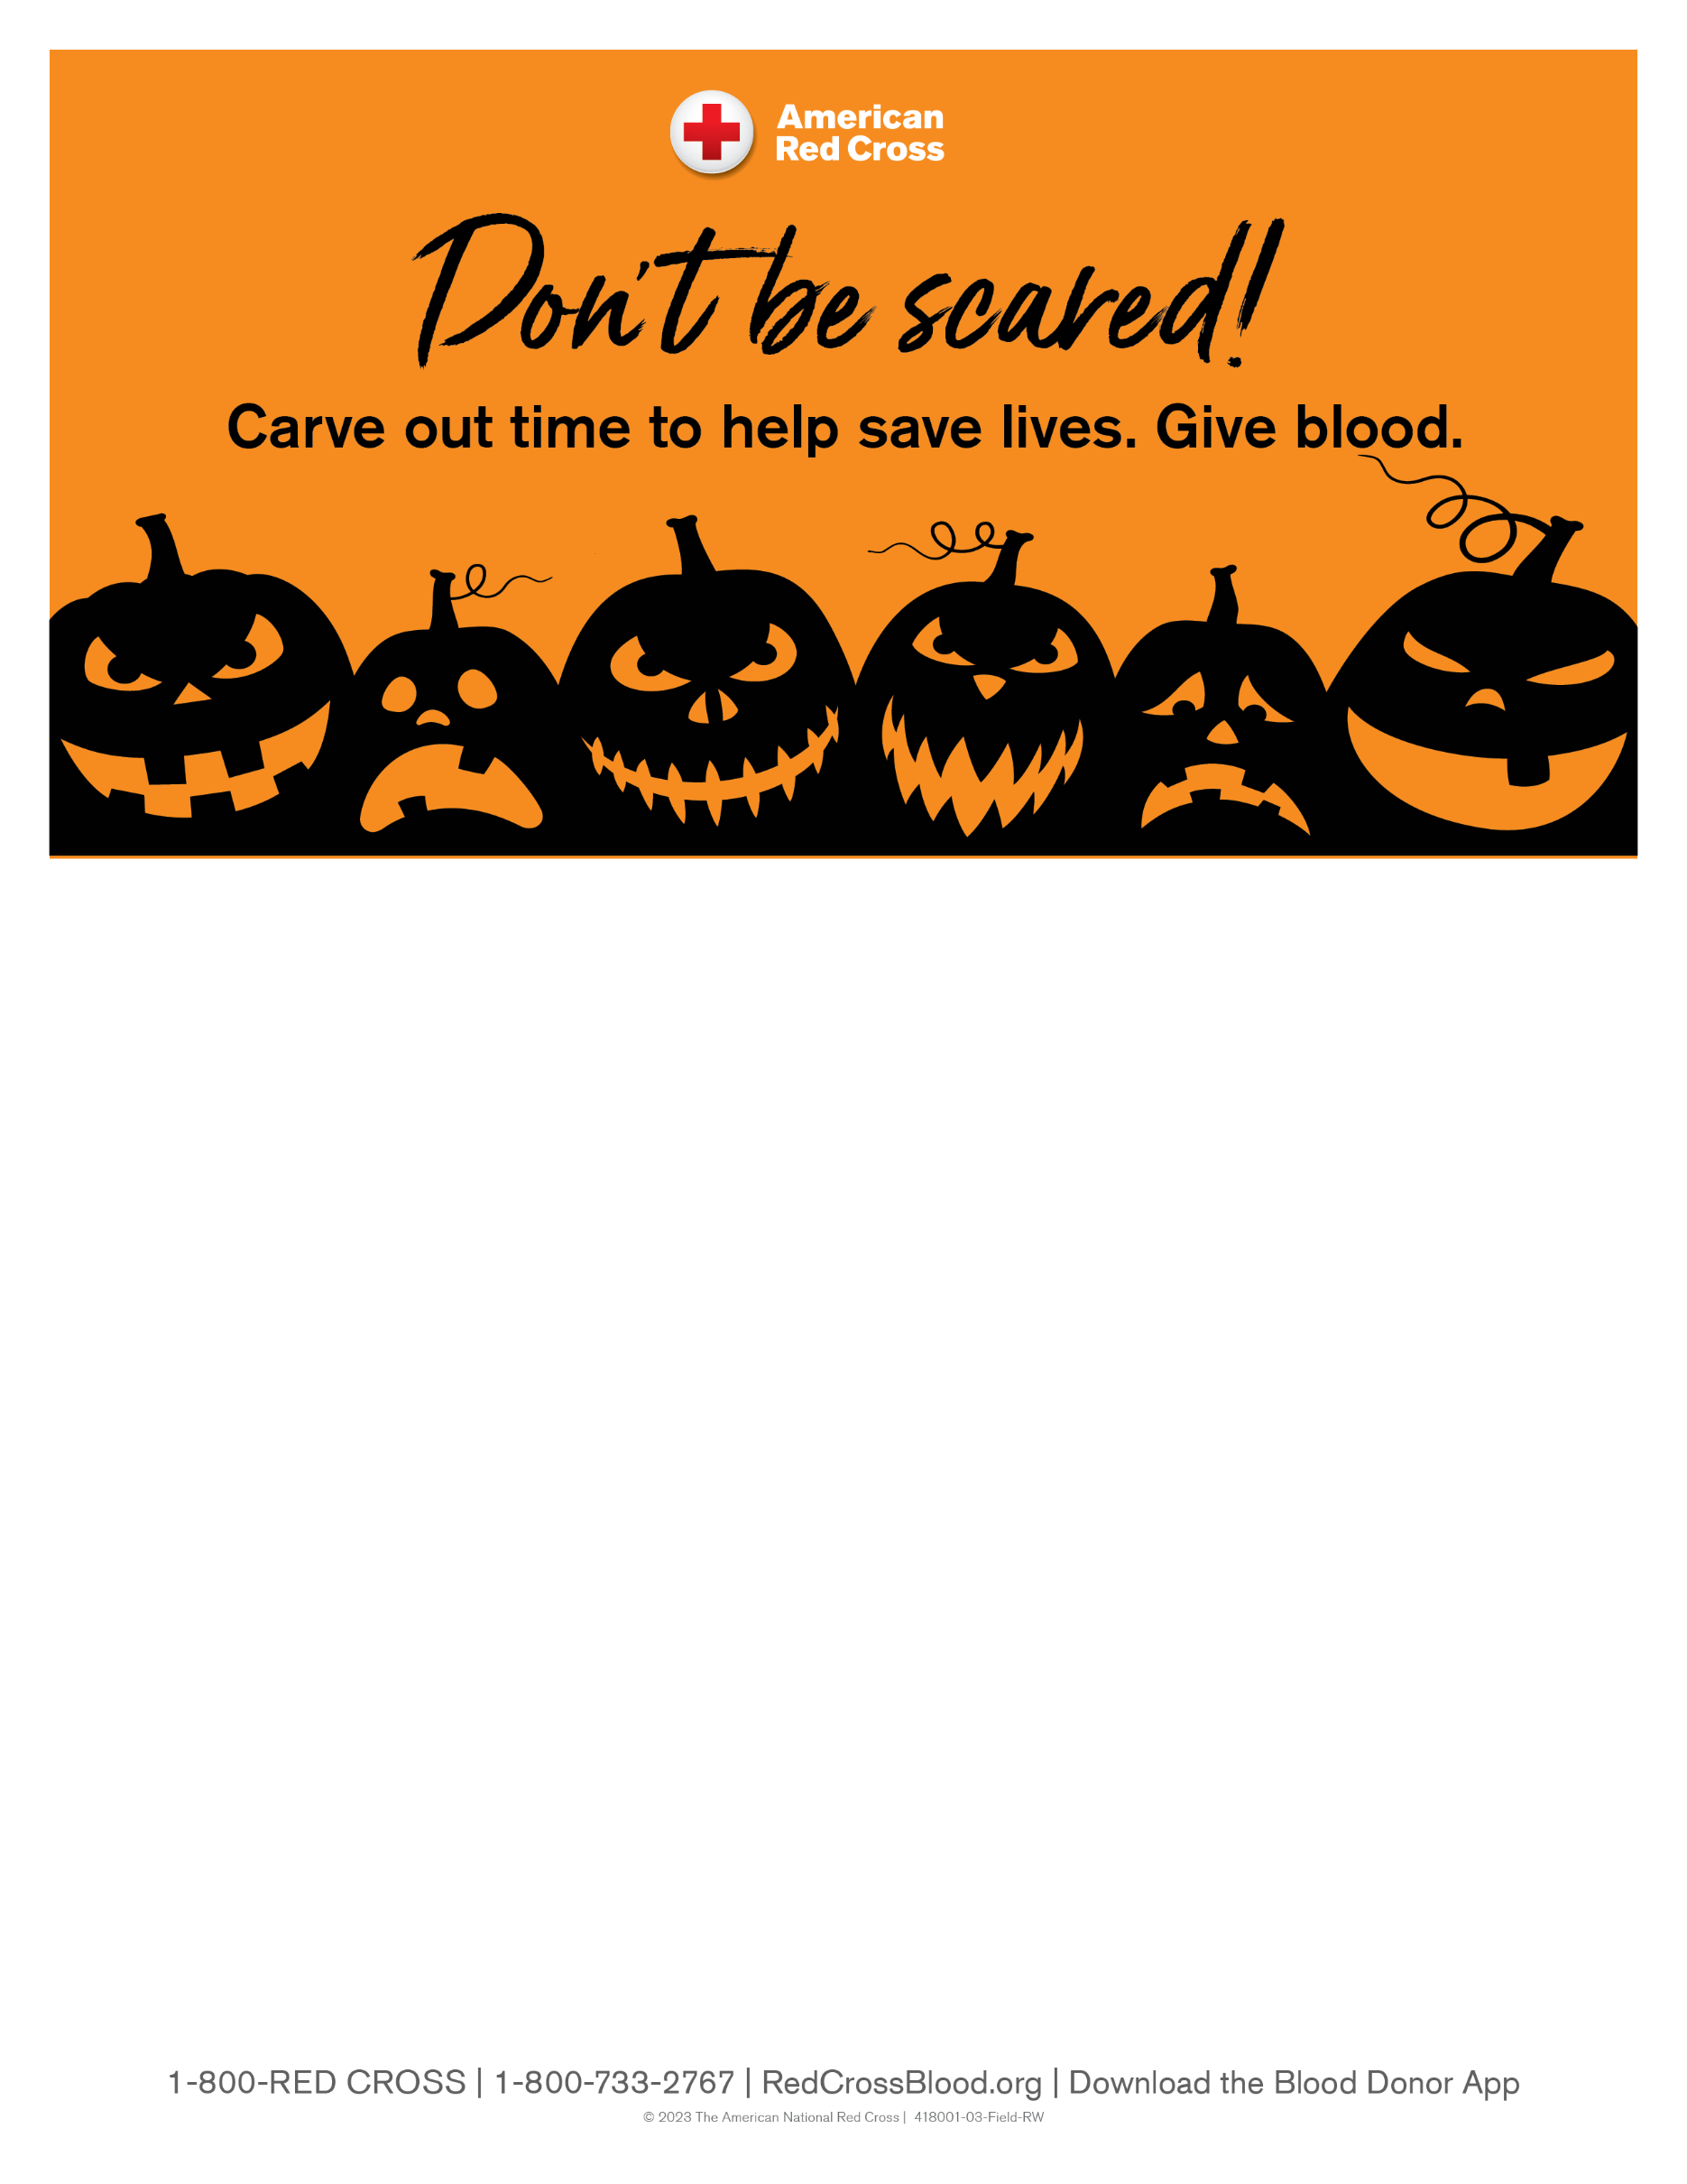

CHATTOOGA COUNTY COMMUNITY
RED CROSS CLUB
BLOOD DRIVE
Monday, October 12, 2026
1:00 pm – 6:00 pm
Chattooga County Chamber & Civic Center
All presenting donors will receive a
$15 Amazon E-GIFT CARD!
For more information and to schedule an appointment, please go to www.redcrossblood.org and enter sponsor code: RedCrossClub

