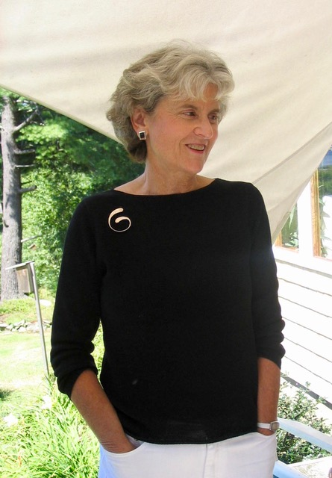
Judi MacMurray, passed away peacefully at Hyder Family Hospice House in Dover, NH on July 8, after an all-too-rapid illness.

Judi was a dedicated member of the KAA family for 15 years, as a member of the Board for several, a founding member of the First Tuesday Poetry group, and a volunteer for many Music Series and First Friday events. (Who can forget her sometimes comedic readings of poems that brought the house down!)

She was also instrumental in establishing the first Kids’ Open Studio sessions, and was a primary member of our Marcia Abigail Ryder Scholarship committee in the Kittery school system.

In the local school system she held many positions, and always enjoyed the opportunity to work and communicate with young people. She was always up to date on what kids were discussing and kept her friends in touch with the reality of the latest trends at school. Around town she was always glad to bump into kids working at local businesses, restaurants, and town events—young people knew her and approached her as a good friend.

Judi also worked with older folks at Kittery Estates in various capacities, most recently by facilitating writing workshops there. She was as faithful in her engagement with her older “students” as she was with her younger ones, bringing the same openness, directness, patience, and humor to all her interactions.

Her many friends will not soon forget her love of summer and the many invitations she extended to share a meal and play croquet in her gracious gardens. Nor will we forget the obvious pleasure she took in visiting her children and grandchildren, returning, always, with happy stories she loved to share with us. Her friendship, character, sense of play and pleasure in the spoken word, and her good counsel and conversation will be deeply missed by all of us.

MJG

