PRESS RELEASE
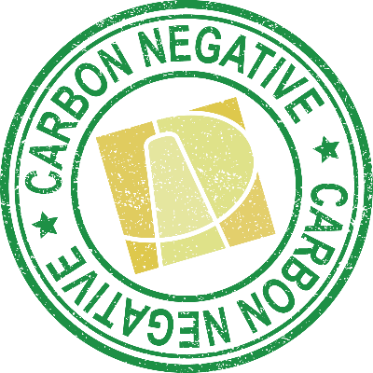
Artisan Dental goes Carbon Negative!
Artisan Dental is excited to be the first general dentistry practice in the United States whose operations have become carbon negative!
This means all of the carbon or greenhouse gas emissions associated with all aspects of patient care have been completely offset with carbon credits. Artisan Dental has also purchased additional carbon credits equivalent to 20% of its yearly carbon production, helping to drawdown existing carbon already in the air. All carbon associated with the operation of our office space, the production and shipping of oral care products and services to us, as well as transportation of team members to and from their homes and continuing education has been included in our offset program. Artisan collaborated with Carbon Credit Capital to assess our Scope 1, 2, & 3 greenhouse gas emissions. For more than a decade, Carbon Credit Capital has helped companies calculate and offset their carbon emissions using rigorous global standards.
The carbon credits Artisan Dental purchased are derived from GreenTrees (ACRE) reforestation program in the Mississippi Valley. The ACRE project (Advanced Carbon Restored Eco-system) plants and grows new forests to sequester carbon, restore biodiversity, and clean and restore watersheds through new eco-system creation on degraded lands. Over regular intervals, independent verifiers measure how much carbon GreenTrees’ new forests have sequestered, and for each metric tonne reduced, one carbon credit is created.
At Artisan Dental we see carbon offsetting as an important element of a comprehensive plan to reduce our negative impacts and enhance our positive impacts. In addition to offsetting the carbon associated with our patients’ oral health care, Artisan Dental also purchases 100% of the electricity used during their oral care services from MG&E’s Green Power program. Using renewable energy sources from MG&E helps to prevent the emission of greenhouse gases. In addition, Artisan Dental offers its team members an incentive to use a wide range of carbon sensitive alternative modes of transportation. We also work cooperatively with our suppliers to consolidate products into fewer shipments and emphasize purchasing from suppliers such as Raw Office who also offsets the carbon associated with the production and delivery of its office products.
“We do not pass the cost of carbon offsetting onto our patients. We believe this is part of fulfilling our mission of serving one of our most important stakeholders, a healthy thriving environment.” Scott Andersen, co-owner.
Artisan Dental’s collaboration with GreenTrees and Carbon Credit Capital has contributed to a range of United Nations Sustainable Development Goals including SDGs 3: Good Health and Well-Being, 8: Decent Work and Economic Growth, 13: Climate Action, 14: Life Below Water & 15: Life on Land.


