Considering transitioning out of your business?

67% of small business owners are over 56! That represents a tidal wave of transition in the next 20 years—often called the silver tsunami. If you are considering what to do with your business, learn your options! Consider transitioning to worker-owned with an ESOP or CO-OP. Options have changed and these choices may offer you outstanding benefits.

The Big Payoff of Shifting to Worker-Owned will guide you through the pros and cons of ESOPs and CO-OPs so you can make an informed decision about your next steps. This class is offered to you through the LBI Virtual Campus and is online and on-demand so you can proceed at your own pace.

Because you are a member of Dane Buy Local, you can receive this course at half price using code danebuylocal.
LEARN MORE.

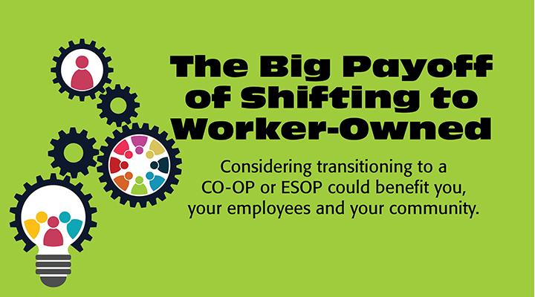

The classes are quick—just a few minutes each, interactive and very informative. The course covers the ins and outs of ESOPs and CO-OPs and how each might benefit you, your business, your employees and your community. You’ll leave this class with a clear understanding of each and a plan for your next step.

GET STARTED NOW

The LBI Virtual campus offers many other classes for small local business. We are constantly developing new material and welcome your opinions on what else you would like to see.

