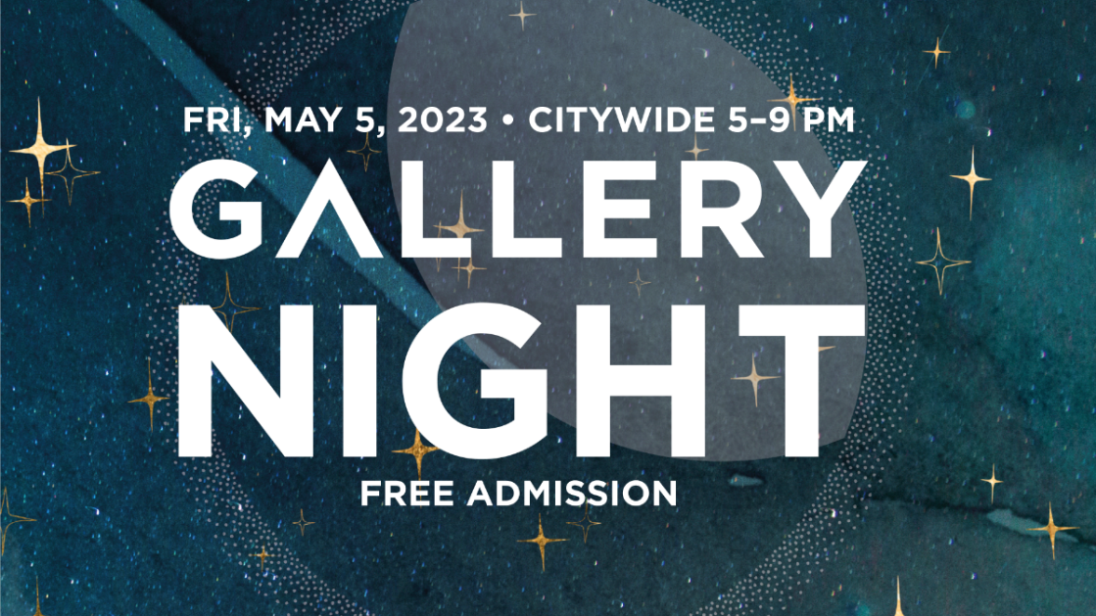

Step Out Friday Evening for Gallery Night
May 5 • 5–9 PM • 65 Venues Citywide • Free Admission

At last, Gallery Night arrives this Friday, May 5, from 5–9 PM at 65 venues citywide! This longtime event, organized by MMoCA, features local artists and their artwork in a community celebration taking place around town. Admission is free.
Each Spring and Fall, businesses, museums, galleries, coffee shops, and studios throw open their doors to share their space for artists to show and sell their work, provide demonstrations, and, sometimes, offer food, beverages, and music. Participating in Gallery Night is a great way to support the local arts and business community, and hopefully find something unique for your home or a friend’s.
To help plan your outing, be sure to view the interactive map of establishments in the eight participating neighborhoods. The event is from 5–9 PM, though some venues may set their own hours. Rain or shine, Gallery Night is the place to be.

