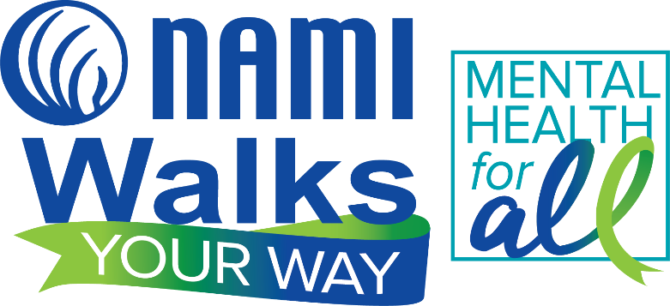
Sample Social Media Posts
- Join me in a national effort to raise awareness for mental illness! I am participating in NAMIWalks Your Way Maryland as part of a #MentalHealthforAll movement. Show your support for me by donating now, joining my team, or help spread the word by sharing to your contacts! (insert your walker page link). Remember, you are #notalone – we’re in this together!
- Walk Your Way with me! I’m a part of NAMIWalks Your Way Maryland campaign to raise awareness for mental illness. You can walk around your block, your garden, or in your kitchen – anything you do will help support the one in five of us with a mental illness. Please support me here: (insert your walker page link). #NotAlone #MentalHealthforAll
- I am striving to raise a goal of $______ for NAMIWalks Your Way Maryland, which supports the important work of NAMI to help people who are affected by mental illness right here in our community. Please walk with me or make a secure donation here: (insert your walker page link). Thank you, and remember – you are #NotAlone
- Thank you to all who have supported my NAMIWalks Your Way efforts so far! I am getting close to reaching my goal of $______________ for NAMI’s mission to support, educate and advocate for individuals and families affected by mental illness. We are fortunate to have NAMI in our community. Your contribution – either by walking virtually with me or making a donation – is very much appreciated! Support me here: (insert your walker page link)
#CreativityConnects Social Media Posts
- The arts have a unique power to speak to the human condition. That’s why I am taking part in the NAMIWalks Your Way Maryland: Creativity Connects campaign to explore the connection between art and #mentalhealth! (Your personal connection is always the most impactful. How has it helped you? And/or in what ways are you addressing mental health through art and creativity?) Support my campaign at: (insert your walker page link)
- Creativity connects, provides healing, ways to speak to our common humanity and communicate our struggles. That’s why I am asking you to support NAMIWalks Your Way Maryland: Creativity Connects campaign. Explore the connection between art and #mentalhealth! Support the fundraiser here: (insert your walker page link)

Remember use these hashtags when talking about NAMIWalks Your Way: #NotAlone #MentalHealthForAll #CreativityConnects

