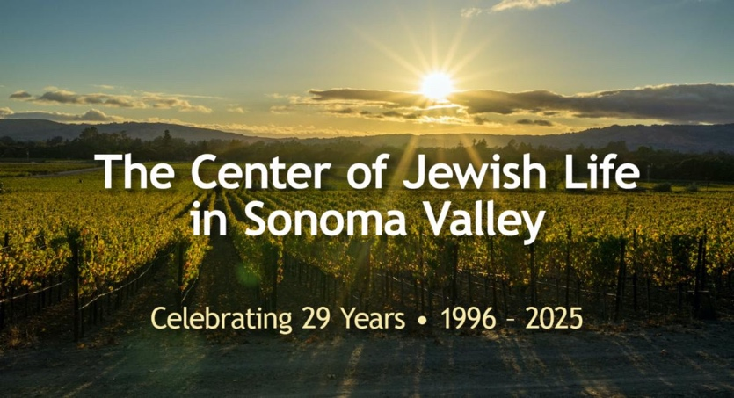

Celebrate Chanukkah with Congregation Shir Shalom in Sonoma Valley

In celebration of Chanukkah, Congregation Shir Shalom, The Center of Jewish Life in Sonoma Valley, invites the Sonoma community to join them for two festive events that the synagogue hosts each year.

Hebrew School Chanukkah Celebration
On Wednesday, December 17, Congregation Shir Shalom’s Hebrew school will share the story of Chanukkah and perform traditional songs celebrating this joyous holiday. The event will take place at the Sonoma Plaza Amphitheater from 4:00-4:30 p.m.

Community Chanukkah Celebration – 8th Night of Chanukkah
On Sunday, December 21, at 4:00 p.m., Congregation Shir Shalom invites Sonoma friends, neighbors, and their families to celebrate the final night of Chanukkah. The festivities will include lighting the 8th candle on the menorah, dancing in front of the synagogue on W. Spain St. and enjoying potato latkes and hot chocolate. Please note that W. Spain will be closed to traffic, between 2nd and 3rd streets, at approximately 3:30 pm.

“This is a wonderful opportunity for families and community members to come together, enjoy the spirit of Chanukkah, and experience the traditions that make this holiday so special,” said Shir Shalom Rabbi, Steve Finley.

