



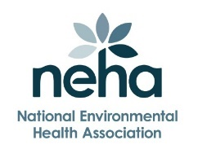
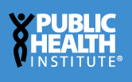
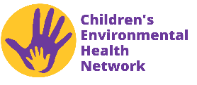

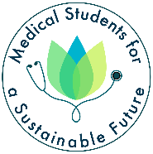
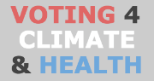
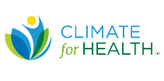
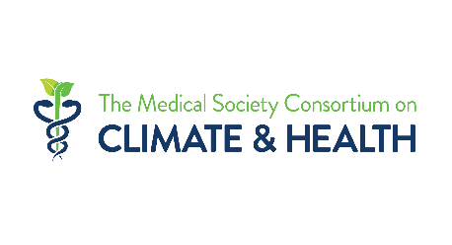

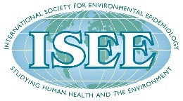
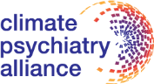
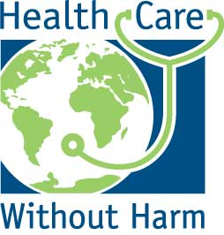
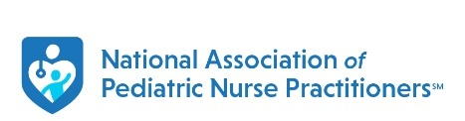

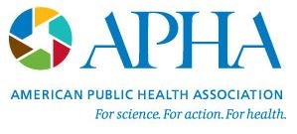

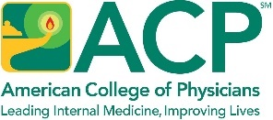


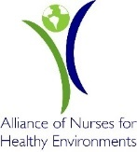
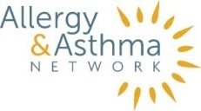


A Declaration on Climate Change and Health, 2025
May 20, 2025
We are leading medical, nursing, healthcare, patient advocacy, public health, and environmental health organizations. We work to ensure that our patients and our communities are healthy and safe. But health and safety are actively threatened by climate change driven by the burning of fossil fuels like oil, gas and coal.
People everywhere understand that our changing climate is harming our health because they’re living through the impacts right now – from worsening wildfires, extreme heat and flooding events, to the increased spread of diseases like Lyme and West Nile, to poorer mental health as a result of climate disasters. As health organizations, it is our duty to urge leaders at every level to take swift action to address the health impacts of climate change and reduce the pollution driving it.
Climate change is a health emergency that is already harming health and causing loss of life. The window to prevent the worst impacts is rapidly closing.
Here are health impacts of climate change that everyone should know:
- Climate change puts everyone’s health at risk, regardless of where you live.
- Lots of people are at increased risk of getting sick or injured as a result of climate impacts, even if they don’t realize it. They include kids, seniors, people with chronic diseases like asthma or diabetes, people who are pregnant, people with disabilities, people who work outdoors, people with low-incomes, people of color and many more.
- Extreme heat is killing people. It causes more deaths than any other weather-related hazard, and climate change is making it much worse. Heat is also linked with a wide array of short-term and long-term illnesses.
- Wildfires are becoming more frequent and intense, spreading dangerous smoke that is making people sick. Particle pollution and other harmful substances in the smoke are linked to lung disease, lung cancer, heart disease, stroke, dementia, and preterm birth.
- Climate change is making smog worse. Warmer temperatures increase smog (also called ozone pollution), which is linked to asthma attacks, lung disease, cardiovascular disease, preterm and low birthweight infants, cancer, harms to brain health and premature death.
- Storms and flooding are getting more severe, causing injuries, worsening physical and mental health, and cutting people off from their healthcare.
- Disease-carrying insects like ticks and mosquitoes are multiplying and spreading to new areas, increasing exposure to illnesses like Lyme disease and Dengue fever. Water- and food-borne pathogens are also spreading.
- Allergy seasons are getting longer and more intense.
- Rising carbon dioxide are projected to decrease the nutritional content of crops.
Here’s the good news: we are making progress, and there are commonsense opportunities for action at every level. Plus, most of the actions that reduce the pollution driving climate change result in immediate health benefits by reducing other dangerous air pollution too.
Leaders at every level must take action to:
- Dramatically reduce greenhouse gas emissions from power plants, vehicles, industry, and appliances in buildings.
  - Burning coal, methane gas (aka “natural” gas), oil and other fossil fuel is driving climate change and making people sick from air pollution at the same time.
  - We need to power our vehicles, heat and cool our buildings and run our manufacturing facilities on electricity wherever we can, and get that electricity from truly clean sources like wind turbines and solar panels. The best way to protect health is to make as much of each of these sectors as zero-emission as possible.
- Ensure that pollution is cleaned up in all communities. Don’t allow communities that have historically borne a disproportionate burden from air, water and soil pollution to continue to suffer the most severe health harms, and protect these communities from new polluting industries.
- Defend existing rules that protect our health. The nation has strong measures currently on the books that are helping to drive down dangerous emissions. Leaders at every level should call for them to be kept in place, not rolled back or weakened. They include tighter limits on mercury and air toxics from power plants, limits on the carbon pollution that drives climate change from power plants, strong new limits on methane pollution from the oil and gas industry, an updated national standard for particle pollution, new cleaner cars standards, new cleaner trucks standards, and investments in clean electricity and clean transportation.
- Ensure funding and staff expertise for public health, health care and environmental health systems to ensure they have adequate resources to protect communities by identifying, preparing for and responding to the health impacts of climate change.
- Coordinate across the federal, state, and local levels to empower community leaders to protect those most at risk and ensure access to continuous, quality healthcare during and after disasters.
We call on decision makers at every level to protect America’s health by taking steps now to dramatically reduce pollution that drives climate change and harms health.

Signed,
Allergy and Asthma Network
Alliance of Nurses for Healthy Environments
American Academy of Pediatrics
American College of Chest Physicians
American College of Physicians
American Lung Association
American Public Health Association
American Thoracic Society
Asthma and Allergy Foundation of America
Center for Climate Change and Health
Children's Environmental Health Network
Climate for Health
Climate Psychiatry Alliance
Health Care Without Harm
Infectious Diseases Society of America
International Society for Environmental Epidemiology, North America Chapter
Medical Society Consortium on Climate Change and Health
Medical Students for a Sustainable Future (MS4SF)
National Association of Nurse Practitioners in Women's Health
National Association of Pediatric Nurse Practitioners
National Environmental Health Association
National League for Nursing
National Student Nurses’ Association
Oncology Advocates United for Climate and Health (OUCH)
Physicians for Social Responsibility
Public Health Institute
Voting4Climate&Health

