Justice, Compassion, and Democracy in 2025 & Beyond

What role, if any, should the Church have in engaging social and political issues in the public domain? Religious leaders are calling for varied responses to the emerging policies of our national government, and to rising Christian nationalism. After-worship meetings on January 5 and January 19 were well attended, and many people, with varied perspectives, shared their perspectives.

On Sunday, February 2, following worship, we will continue our discussion. We plan to break into smaller groups to better facilitate shared conversation. We will first convene in Unity Hall as usual.

PREPARING FOR THE CONVERSATIONS
Please read articles by Bishop Mariann E. Budde and by Vermonter Carl Krieg in advance and reflect on these questions:
- Should the Church (and our Church) be engaging these issues at all?
- Have we already taken steps to engage them? When? How? Are we comfortable or uncomfortable with these activities?
- What constructive steps might we take in the coming months to work for justice, compassion, and peace – as Jesus instructed? How, without crossing a line that some might see as being too explicitly political?
Join us at 11:30 a.m. in Unity Hall on February 2.

The Bishop Who Pleaded With Trump: ‘Was Anyone Going to Say Anything?’
Bishop Budde locked eyes with President Trump and made a plea for mercy — and the war over spiritual authority in America was ignited anew.
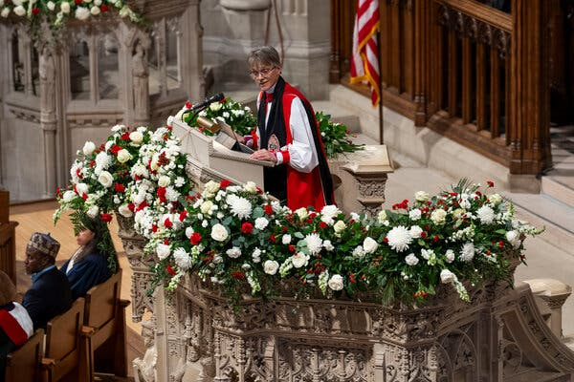

Bishop Mariann E. Budde delivering a sermon at a prayer service on Tuesday at Washington National Cathedral. Credit...Doug Mills/The New York Times
Jan. 22, 2025
Standing in the storied Canterbury Pulpit above the president on Tuesday, Bishop Mariann E. Budde was a little afraid.
The leader of the Episcopal Diocese of Washington, she had planned for months to preach on three elements of unity — dignity, honesty and humility. But just 24 hours earlier, she had watched President Trump proclaim his agenda from the inauguration stage, as conservative Christians anointed him with prayer.
He was no longer just campaigning — he was governing, she thought. His nascent presidency and flurry of executive orders had so far encountered little resistance. She felt called to add a fourth element to her sermon: A plea for mercy, on behalf of everyone who is scared by the ways he has threatened to wield his power.
“I had a feeling that there were people watching what was happening and wondering, Was anyone going to say anything?” she explained quietly in an interview on Tuesday night. “Was anyone going to say anything about the turn the country’s taking?”
So, she took a breath, and spoke.
President Trump, seated seven feet below and some 40 feet to her right, made eye contact. One representation of American Christianity began speaking to another, and the most powerful man in the world was arrested by the words of a silver-haired female bishop in the pulpit. Until he turned away.

Bishop Asks Trump to ‘Have Mercy’ During Sermon

Bishop Mariann Edgar Budde addressed President Trump during an inaugural prayer service, and asked him to show mercy to immigrants and the L.G.B.T.Q. community.
“Let me make one final plea, Mr. President: Millions have put their trust in you. And as you told the nation yesterday, you have felt the providential hand of a loving God. In the name of our God, I ask you to have mercy upon the people in our country who are scared now. There are gay, lesbian and transgender children in Democratic, Republican and independent families, some who fear for their lives. And the people, the people who pick our crops and clean our office buildings, who labor in poultry farms and meatpacking plants, who wash the dishes after we eat in restaurants and work the night shifts in hospitals, they — they may not be citizens or have the proper documentation, but the vast majority of immigrants are not criminals. I ask you to have mercy, Mr. President, on those in our communities whose children fear that their parents will be taken away, and that you help those who are fleeing war zones and persecution in their own lands to find compassion and welcome here, Mr. President.” Reporter: “Mr. President, what did you think of the sermon?” “I didn’t think it was a good service, no. Thank you very much.” “Thank you — press, thank you.” “They can do much better.”
For everyone watching, the vastness of Washington National Cathedral compressed, in one stunning moment, into a sudden intimacy. And with it, all the existential fights not simply of politics, but of morality itself. In a flash, the war over spiritual authority in America burst into a rare public showdown.
The Canterbury Pulpit confronted the bully pulpit on the greatest possible stage.
For nearly a decade, American Christianity has been torn apart in every possible way. Christians have fought over whether women should be allowed to preach. Over the place of gay people. The definition of marriage. The separation of church and state. Black Lives Matter. And at the heart of much of it has been Mr. Trump’s rise as the de facto head of the modern American church, and the rise of right-wing Christian power declaring itself the one true voice of God.
Many of these fights have been siloed, rarely in dialogue. Christians of opposing perspectives almost never worship in the same sanctuary. They do not listen to one another’s sermons, or hear the other’s prayers. Mainline Protestants have wondered if their voice can have any measure of authority. At a moment when conservative Christians are poised to gain even more power through Mr. Trump’s second term, Bishop Budde tried something different at the interfaith service.

Mr. Trump was unmoved. When the sermon ended, he exchanged a look with Vice President JD Vance, a conservative Catholic, who shook his head in apparent disapproval. On Wednesday morning, Mr. Trump retorted on his social media platform Truth Social, demanding an apology from the “so-called Bishop” and “Radical Left hard line Trump hater.”
“She brought her church into the World of politics in a very ungracious way,” Mr. Trump declared on Wednesday. “She was nasty in tone, and not compelling or smart.”
Bishop Budde, 65 and the first woman elected to her role, and Mr. Trump clashed in 2020 when he held a Bible aloft at St. John’s Church, after officers used tear gas against protesters calling for racial justice in nearby Lafayette Square. She wrote in an opinion piece for The New York Times that she was “outraged” and “horrified” that he used sacred symbols to espouse “positions antithetical to the Bible.”
On Wednesday, Representative Mike Collins, Republican of Georgia, said Bishop Budde should be “added to the deportation list.” Others said her gender itself undercut any claim to spiritual authority.
“Female bishop is all you needed to know how it was going to turn out,” Kristan Hawkins, a Catholic anti-abortion activist, wrote on X.
But progressive Christians felt their convictions finally had a voice in the melee. Former President Joseph R. Biden Jr., a practicing Catholic who represented a recovery of liberal Christianity after the first Trump presidency, has left Washington, taking an era with him. Catholic power in America has shifted greatly to the right since Pope Francis, now 88, was welcomed to Washington during the Obama era.
More than 14,000 people signed an online petition thanking Bishop Budde within four hours. Episcopalians around Washington proudly posted online in gratitude that Bishop Budde was their spiritual leader, representing their Christianity.
For her part, Bishop Budde felt her sermon was “a perspective that wasn’t getting a lot of airtime right now, and it was a perspective of Christianity that has been kind of muted in the public arena,” she said.
She knew she did not have a lot of authority in the room, she said, “because I am not a part of the spiritual circles that have surrounded the president and his party.”
The venue was meaningful, offering her words the power of Christian history. Washington National Cathedral has long been home to significant American political moments — services marking the end of wars, and state funerals for presidents from Eisenhower to Carter.
And the Canterbury Pulpit itself is an imposing platform, even when not addressing the president, Bishop Budde knew. Its Caen limestone is believed to have been brought to England by William the Conqueror, and used in the Canterbury Cathedral itself. The pulpit is where the Rev. Dr. Martin Luther King Jr. preached his final Sunday sermon, days before his assassination.

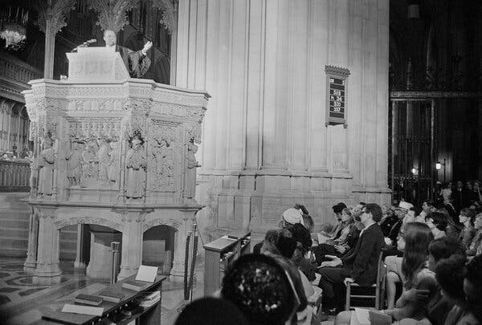
The Rev. Dr. Martin Luther King Jr. preaching his final Sunday sermon from the Canterbury Pulpit in Washington National Cathedral. He was assassinated days later.Credit...John Rous/Associated Press
Its central carving depicts the signing of Magna Carta, the 809-year-old charter establishing that the king of England was not above the law.
Bishop Budde occupied the lofty perch with no real power beyond the spiritual authority of her position, and the power to speak uninterrupted, for 14 minutes. She was robed in her liturgical vestments, the red and white rochet and chimere, used for prayer services without the Eucharist. Her academic hood signified her seminary doctorate. The black tippet around her neck was embroidered with the emblem of the Cathedral.
Bishop Budde does not believe she was speaking directly for God. “I’m saying, this is the best that I can do to understand and interpret what I believe our teachings and our scriptures and what the Holy Spirit might be wanting us to hear,” she said.
Amid America’s diversity, she sees discernment over spiritual authority as an important task. She thought of what Howard Thurman, the American theologian, called “the sound of the genuine.”
“What is real?” she asked. “What resonates with authority because it rings true, and it touches upon some fundamental principles that perhaps we agree upon?”
Previous inaugural prayer services were hosted by the Cathedral but planned with the Presidential Inaugural Committee, meaning the president-elect often picked the participants. But that changed last year, when the Cathedral itself took over the planning well before Election Day, Bishop Budde said. It was a move toward religious independence, so the service itself would be free of partisan interference and so it would not be seen as a coronation or sacred anointing.
After Mr. Trump won in November, the Cathedral gave his team a selection of proposed music and readings to consider for the service. But the choice of preacher was reserved for the Cathedral alone, a spokesman for the Cathedral said.
The part of the sermon that would attract the most attention, however, wasn’t crafted until hours before the service.
“To plea for mercy is actually a very humbling thing to do,” Bishop Budde said. “I wasn’t demanding anything of him. I was pleading with him, like, can you see the humanity of these people? Can you acknowledge that there are people in this country are scared? … If not him, if not the president, could others?”
On Wednesday afternoon, Bishop Budde was still working through the aftermath.
She had not anticipated the level of fury and personal attack that her words had unleashed, she said. People were questioning everything from her character and qualifications to the state of her eternal soul, and “how soon I should get to my eternal soul, and whether I belong in this country.”
“Maybe this was naïve on my part, when I decided to plea to the president I thought it would be taken differently,” she said, “because it was an acknowledgment of his position, his power now, and the millions of people who put him there.”
But she also had not expected the overwhelming gratitude from so many others.
“These are things I say all the time,” she said. “But publicly, people aren’t paying attention.”
In the pulpit, she said, “you can never really predict how things will land.”

Question & Answer. Progressive Christianity 1/16/25
Q: By A Reader
I know lots of people I consider good and moral, and yet they voted for Trump and his policies and attended many of his rallies. Can you help me understand?
A: By Carl Krieg, Ph.D.
Dear Reader,
Your question reminds me of something that happened to me in high school. I was in a small phys ed class, and the teacher, whom we called O.B. [O’Brian], was interested in how much we knew about sports rules. One question was: what do you get points for in football, a safety or a touchback? I knew the answer was safety, but one or two of the “tough guys” in the class said touchback, and I immediately agreed with them.
In 1932, theologian Reinhold Niebuhr wrote a book called Moral Man and Immoral Society, the title of which pretty much tells the story. An individual person can and will make ethical decisions on the basis of some chosen standard, whatever that standard might be. It could be a morality based on one’s religion, or societal law, or common respect and decency. The source of the decision-making is not the issue here. The point that Niebuhr makes in this book is that when a moral person becomes part of a group, group-think can overpower the individual’s sense of right and wrong, truth or falsehood. And that is exactly what happened to me in that choice between safety and touchback.
The time of Niebuhr’s writing was just prior to Hitler’s takeover of Germany. How could it be? How was it possible that the good and moral people of Germany could follow the hate-filled rhetoric and leadership of the Nazis? Western governments thought it was not possible, but it was. The answer was quite simple: moral people, as social animals who want to belong to the group, get caught up in the fervor of group immorality and lose their own sense of right and wrong. The decade of the 1920s was a time in Western theology known as the Social Gospel, a time filled with the great expectation that social programs, coupled with increased education, would change the world for the better. Confidence filled the air, even as troublesome political and economic reality seethed beneath the surface. With the rise of Hitler and led by theologians such as Niebuhr, the Social Gospel gave way to what is called Christian Realism, Moral Man and Immoral Society being a foundation of that new understanding.
Loss of moral fabric has happened and can happen, and the formula for creating it is simple. Start with economic hardship, identify a scapegoat who is then labeled as the source and cause of your hardship, set forth a leader who assumes messianic proportion as the one who can fix anything, and create a group that the individual can join. Result? A collection of moral individuals becomes an immoral society. This is where we are here in America. Income inequality has created an underclass in our society that has no hope. We give more tax breaks to the rich and impose tariffs on the world, which will be paid for by the underclass to make up the additional deficit in the budget. Trump has deceivingly called immigrants the cause of this inequality, immigrants who are—what else?—brown and black, proclaimed himself Messiah with the help of the fundamentalist church, and offered male white pseudo Christian nationalism as the group to join.
This we understand, but understanding the rise of Nazism does not excuse it, just as understanding the American parallel phenomenon we call MAGA does not excuse all its hateful tendencies. So, what can we do? The answer is manifold, but if anything, this understanding underscores the need for a rebirth in our society of respect, civility, and economic justice, a rebirth in which Niebuhr’s Moral Man and Immoral Society, is replaced by its alternative, Moral Man and Moral society. This alternative is both our responsibility and our calling.
~ Carl Krieg, Ph.D.
About the Author
Carl Krieg, Ph.D. received his BA from Dartmouth College, MDiv from Union Theological Seminary in NYC, and Ph.D. from the University of Chicago Divinity School. He is the author of What to Believe? the Questions of Christian Faith, The Void and the Vision and The New Matrix: How the World We Live In Impacts Our Thinking About Self and God. His latest book is How the Rich Stole Jesus. As professor and pastor, Dr. Krieg has taught innumerable classes and led many discussion groups. He lives with his wife Margaret in Norwich, VT.

