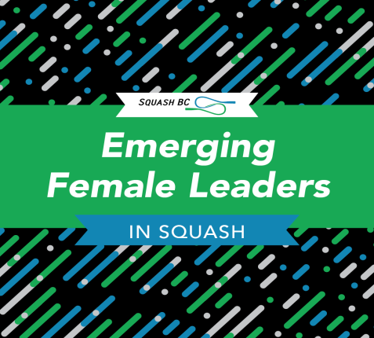
2020 Squash BC’s Emerging Female Leader Nomination Form
Name of Submitter: _______________________________________________________________ Member Club: ______________________________________ Title: _______________________ Address: ________________________________________________________________________ Phone: ________________________________ Email: ___________________________
I am nominating the following woman for the Emerging Female Leader in Squash:
Name: _________________________________
Phone: ________________________________
Email: _________________________________

Provide reasons why your nominee is an ambassador for women and girls in squash in BC? __________________________________________________________________________________________________________________________________________________________________________________________________________________________________________
______________________________________________________________________________

Can you tell us how your nominee has enhanced the clubs events/activities/involvement for women and girls in squash at the club?
_______________________________________________________________________________
_______________________________________________________________________________
_______________________________________________________________________________
What are the club’s plans to enhance activities to attract and retain girls and women in squash in 2020?
________________________________________________________________________________
How will you use the $500 grant if it is awarded to the club? _______________________________ _________________________________________________________________________________ _________________________________________________________________________________

Nominations must be submitted by noon on January 29, 2020. Late submissions will not be accepted.
Two grants of $500 each will be awarded to two clubs in 2020. Clubs will be notified by February 12, 2020.
Award-winning clubs are expected to complete a brief report in November 2020 as to how the funds were used and the impact of attracting new women and girls or retaining them in the game.

