New Braunfels Herald-Zeitung

Area Texas Ramp Project team completes 100th build amid nonprofit’s 40th anniversary
Erica Wilson | The Herald-Zeitung - Oct 23, 2025

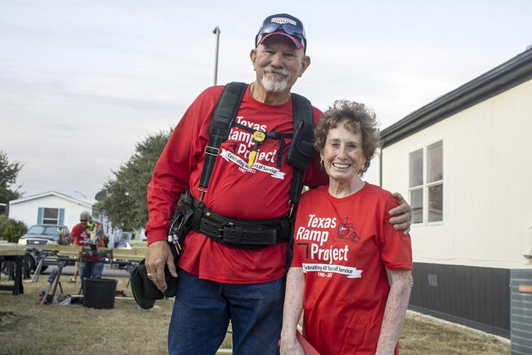
Robin Roark and Kay Geurin sport T-shirts celebrating the Texas Ramp Project’s 40th anniversary while completing the Cross County Team’s 100th ramp build on Wednesday, Oct. 22, 2025.

Two years ago, a number of retired area residents came together to form a team for the Texas Ramp Project nonprofit to help address a backlog of homeowners waiting for ramps across several counties. On Wednesday, the team completed their 100th build together, providing a ramp for a New Braunfels homeowner.

This group calls themselves the Cross County Team, or XCT. The team members build where they are needed, including counties such as Caldwell, Comal, Hays and Wilson.

“We’re just kind of a ragtag [group] from wherever, but we get together and enjoy doing this,” said Robin Roark, who is the lead of XCT. “It’s a great service, and you really do change somebody’s life in a couple hour stretch.”

The Texas Ramp Project was incorporated in 2006 as an expansion of the Dallas Ramp project, which began building ramps in 1985, according to a media release. The nonprofit’s vision is to ensure that no Texas resident lacks safe access due to financial limitations, and volunteer teams across the state come together to make that vision a reality.

This year, the nonprofit is celebrating 40 years of providing ramps for more than 30,500 recipients, making the timing of the XCT team’s 100th build together that much more meaningful.

Roark said that during the first build he remembers, the lady came outside to tell the team that it was the first time she had left her home in three years without someone carrying her out.

Regional coordinator Kay Geurin also recalled the very first time she learned to build a ramp in Kyle. It was for a little boy in a mobile home.

As the boy watched them build the ramp, she asked, “What are you thinking about all this?” and he responded, “I get to go outside with my brothers and sisters.”

Seguin resident Chuy Ozuna was another of the XCT members who came out to New Braunfels Wednesday to help with the 100th ramp build. He said volunteering with XCT has been a lot of fun, and through his time volunteering, he has seen the impact it has for community members.

“They really benefit from them, and it gives them the freedom to do whatever they need to do, and it helps the caretakers a lot,” Ozuna said.

To learn more about the Texas Ramp Project, visit texasramps.org/.

Erica Wilson is the New Braunfels Herald-Zeitung's education and nonprofit reporter.

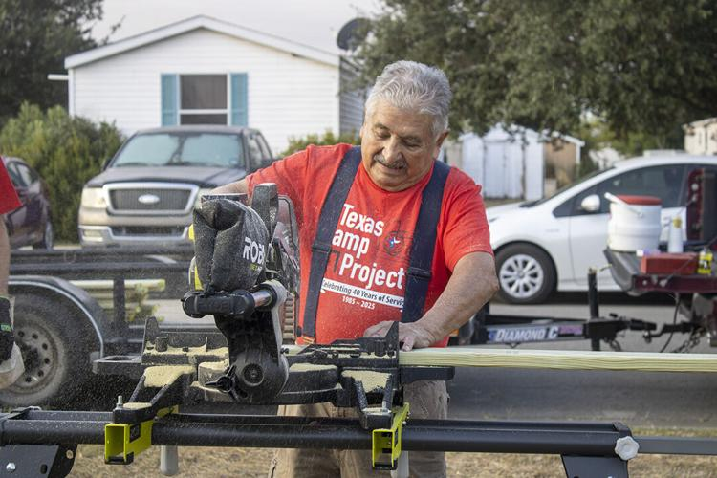
Seguin resident Chuy Ozuna helps build a ramp for a New Braunfels homeowner as part of the Cross County Team for the Texas Ramp Project on Oct. 22, 2025.

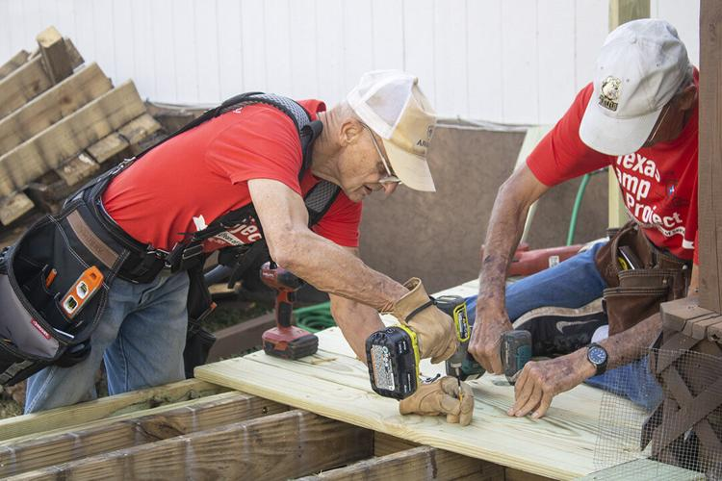
Members of the Texas Ramp Project’s volunteer team called the Cross County Team build a ramp for a New Braunfels homeowner on Wednesday, Oct. 22, 2025.

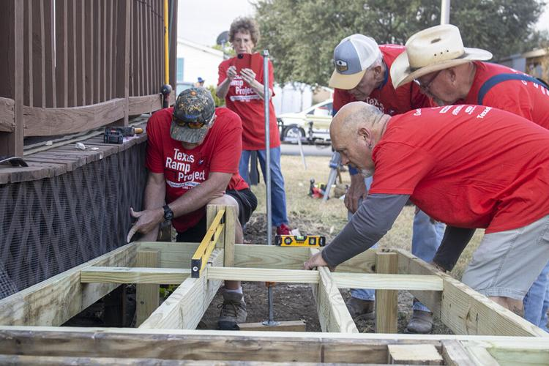
Area residents complete a ramp build for a New Braunfels homeowner on Wednesday, Oct. 22, 2025.
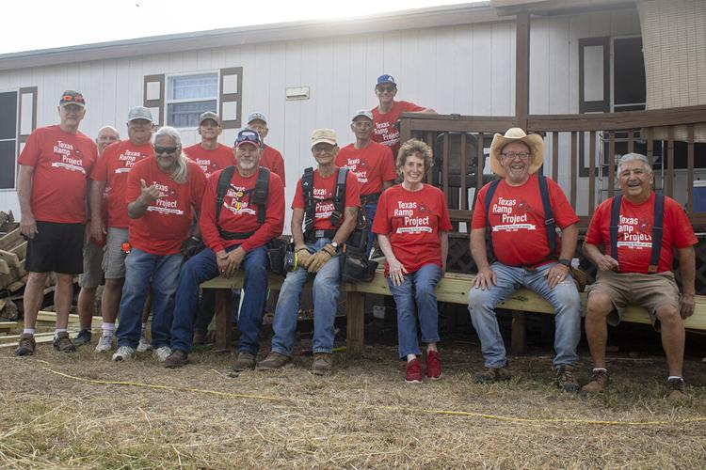
The Cross County Team, or XCT, takes a picture in front of the 100th ramp build for the Texas Ramp Project on Wednesday, Oct. 22, 2025.

