Wilson County News

Building freedom, one ramp at a time
By Nannette Kilbey-Smith August 11, 2026

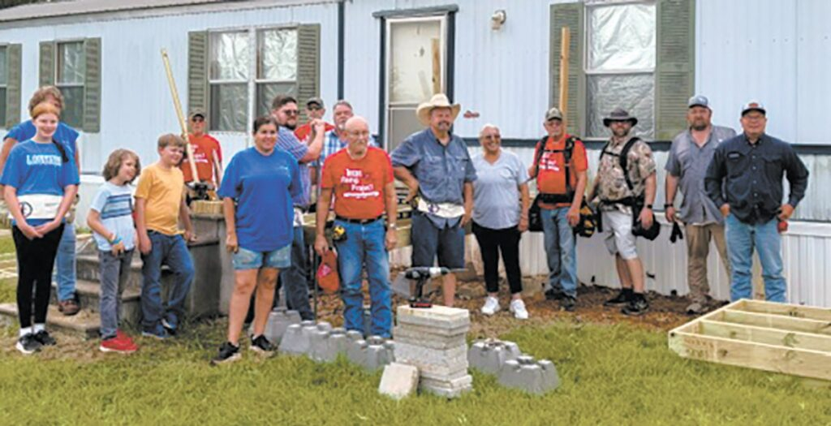
A job well done! Volunteers celebrate the completion of a new ramp, constructed and installed by volunteers working with the Texas Ramp Project, for a Wilson County resident. The nonprofit Texas Ramp Project has installed more than 33,000 ramps in the past 40 years. COURTESY PHOTOS/ESD

During the heat of a Texas summer, many families opt to spend time cooling off — splashing in a pool, tubing a river, wading the waters on a Texas beach.

But Nikki Hardwick, clinical operations manager and community paramedic with Wilson County Emergency Services District 3 (ESD 3), and her two kids turned out on a hot Saturday morning July 11 with a group of other volunteers to make life a little easier for a community member in need. They assisted the Texas Ramp Project, helping construct and install a ramp to help an individual with mobility needs.

Through her job with ESD 3, Hardwick oversees the district’s Mobile Integrated Health program. ESD 3, through Wilson County District 3 EMS, provides emergency medical services to all of eastern Wilson County and part of Guadalupe County.

Making connections

The Mobile Integrated Health program helps connect community members encountered by the EMS with community resources, helping improve lives and bridging the gap between what insurance might cover and what people need.

“Some of the most common issues I see are medication questions, transportation services, mobility aid device needs, food insecurities, chronic illness education, veteran services, behavioral health services, and community resources,” she said. She helps people connect with food pantries, community organizations that can provide assistance, veterans organizations and services, and more.

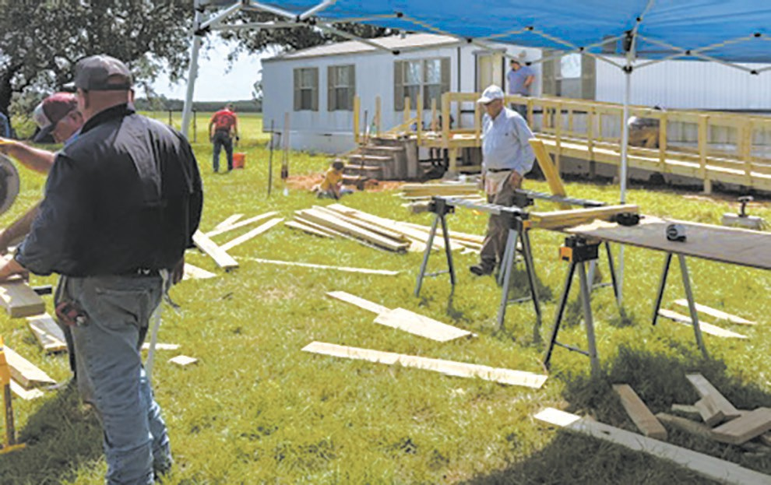
Volunteers gather in July to install a ramp for a Wilson County community member. The volunteer group working with the Texas Ramp Project included Wilson County ESD 3 Clinical Operations Manager Nikki Hardwick and her two children.

The Mobile Integrated Health service is free within the ESD 3 service area — including La Vernia, Sutherland Springs, Stockdale, Pandora, and nearby areas.

“If I don’t have the answer or solution, I can find somebody that does,” Hardwick said.

Providing freedom

Over the past two years, Hardwick has helped some community members by providing referrals to the Texas Ramp Project, which has — with volunteers — constructed and installed more than 33,0000 ramps for people in need across Texas. Recently, she not only made the referral, she was invited to assist with the builds.

Texas Ramp Project leaders visit the proposed site, take measurements, order materials, assemble a team of volunteers, and set the building date. David Teel is the Texas Ramp Project leader in the Wilson County area.

On July 11, Hardwick said, “13 volunteers gathered bright and early” and assembled an Americans with Disabilities-approved ramp in about 1-1/2 hours.

“Something that has made my heart so happy is that I have been able to share my passion for helping others with my children,” she said. “Both of my kiddos have now successfully helped to build a ramp within our area.”

Hardwick also helped with another Texas Ramp Project installation in June. The night before, she helped demolish the old ramp at the Floresville-area property — “not afraid to get her hands dirty,” Teel said — then was one of the volunteers, along with Wilson County Rotary Club President Cynthia Cuevas and member Holli Smith, who installed a 40-foot ramp the next day. Together, 15 volunteers completed the project in 5 hours, Teel said.

“There are countless man hours that go unseen in drafting up an ADA-approved ramp, gathering materials, and organizing the volunteers,” Hardwick said. “The day of build — and sometimes demolition, if needed — is fast-paced and oh-so-rewarding.”

ESD 3 Mobile Integrated Health

Wilson County ESD 3 connects community members “who could use a little help” with services, according to Clinical Operations Manager Nikki Hardwick. This can include:
•Medication questions or prescription assistance
•Transportation services
•Food insecurity
•Mobility aid devices
•Chronic illness education
•Veterans services
And more.

Learn more at wcesd3.net/mih-services, or call 830-581-0380.

Texas Ramp Project

Texas Ramp Project, for more than 40 years, helped provide freedom for many Texans who use a wheelchair or walker, by providing ADA-approved ramps to help them navigate safely to and from their homes.

The nonprofit organization’s mission is to build free wheelchair ramps for those who find their steps a barrier. Ramps are provided without regard to a recipient’s race, religion, ethnicity, age, or gender.

Since incorporation in 2006, Texas Ramp Project has installed 33,378 ramps; if laid end-to-end, they would stretch more than 158 miles!

Locally, Texas Ramp Project leader David Teel has been working with volunteers from the Combat Veterans Association and other volunteers to meet the needs of community members. But volunteers are still needed to help meet the ongoing needs.

“We always welcome volunteers,” said Teel.

“No experience is required,” said Wilson County ESD 3 Clinical Operations Manager Nikki Hardwick, who worked on two recent installations.

Learn more about Texas Ramp Project at texasramps.org/.

To volunteer locally, call Teel at 830-581-9975.

