Mount Pleasant Tribune

Volunteers help Mount Pleasant woman regain mobility, independence

By From Staff Reports on Tuesday, December 2, 2025

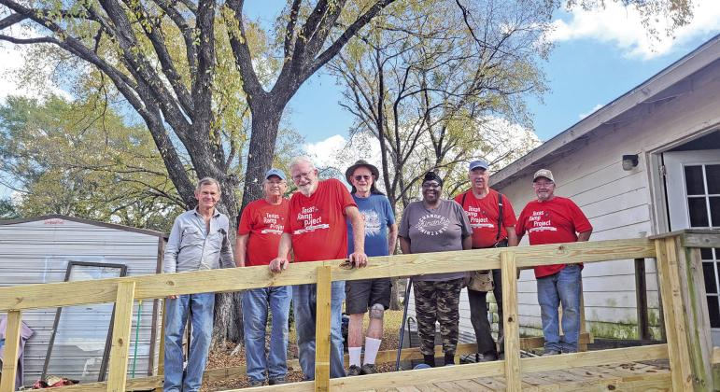
—Dorothy Turner Ramp Courtesy photo

Texas Ramp Project volunteers came together on Thursday, November 13, to help a local resident regain her mobility. They installed a wheelchair ramp, free of charge, at her home in Mount Pleasant. During October and November, Texas Ramp Project volunteers across the state have been building ramps in celebration of the nonprofit’s 40th anniversary campaign. The ramp in Mount Pleasant was...

Premium Content is available to subscribers only. Please login here to access content or go here to purchase a subscription.

