

Texas Ramp Project Builds Near Flatonia

Mon, 12/22/2025 - 18:43
By News Staff

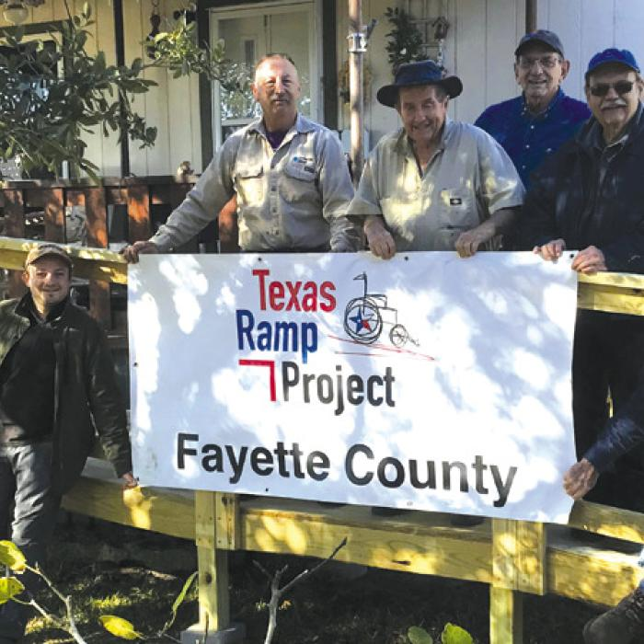
Texas Ramp Project Builds Near Flatonia

On Dec. 11, Fayettte County Texas Ramp Project volunteers built a 38 ft. wheelchair ramp on FM 2762 near Flatonia.

