Burleson County Tribune

Caldwell Lions helping build wheelchair ramps
By Roy Sanders on Wednesday, December 24, 2025

Local men’s club assists with Texas Ramp Project

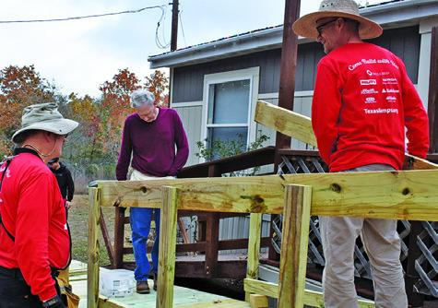
A RAMP IS built at this home off Park Road 57 thanks to these volunteers.

Many Texans using wheelchairs or walkers are stuck in their homes for long stretches of time, but the Caldwell Men’s Lions Club has partnered with the Texas Ramp Project to help alleviate those burdens in Burleson County. The Texas Ramp Project uses volunteer labor to build wheelchair ramps at people’s homes, and this year they have built 34 ramps in the county with 21 of those done w...

Premium Content is available to subscribers only. Please login here to access content or go here to purchase a subscription.
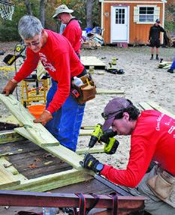

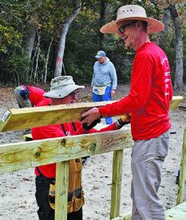

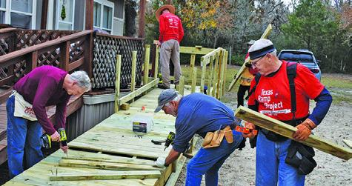
VOLUNTEERS, INCLUDING MEMBERS of the Caldwell Men’s Lions Club, build this ramp last Thursday on Park Road 57.

