The Seguin Gazette

Volunteers build 100th Texas Ramp Project ramp in Guadalupe County
Dalondo Moultrie | July 14, 2026
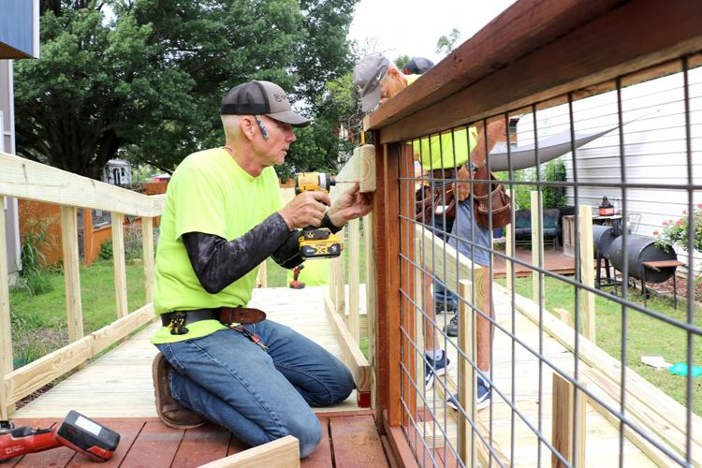
A volunteer with the First Methodist Church build team works on installing the group’s 100th Guadalupe county as part of the Texas Ramp Project on Friday, June 26, 2026 in Guadalupe County.
For over a quarter century, James Harrison has lived in his Guadalupe County home just outside of Seguin.
In that time, of course, he has aged and things changed, namely his spry mobility. Issues with Parkinson’s disease made things even worse for the county resident who used a walker the past 18 months or so before he broke his hip in a recent fall. He needed other means of assistance getting up and down the steps of his coveted home, Harrison said.
“Medicare billed me an electric wheelchair,” he said. “I couldn’t use it because I couldn’t get it on the ground.”
The ramp is a Godsend, he said.
However, all of that changed recently when volunteers with a local charitable group showed up at his home to build a ramp that will allow Harrison to wheel himself in and out of his home at will.
“I needed one a long time ago,” Harrison said. “It’ll get me out of the house.”
That’s just what volunteers like Robin Roark like to hear about the work they put in with the Texas Ramp Project. Roark said he and about a dozen other volunteers with the organization’s First Methodist Church build team reached a milestone late last month installing Harrison’s ramp.
“This is our 100th build. We started back in 2019,” he said. “It’s amazing to see the gratitude of someone — coming out and giving them something — from the bottom of their heart.”
The Texas Ramp Project is a nonprofit organization that provides wheelchair ramps to low-income older adults and people with disabilities identified by local healthcare providers, according to information on the organization’s website.
Volunteers build ramps, which helps keep down costs, it read. The bridges are built without regard to race, religion, ethnicity, age or gender, according to the website.
The First Methodist team started June 2019 working with Texas Ramp Project, said Pastor Cathe Evins. The team built its first ramp in July 2019 and a year later, the church assumed warehouse duties to store supplies for builds, she said.
“The Ramp Project has given people a new lease on life by providing a way for previously housebound persons to be able to leave their homes for appointments, errands, etc., without having to depend on social services for transportation needs,” Evins said. “It is such a worthy endeavor and makes a difference on so many levels.”
Volunteers buzzed around using power tools, hand tools and good, old-fashioned elbow grease on a recent Friday morning installing Harrison’s 54-foot ramp. Ramps generally measure about 37 feet depending on dimensions needed to fit the home, Roark said.
Once they complete a build, they get a near-immediate payoff for their sweat equity, he said.
“Folks can’t get out of their houses,” Roark said. “It’s amazing seeing folks that couldn’t get out of their houses on their own.”
His Parkinson’s disease threw off his balance, which led to him falling about seven weeks before the ramp build, Harrison said. Doctors put three pins in his hip, which made his mobility even worse, he said.
The steps leading into his house made leaving it near impossible. But, thankful for the First Methodist build team’s Texas Ramp Project work, Harrison said he already had plan where he would go first right after the ramp was complete.
“To get me some tacos,” he said with joy beaming from his face.
Dalondo Moultrie is the assistant managing editor of the Seguin Gazette. You can e-mail him at dalondo.moultrie@seguingazette.com .

