The Gatesville Messenger

Local Texas Ramp Project volunteers help community

By Ally Hinkle The Gatesville Messenger on Friday, July 31, 2026

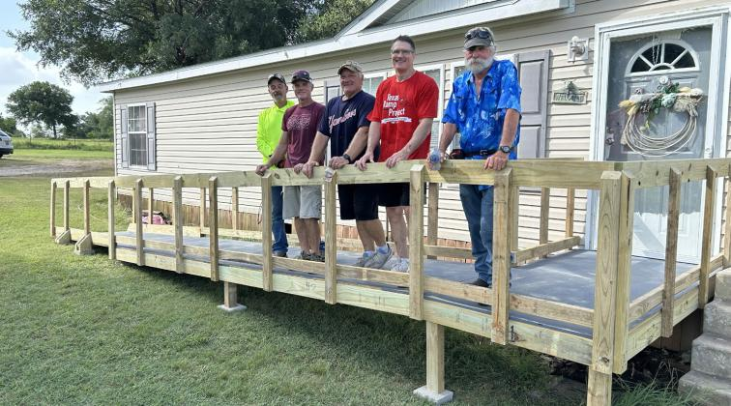

A group of volunteers from Coryell Community Church (CCC) aid a non-profit’s mission to provide wheelchair accessible ramps to those with disabilities or low-income elders.

The Gatesville branch of the Texas Ramp Project (TRP) was founded sometime in 2021 by Jim and Marcia Hoge, formerly members of the Waco branch, after they moved to Gatesville.

According to volunteer Kelly Adair, since the branch’s founding the TRP volunteers have built around 30–40 ramps around Gatesville, Copperas Cove and Moody.

He stated that within the first year they had only built around two to three ramps in the entire year, and now they try to build at least one ramp a month.

The latest ramp they built was special to Adair, being built for a member of the CCC congregation in what he deemed as “record time.”

The last ramp was built for Jim Brown, who at the time was in the hospital recovering from a major surgery, and the process took 11 days from the paperwork being submitted to the ramp being completed.

According to Adair, this was due to the build of the ramp, which Adair referred to as pre-built, and that allowed them to complete the ramp in record time.

“It was special since it was for one of our own, and because it was so quick,” Adair said.

Typically, the process can take anywhere from six to eight weeks from paperwork being filed to the recipient of the ramp being able to use it for the first time.

According to the parent organization, the TRP will only accept referrals from qualified organizations or healthcare professionals. From there, the organization will supply the materials while all the work is done by volunteers.

The Gatesville branch will also receive donations from CCC as well as from individuals who have received ramps through the program.

The ramps are built from the recipient’s front door of their home to their driveway or wherever their vehicle is parked at their home. Adair said typically in Gatesville the modules and a majority of the building takes place in his workshop next door to his home before a group of six to seven volunteers assemble the ramp in a couple of hours at the recipient’s home.

The parent organization was founded in 1985 in Richardson, Texas, before becoming a statewide nonprofit in June of 2006. Since 2006, the TRP has expanded to cover over 150 counties within Texas and have built nearly 33,400 ramps. These ramps are built for individuals regardless of race, religion, age, gender or ethnicity. These ramps are also free to the recipients.

For more information, visit the TRP website at texasramps.org.

