Crossroads Today

Texas Ramp Project creates handicap access for Mission Valley woman
Trenton Whiting - 25 News Now - May 9, 2026

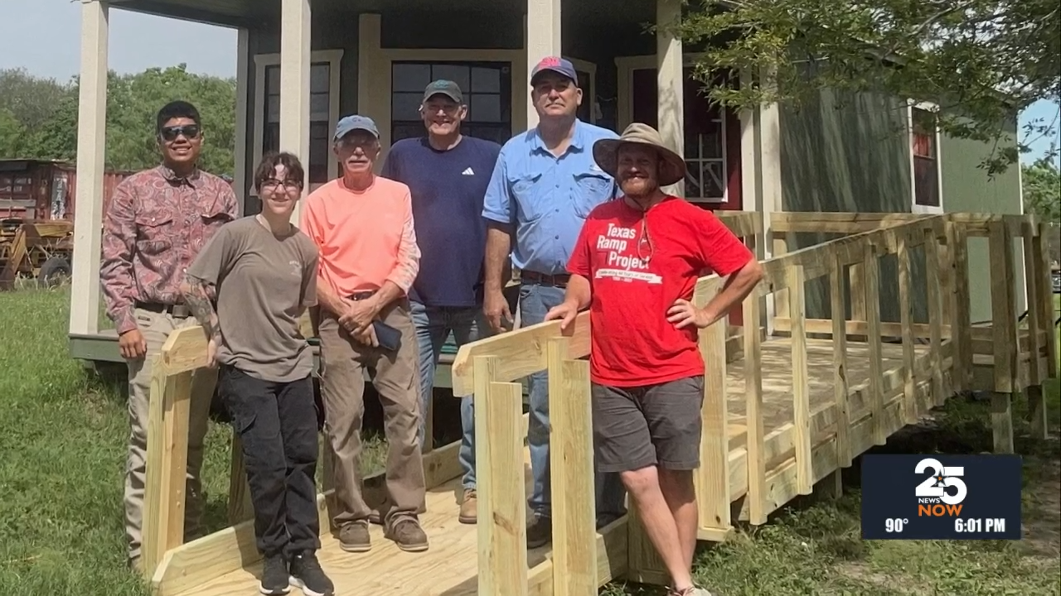

VICTORIA COUNTY, Texas - A group of woodworking volunteers have continued their campaign to increase home accessibility for handicapped and low-mobility local residents.

Their most recent project on May 9 was for a 68-year-old woman battling physical difficulties and undergoing surgery for her back.

Their project was supported by carpentry students from Victoria College.

Volunteers continue to be a major point of emphasis from the core group of workers, saying these projects require many manpower hours, as well as a group leader for the South Victoria Chapter that includes the city of Victoria.

Their next project is scheduled for Wednesday, June 3 as the team attempts to build a 70 ft. ramp. Those interested in volunteering can call Mark Kortokrax at 361-799-9098.

