My Southlake News

Southlake Resident Receives Yellow Rose of Texas Commission

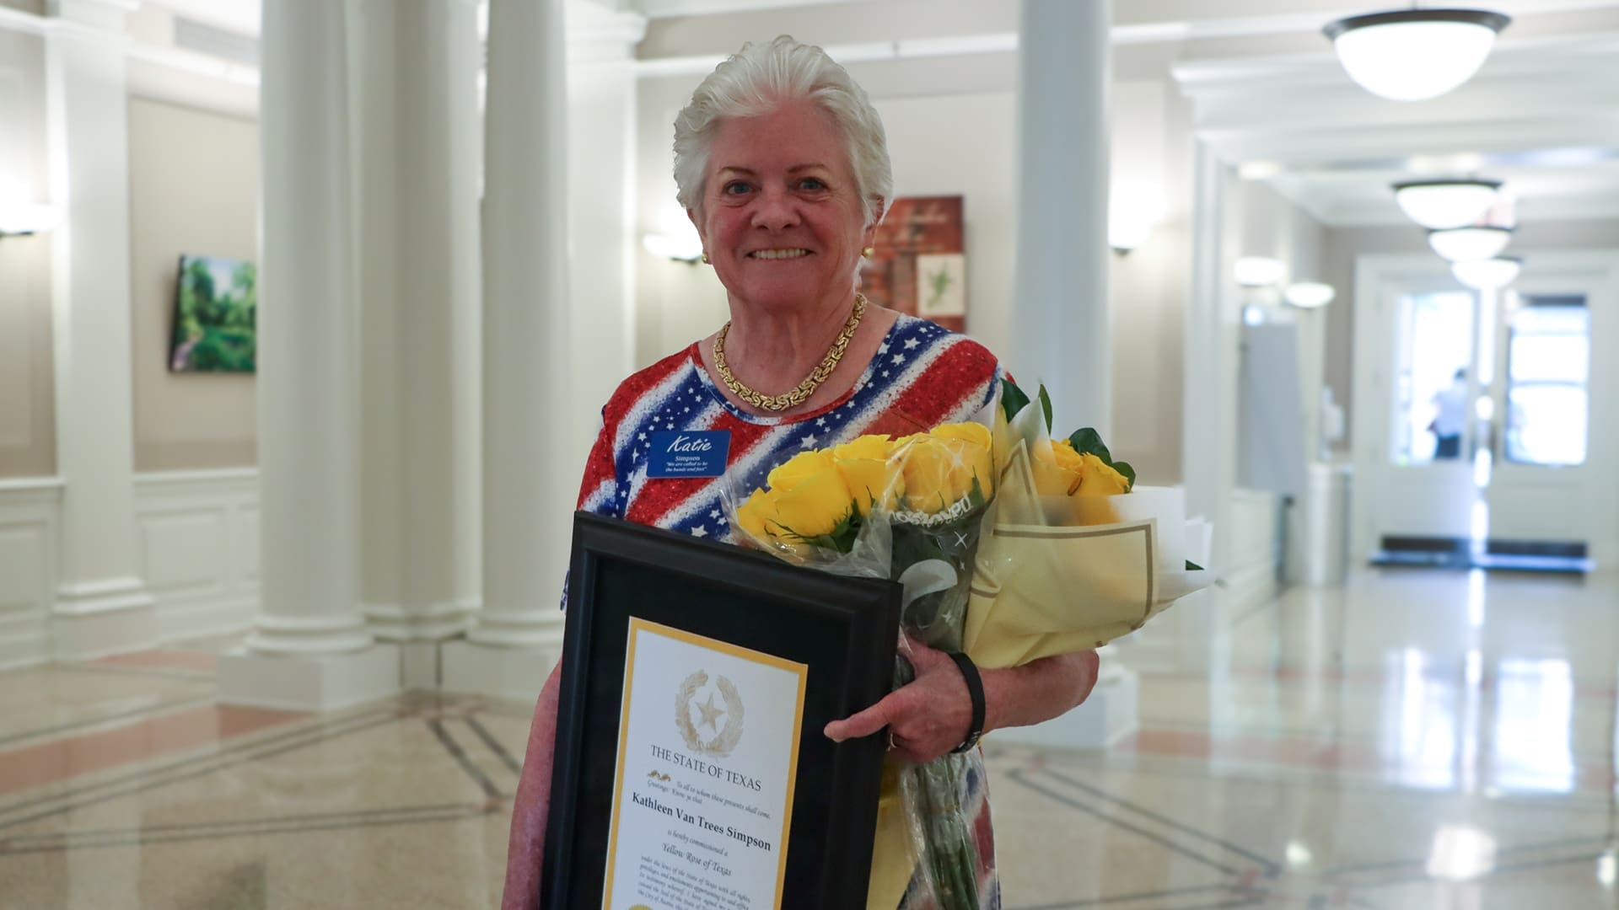
|Dr. Katie Van Trees Simpson was commissioned as a Yellow Rose of Texas, one of the state’s highest honors for women, recognizing her decades of volunteer service and commitment to those in need.

Aug 6, 2026 – During the Tuesday, August 5 City Council meeting, Mayor McCaskill and City Council members, along with a large audience of supporters, recognized Southlake resident Dr. Katie Van Trees Simpson for the remarkable achievement of being commissioned as a Yellow Rose of Texas, one of the state’s highest honors for women.
The Yellow Rose of Texas is bestowed by the Governor of Texas in recognition of women who have made exceptional contributions to their communities and the State of Texas through acts of volunteering and public service. The recipients of this recognition are presented with a certificate that officially commissions them as a “Yellow Rose of Texas”.
Though her volunteer journey began through supporting military families during her husband’s Air Force service, Simpson’s dedication has extended well beyond the military community. Today, she is a familiar face in Southlake, sharing her time and talents with organizations that improve the lives of residents throughout the city and beyond. As a team leader for the Texas Ramp Project in Tarrant County, she surveys, designs, and leads crews in building wheelchair ramps for Texans with disabilities. She is also a member of Southlake CERT (Community Emergency Response Team), the Southlake Citizens’ Association, and serves as a local elections volunteer.
When she isn’t helping build wheelchair ramps, she is likely delivering meals to Southlake seniors through Metroport Meals on Wheels, ensuring older adults who are unable to prepare meals or shop for groceries receive the support they need.
The Yellow Rose of Texas Commission is the latest in a series of honors recognizing Simpson’s commitment to service. Previous recognitions include being named a Stories of Distinction honoree by the Points of Light Foundation in 2025, a Texas-24 Hometown Hero by Congresswoman Beth Van Duyne in 2025 and receiving the Distinguished Citizen medal from the Captain Molly Corbin Chapter of the National Society Daughters of the American Revolution in 2021.
“It’s about answering prayers. Everybody can do something, and there are so many needs in our community. Some are as simple as delivering a meal. Others are helping someone who needs a wheelchair ramp because they’re trapped in their home. I wake up every day asking, ‘What can I do to answer a prayer?’” Simpson said.
Through her dedication to serving veterans, neighbors, seniors, and those who are in need, Simpson exemplifies the spirit of service the Yellow Rose of Texas Commission was created to recognize. Her unwavering commitment to helping others also reflects the compassion, and civic pride that define the Southlake community.
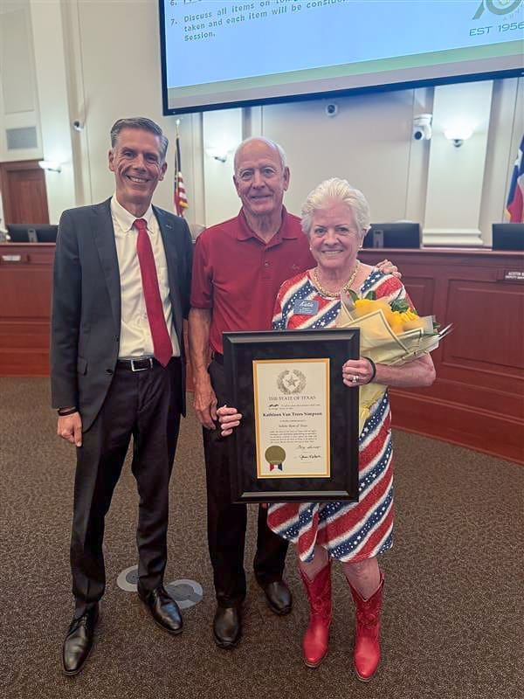
Share

